VISUAL STORY
For the relaxed performance of The Play That Goes Wrong
Sunday, Aug 9, 2026, at 7:00pm
The Lindsay Family Stage at Granville Island (1585 Johnston St, Vancouver, BC V6H 3R9)


Image description 1: "THE PLAY THAT GOES WRONG" is written in bold white text (except for the word WRONG which is red) over a black background.
By Henry Lewis, Henry Shields & Jonathan Sayer



ARTSCLUB.COM 604.687.1644

Table of Contents
What is a relaxed performance? 2
What is a visual story? 3
What to expect at the theatre 3
How to get to the Lindsay Family Stage at Granville Island 6
Arriving at the Theatre 8
Inside the Theatre 13
About the Show– The Play That Goes Wrong 14
Brief Synopsis. 16
Detailed Synopsis 16
Glossary 28

What is a relaxed performance?
Relaxed performances are designed to welcome people who benefit from a more casual audience environment, including (but not limited to) people with sensory processing conditions, autism, a learning or intellectual disability, or parents with infants. There is a more casual approach to noise and movement within the theatre space, which can also be a good introductory experience for people attending the theatre for the first time.

What is a visual story?
A visual story gives audience members an idea of what the theatre experience will be like as well as offer audience advisories for the play.

What to expect at the theatre
How do I get my tickets?
Print-at-home tickets will be emailed to you and will call tickets are available at the box office on the day of the performance. You can pick them up on show day as early as 12 PM or one hour before the show.

How long does the play last?
The official run time estimate is 2 hours 20 minutes including a 20-minute intermission but since this is a live performance, the play may be longer or shorter than the scheduled time. Remember, it is okay to leave the theatre during the show and take a break.

Phones and electronic devices
Phones are welcome, but please do not take photos during the performance. You are welcome to bring in other devices, such as iPads or headphones.

Accessibility
- Limited wheelchair accessible seating is available inside the theatre.
- There is a place to leave wheelchairs and walkers in the lobby. You can ask a front of house attendant or volunteer for assistance.
- Limited assistive-listening devices are available for patron use during the performance.
- Service dogs are always welcome.
- We will have our relaxation station available, which will include fidget toys.
- A quiet zone is provided and will have signs directing patrons to it if you need a quieter, more private space. Also feel free to ask a front of house attendant or a volunteer for assistance in locating this quiet space.
- A printed and/or digital venue guide will be available upon request.
- The theatre is a scent-free zone; please arrive without cologne or perfume.
- Please contact the box office with any inquiries or requests for accessibility services.

Age recommendation
This show is recommended for all ages.

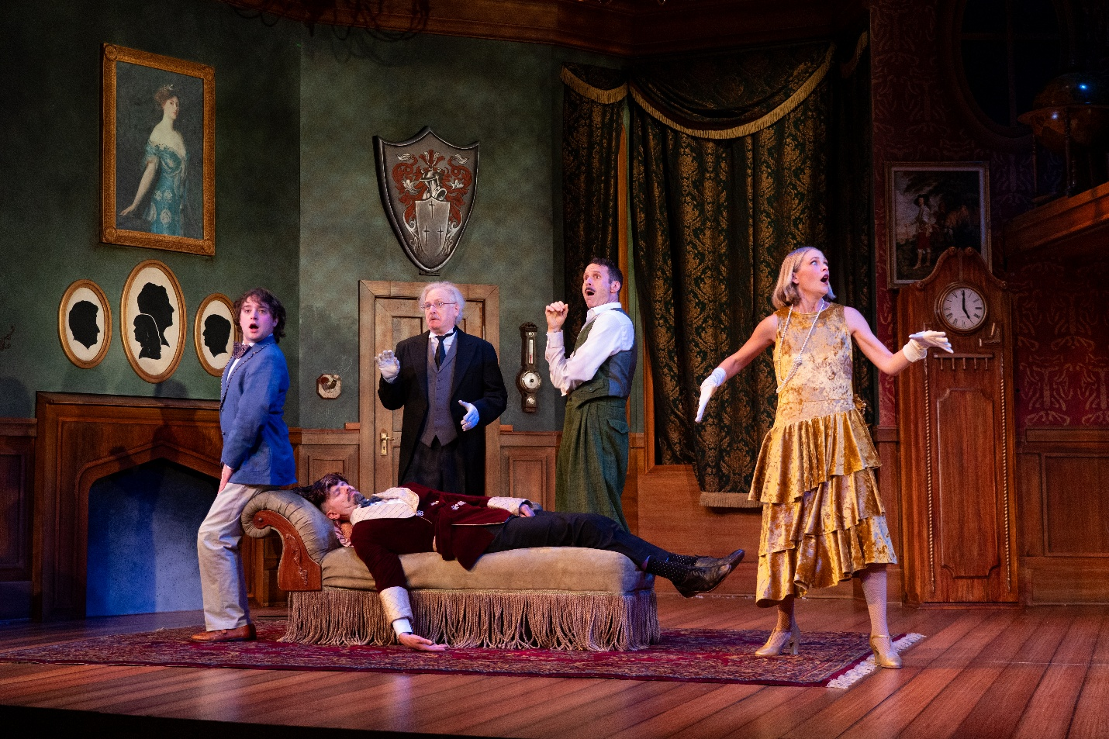
Zander Eke, Ben Elliott, Scott Bellis, Genevieve Fleming, and Andrew McNee in The Play That Goes Wrong, 2026; set design by Ryan Cormack; costume design by Jessica Oostergo; lighting design by Sophie Tang; photography by Moonrider Productions for the Arts Club Theatre Company

Audience Advisory / What to Expect
- There will be eleven adult actors telling the story, performing as people playing characters in a “play within a play” format.
- An actor begins the show as an Uber Eats driver and will be entering the theatre during the stage manager’s front of house speech.
- This production contains fire and fire sparks, loud sounds, a spinning bookshelf, falling props, water-based haze and fog, flashing lights, broken floorboards, and a falling upper platform. Many items break and fall.
- The walls of the set will collapse at some point.
- The actors have many on stage fights, injuries, and other mishaps throughout the play.
- A prop gun goes off, injuring the actor who is holding it.
- Depictions of drinking alcohol onstage, except the alcohol is switched out with gasoline.
- Swordfights, stage combat, and fist fights occur at various points throughout the play.
- There are kisses between some characters. One female actor comes out in her under garments (1950s-esque) for a large portion of the act.
- Actors pretend to be knocked out and/or hurt at various moments.
- A running gag is that the dog in the show has gone missing. There is no actual dog in the show.

About the Theatre
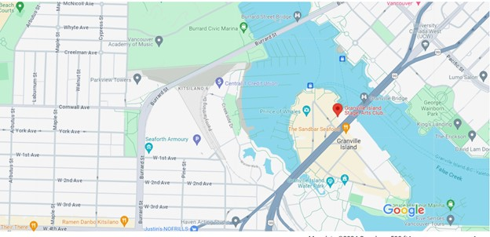
The Play That Goes Wrong is playing at the Lindsay Family Stage at Granville Island, located at 1585 Johnston St, Vancouver, BC, which you can see on the map below…
Photo of Google Maps pinning the Lindsay Family Stage at Granville Island

How to get to the Lindsay Family Stage at Granville Island
By transit
Visit translink.ca for transit trip planning options. We highly recommend using public transportation, including False Creek Ferries or Aquabus. Parking on Granville Island is limited, especially for matinee performances, weekends, and holidays.

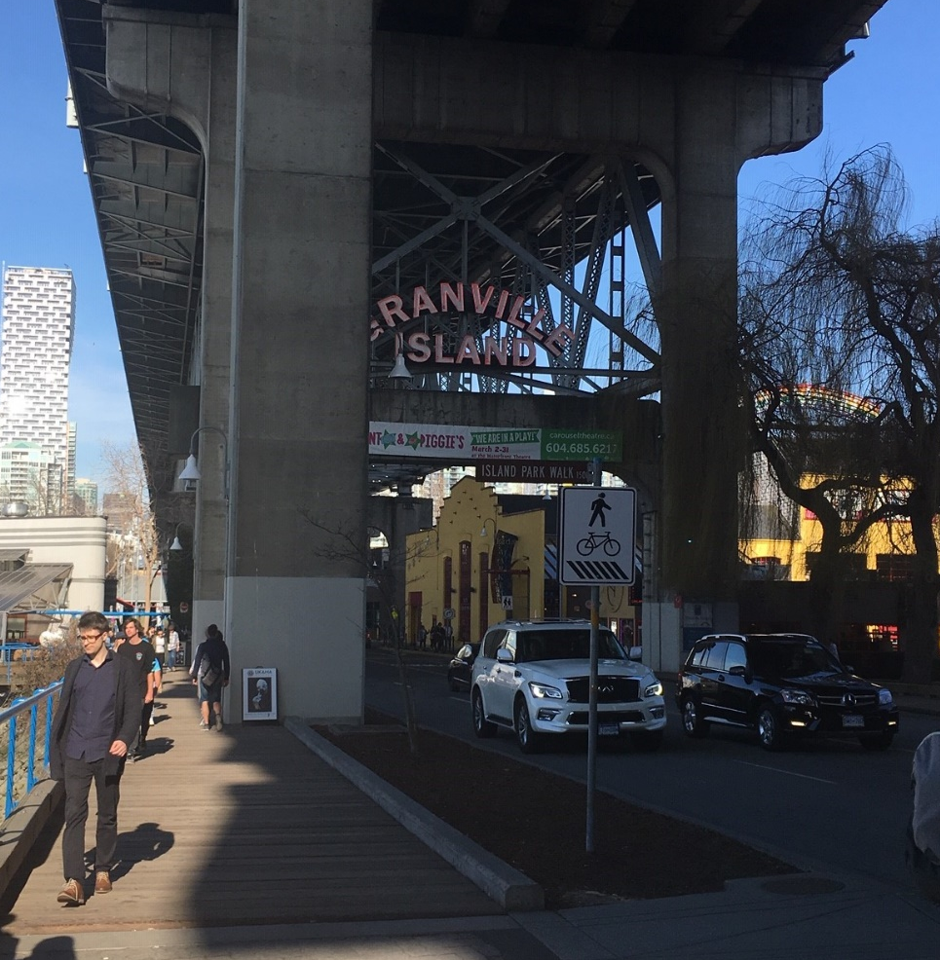

Photo of the entrance to Granville Island, on Anderson Street

Parking
Parking on Granville Island is very limited, especially for matinee performances, weekends, and holidays. We highly recommend using public transportation, including False Creek Ferries or Aquabus, rideshare, taxi, or biking. If driving, plan to arrive at least 60 minutes prior to showtime to find a parking spot.
Pay parking on Granville Island is in effect 9 AM–10 PM in all lots. For more information about Granville Island parking and rates, shops, restaurants, and attractions, visit granvilleisland.com. The closest parking lot just outside of Granville Island is Diamond Parking Lot #3945.

There is a drop-off zone in front of the public market (20 minute stopping zone), and there are accessible parking spots right by the theatre, in the parking garage near Alimentaria Mexicana, in the parking lot near the new Arts Umbrella building, and around the Public Market and the Net Loft.
Visit https://artsclub.com/visit/locations-and-parking-tips#granville for more tips on parking.

Arriving at the Theatre
The lobby to the theatre will open at 6 PM for the relaxed performance. You can arrive between 6 and 7:00 PM.
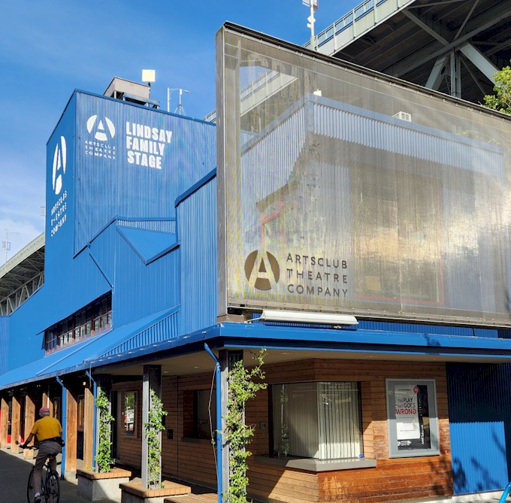
Entrance to the lower lobby
Photo of the theatre entrance, next to the Public Market
Box office window
If you do not yet have your ticket, you can pick it up at the box office, located to the right of the lobby doors. Front of House Attendants will be waiting at the front of the theatre to help guide you to the correct line.

If you printed your tickets at home or already have a ticket, you can go right to the front of house attendant who will scan your ticket at the lobby door.

You will then enter the lobby. The lobby is the area where the audience waits before going into the theatre to see the show.

In The Lobby
The Lindsay Family Stage has a lower lobby and an upper lobby (not accessible by wheelchair or powerchair). When you first enter, you arrive in the lower lobby. There are stairs to the left that lead to the upper lobby, where you can enter the theatre from the back. There are 25 stairs from the lower lobby to the upper lobby.
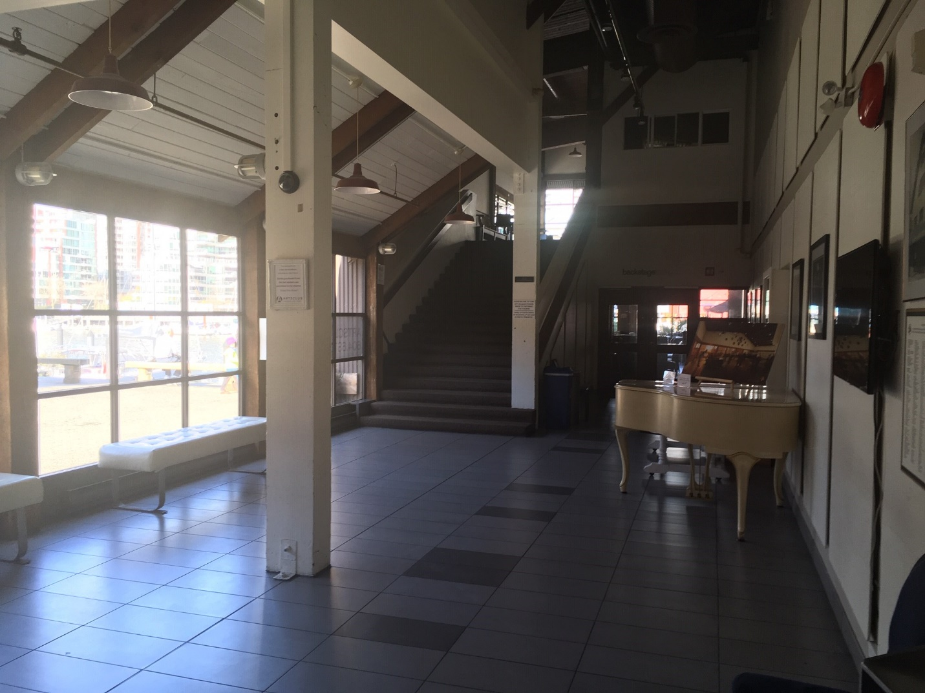
Relaxation Station (where fidget toys, colouring, and other access items will be)
Stairs to the upper lobby
Doors to the Backstage Lounge and washrooms

Photo of the lower lobby
Entrance to the theatre
Photo of the theatre entrance, next to the Public Market

If you would like, you can order a drink or a snack from the bar. You are also welcome to bring your own food into the theatre. There is an area that was a bar through the doors at the back of the lower lobby, which is part of a building called the Backstage Lounge. There is an in-use bar up the stairs in the upper lobby.

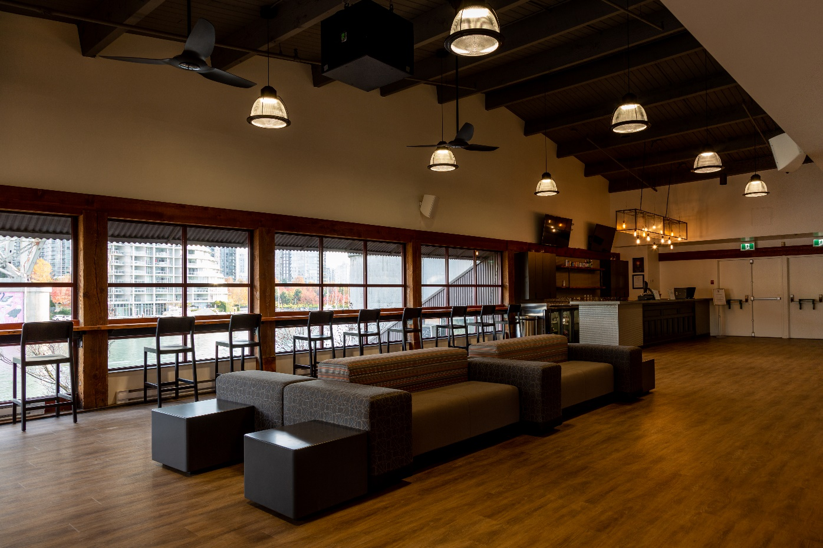
Photo of the Upper Lobby. High top seating along the windows, couch seating in the middle of the room, Bar on the far side. Upper Theatre entrance on the right.

Doors which lead to the upper seating area in the theatre
Bar
Lobby Seating

All washrooms are located on the lower lobby in the Backstage Lounge. Both washrooms are wheelchair accessible.

Photo of doors at the back of the lower lobby, which lead to the Backstage Lounge and washrooms

If you want a break from the show, you can come out to the relaxation station in the lower lobby. You can sit in a chair, walk around, and watch the show from a video monitor. You are welcome to enter and leave the theatre whenever you want.

If you need help, look for Arts Club staff and volunteers wearing yellow buttons.

Inside the Theatre
Guests will be able to enter the theatre starting at 6:30 PM.
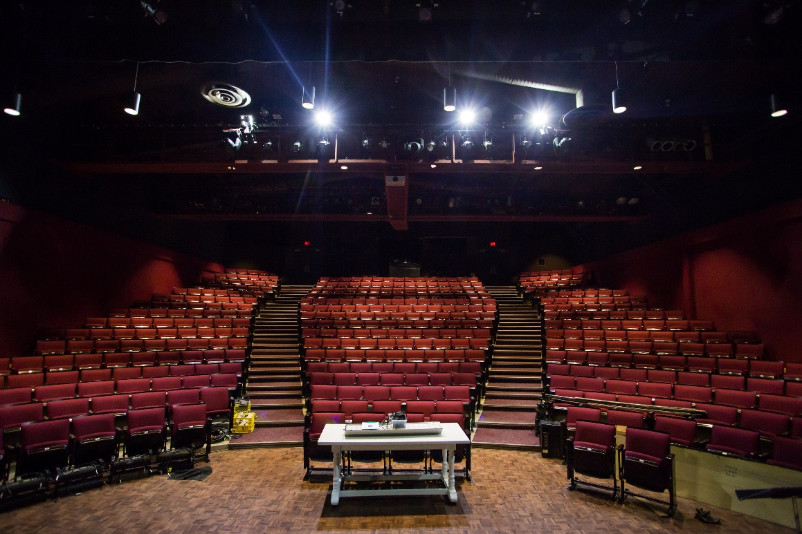
Photo of the seats inside the theatre at the Lindsay Family Stage.
Theatre entrance/exit

Theatre entrance/exits
The seats in the theatre are organized by row letters and seat numbers, which are both on your ticket. Front of house staff near the doors will help you find your way. If you need to leave the theatre, you can leave at any time and come back to your seat at any time.

The Start of the Show
When the show is about to start, there will be a pre-show announcement from the front of the theatre. This will prepare you for the start of the show.

Intermission
The intermission is a 20-minute pause halfway through the show. This is a good time to take a break and think about what you have seen so far. Or you may want to get a drink or a snack from the bars! The lobby lights will flash towards the end of the intermission to alert guests in the lobby to return to their seats in the house for the second act.

After The Show
After the play ends, the actors will come back out and take a bow. They will also remind the audience of who they are, their character, and that their injuries are not real. If you would like, you can clap for the actors.

About the Show– The Play That Goes Wrong
After months of preparation, the Cornley Drama Society is finally ready for opening night of The Murder at Haversham Manor! Surely, everything will go to plan. Right? Wrong. Things go very wrong. Props fail and cues are missed, but the accident-prone thespians push through to deliver a 1920s whodunit story like you’ve never seen before. This chaotic comedy will have you howling with laughter long after the final curtain.

Character Breakdown
As with any play-within-a play format, you have the added complications of the characters of the actors doing the play-within-the-play and the character within the play-within-the-play. To make it a little simpler, the names are laid out below in two lists: firstly the members of the Cornley Drama Society who are putting on the play, and secondly the characters of The Murder at Haversham Manor.
CHRIS: He/him. Overly serious and highly strung director of the Cornley Polytechnic Drama Society. He plays Inspector Carter.
ROBERT: He/him. Robert is a bold, enthusiastic, and somewhat overconfident actor who takes his craft very seriously—despite his obvious lack of skill. Robert plays Thomas Colleymoore.
SANDRA: She/her. She loves being the center of everyone’s attention and often leans into melodramatic performances. Sandra plays Florence Colleymoore.
MAX: He/him. Excitable, innocent, and somewhat naïve actor who is performing in his first major production. Max plays Cecil Haversham and Arthur the Gardener.
DENNIS: He/him. Dennis is not naturally suited to the stage and seems to be part of the production more out of obligation or desperation than passion. Dennis struggles to remember lines and often mispronounces or delivers them with interesting timing. Dennis plays Perkins.
TREVOR: He/him. Trevor is the play’s long-suffering lighting and sound technician. He is not an actor, but he constantly gets dragged into the disaster when technical cues fail, props break, or actors demand his help.
ANNIE: She/her. The hardworking and frazzled stage manager. Annie ends up having to play Florence Colleymoore.
JONATHAN: He/him. Cheerful and eager actor who is thrilled to be part of the production—he takes his part seriously but struggles when chaos ensues. Jonathan plays Charles Haversham.
STAGE CREW/ENSEMBLE: The Crew of the stage production (actors).

Setting

The play takes place on the opening night of the fictional Cornely Drama society’s fictional production of The Murder at Haversham Manor. This play takes place during present day.

Detailed Synopsis

*Note that throughout every scene, there are multiple instances of props and set pieces hitting the actors. There are added gags throughout the play that may not be captured below due to the sheer volume of shenanigans happening on-stage.
ACT I
The play opens looking at the private rooms of Charles Haversham. This is the set when the audience comes in. While the audience is getting seated, actors are playing stage crew. Note: these are actors and are not really the stage crew! One crew member breaks their hammer while working on stage. Two others are searching through the audience for a missing CD. Chris is dressed up formally and is greeting audience members as they arrive. Annie is getting help from an audience member to try to get a book onto the mantlepiece.
The play opens with Trevor addressing the crowd. As he does so, the mantelpiece that Annie was working on collapses onstage. As this is a play-within-a-play, Trevor, who runs the lights and sound for this fictional show, is welcoming the audience to The Murder at Haversham Manor, which is the pretend play that the actors are about to perform. Trevor gives a Front of House speech. He also mentions that there is a lost CD and that if an audience members finds it, to drop it in the tech box by the end of the show. The house lights lower, and the stage lights come on. Before it starts, Trevor also announces the show’s dog, Winston, who plays the guard dog has gone missing. Chris, an actor/the director of this play makes another speech that hints towards this company’s string of bad theatrical luck.
The play begins with Jonathan, who is playing Charles Haversham, entering and tripping as he comes out. The lights come on revealing him on the floor and then the lights go out again as he makes his way to the sofa where the lights come on again prematurely. Things are going wrong right away! Dennis and Robert call from off stage that they are at the door and please let them in as Charles has been in there too long and they want to raise a glass to his engagement downstairs where more guests are waiting. The door is locked, and Charles is not answering so they try keys and a hammer, but it doesn’t work so they simply walk around the set to get in the room. There they find that Charles is dead. Dennis calls for the rest of the house guests to come to Charles’ room. They decide to contact Inspector Carter, who lives nearby, and tell him that there has been a murder. There is a sound effect error during the phone call. They decide to lock all the doors while they wait for the inspector to arrive.
Meanwhile, the characters are all still trying to enter through the door, which is still stuck. The stage crew manage to open it but are seen by the audience. Max, Charles’ brother arrives to see him dead. There is an elevator onstage that’s takes Dennis to the study on the upper level to get a drink for Max. Sandra, Charles’ fiancé is also in the main room. Dennis declares that the scotch bottle is empty, and that Charles must have drunk it. However, the bottle is not empty, so Dennis pours it down the voice pipe and it splashes all over Robert. He soon realizes that he grabbed the wrong bottle and finds the proper one comes down to the ground floor and puts the bottle with a tray of short glasses. As he is passing the window, Annie appears and grabs the bottle and replaces it with a bottle that says “White Spirit” on it. The bottle has a large “flammable” symbol in it. Dennis doesn’t notice.
Sandra starts to become hysterical pounding on Jonathan’s chest. Dennis pours Max a drink from the flammable liquid bottle. He pretends to like it but spits it out and asks for more, primarily to stay in character. He spits it out after each refill and after a while it starts to burn, and he spits it into Jonathan’s face. Discussion continues as Max says that he thinks Charles died by suicide. Dennis believes it was murder. To prove Max’s point, he asks to show everyone Charles’ journal. In the journal Charles says that he fears that Florence does not love him.
The inspector arrives after a doorbell sound cue goes wrong and Inspector Carter, played by Chris, enters. He makes sure that that everyone is accounted for and finds out all are there except Arthur the Gardener and his dog, Winston. They all decide to lift a glass to toast Charles. They all spit it out but keep pretending that it is a fine vintage. Dennis is asked to move the body upstairs for examination purposes. A stretcher is brought in, and Dennis and Robert try to lift the body, but can’t. They tip him off the couch instead where he lands hard on his face on the stretcher. Then they try to lift the stretcher and the canvas breaks. They pretend to take him upstairs, but the body still lays on the floor. Robert and Dennis pretend to carry the body up to Charles’ private study on the second floor.
Meanwhile, Max and Sandra remain downstairs, where it’s revealed that they are having an affair. As Max sits on the sofa, he sits on something and finds a ledger under the cushion. He puts it under the sofa. Then Max gets down on one knee in front of Sandra. Charles slowly drags himself upstairs to try to be in the correct position upstairs. But as he is standing behind Robert and Dennis, he startles them when they look behind them. Then Charles lies down on the floor. Robert checks the body’s pockets and Chris gets out some fingerprint supplies. The prop letter is not in the expected pocket, so Charles must non-discreetly pass it to Chris. Dennis drops the fingerprint powder onto Charles’ face which causes him to repeatedly cough.
Downstairs, Max proposes to Sandra. At the same time, Charles coughs so strongly that he slips off the upper level where he eventually falls back down to the main level. While Sandra accepts the proposal and they start to kiss, Robert bursts in looking for a pencil for the Inspector. There is no pencil prop where it should be, so he takes a set of keys instead. They try to kiss again, and Dennis come in and interrupts needing the keys to lock everyone inside, as per the Inspector’s orders. As the keys are gone, he picks up the Inspector’s notebook instead. As they try to kiss again, Robert bursts back in looking for the notebook. As it’s gone, he instead picks up a vase of flowers. After he leaves, they try to kiss again but wait for the next person to barge in, as was scripted. Lingering to kiss leads to an awkward situation which ends when Dennis bursts in, late for his cue, looking for candlesticks.
Max tells Sandra that he thinks Thomas Colleymoore (played by Robert), Sandra’s character’s brother, killed Charles. He states that it was probably because he didn’t want his best friend marrying his sister. Sandra wonders aloud whether that means he will kill them both if he discovers their affair.
Chris gathers the cast in the main room to let everyone know that he intends to interview them all now that he has finished examining the body. He asks for all of Charles’ personal items to be brought in. Throughout this scene, there is a running gag where characters accidentally keep grabbing the wrong props because they are unable to find the actual item.
As Dennis is being interviewed first, he tries to light a cigarette but drops it into the coal scuttle, where the scotch was accidentally poured. This starts a fire. Robert tries to extinguish the fire while the interview continues. After the inspector is finished with Dennis, he asks him to bring in Sandra for the next interview.
As Sandra’s interview progresses, their lines go out of sync where Sandra starts to answer questions before they are asked. During this jumbled conversation, the Chris reveals that he read the letter that admits to the affair. It was found in Charles’ jacket. Sandra says this proves that he killed himself out of grief. He mentions that it is as likely that Sandra and Max murdered him. Robert and Max burst back in, and in the process hit Sandra with the door which knocks her out. They try to continue the scene as if Sandra is awake.
Chris interviews Max next (while Sandra is unconscious on the floor) and Robert peeks through the large window at the centre of the set and attempt to pull Sandra through, hitting her against the set as they do. They manage to sit her up, only for her to fall backwards again, her dress riding up to reveal her underwear. Sandra, still unconscious, keeps getting hit as the interview continues. Chris pulls back the curtain to disprove Max’s alibi about the time of day, revealing not only Robert and Jonathan but also the stage crew in their efforts to remove Sandra. The stage crew freezes like trees to try to blend into the set. Max and Chris continue the interview as the others resume their attempts, increasing the volume to match the chaos behind them. They manage to remove Sandra as Chris asks for Robert to be brought in next.
As he waits for his next interviewee, Chris lifts some cushions on the chaise longue, hoping to find a ledger where there is none. He desperately searches around the chaise for it, not seeing that Max had previously tucked it underneath. Sometimes the audience calls out to him that it’s there, and Chris interacts with them before resuming the scene. In this ledger, Chris finds the recent will of Charles, tightly bound by string. This doesn’t stop him as he puts it to his head and “transfers” the knowledge to his brain to recite it. The letter reveals who Charles left all his money and the manor to, but Robert and Max interrupt Chris before he says it aloud.
With this new information, Chris excuses himself to Charles’ study, taking the noisy elevator up. A new clanking sound from the elevator is heard, and Chris opens the upstairs elevator doors to reveal the elevator stopped hallway between the two levels. Chris climbs onto the upper platform accidentally sliding the ledger off. Robert, who has been discussing with Max on the main floor, catches it and throws it back up to Chris. He slams the elevator doors shut which causes a voice pipe funnel, on the left of the door, fall off the wall. Robert picks up the funnel and slams it back on the wall, causing the barometer, on the right side of the door, to fall off. Chris is now examining the will as Max and Robert try to put the set pieces back on the wall, only for them to cause the painting above the fireplace to fall too. Max catches it before it hits the floor, but they are both stuck holding up the items that won’t stay on the walls.
The phone rings and Max tries to keep the picture in place while reaching for the phone with his foot. He answers and says it is Robert’s accountant. Max stretches and passes the receiver to Robert to the best of their ability being stuck with their items. Robert listens in extreme discomfort as his character discovers that his deposit of nine thousand pounds was just stolen. Robert calls for Dennis who rushes in through the door, only to hit Robert in the face as both hands are around the door frame. Robert asks Dennis to hand him his bankbook and a pen so he can write down the name of the caller from the bank. With his hands full, he uses his mouth. After Dennis exits, a distressed Max confesses to Robert about his affair with Sandra’s character, and the two drop the items and start to fight. They look at each other in confusion when the voice funnel, barometer, and painting all stay hung up.
Max and Robert instantly go back to fighting, drawing swords hung from the wall and battling it out. Max’s sword gets thrown behind the window set, and when he retrieves it, the blade has snapped off leaving only the handle. The two continue anyways, making clanging sound effects. Robert accidentally thrusts his sword through the underside of the upper level, and it goes straight through between Chris’ legs, who was still frozen in the study. With the sword stuck, Robert mimes it and the two continue an epic battle. Eventually, Robert slashes Max and throws him out of the room. As he slams the door on Max, the picture, voice pipe funnels, and barometer fall to the ground. Denis runs in as three loud gunshots and Max’s screaming are heard offstage.
Chris, Robert, and Dennis reconvene in the main room, and Jonathan pushes a reluctant Annie onstage. She is wearing Sandra’s dress over her own clothes and clutches a script. Continuing the scene with Annie’s bad acting, the group decides Max’s character is the one who murdered Charles. They try to lock the door in protection after a premature entrance by Jonathan with a gun, but Max staggers inside before they can with three bullet wounds in his back. They declare it a double murder, not without some sound effect errors. At least Trevor found his missing CD. Dennis fetches the stretcher poles that broke off from earlier and roll Max on top of them with Robert’s help. To their surprise, Max is lifted, and he holds on tight as they rotate him ninety degrees to exit through the door.
When the two return, Chris, Annie, Robert, and Dennis brainstorm who the murderer is over a glass of the same white spirit bottle from before. As they drink and spit up, Dennis responds with the wrong line, causing the group to repeat this section of lines and forcing them to drink more white spirit. Now stuck in a loop, they repeat the section faster and faster, throwing white spirit in Dennis’ face until he gets the line right. His line reveals that no one except for those in the room could have killed Charles.

INTERMISSION
During the intermission, the actor playing ‘Robert’ may come out into the lobby and join the line for ice cream. The actor playing ‘Chris’ will come and admonish him and send him backstage.

ACT II
Dramatic music plays as the house lights fade. A spotlight rises on Chris who attempts to give another monologue, apologizing for all that went wrong in the first act. However, as he tries to speak, his radio cuts in and out with Trevor’s voice who has accidentally called Chris and is revealing over the radio what a disaster this show has become. Chris introduces the final act, and the lights turn oin, revealing Annie, Max, Robert, Dennis, Jonathan, and the stage crew rehanging and fixing the set. They turn and see the audience, clearly surprised that intermission is over. Chris frantically enters from the stage right wing and gestures off-stage for the lights to go off, which they do.
There is a beat, before the lights turn on again. Annie, Robert, Dennis, and Chris are in their positions from the end of Act One. Jonathan, Max, and the stage crew are gone. All the wall hangings are back in position and Act Two officially begins. As Dennis attempts to speak, the wall hangings all crash to the floor. The cast quickly clear them before jumping back into the murder mystery. Annie is reading from her script.
Chris, in character, attempts to leave through the downstairs door to investigate where the gunshots came from but as he opens the door, Jonathan is revealed to be standing directly behind it. Jonathan quickly moves out of view.
As tensions grow over the murder, Annie trips over the set’s rug and her script pages go flying everywhere. As she picks up the papers, they end up all out of order and Annie attempts to improvise her way through the scene. Dennis and Robert try to support her by offering mimed visual cues to “prompt” her correct line, with no luck. Annie continues to randomly spout off the incorrect lines.
Dennis, trying to keep the story going, announces it is now past midnight. Trevor mistakenly plays a clock chime sound 14 times instead of 12, and calls out to apologize to Dennis, before hitting the chime sound, again. Trevor laughs at his clever sound joke before telling Dennis to continue his line.
Chris enters through the upstairs door, holding a gun. He calls down to Robert through a voice-pipe in the set. Chris tells Robert to join him upstairs in the study, however when Robert attempts to enter in the elevator carriage, the elevator breaks, causing him to fall out in a cloud of smoke. Robert attempts to manually climb to the upper level while still continuing his speech as Colleymoore. Dennis and Annie attempt to assist Robert by helping lift him up to the platform. Once he successfully makes it onto the platform, Chris reveals he has found the murder weapon, a prop gun, and begins to question Robert.
Robert forgets his line and calls out to stage management for his line. Trevor calls back and lets him know that because of how off the rails this show has gone, he has no idea what page they are on. Robert mistakenly repeats this back to Chris, before realizing that wasn’t his line. Chris prompts Robert with his line and the scene continues, with the Inspector questioning Colleymoore on his motives and if he killed Cecil. The two pose, signalling the end of this scene. The audience hears a knock while the lighting shifts to Annie, still attempting to get her script pages together.
Dennis, as Colleymoore, attempts to get the play back on track by moving onto his next line which reveals a hidden bookshelf built into the set. When Dennis/Colleymoore attempts to hide Annie behind the bookshelf, the gag doesn’t work. As Dennis shrugs and looks at the bookshelf, it swallows him whole and takes him off stage. Off stage, Dennis attempts to get Annie to re-open the door, ending up in a spinning door gag as she gets trapped in the revolving door alongside him, being spun around.
After the carousel of Dennis and Annie ends with Dennis falling out of the bookshelf, he is also accidentally followed by Trevor. Trevor, panicking, hides inside the hollow grandfather clock, at the back of the stage.
Dennis, still perservering through, opens the downstairs door to reveal Max, now dressed and playing a new character (Arthur the Gardener). Max now has mutton chops, an overcoat, is holding a watering can and a dog leash with no dog attached. Dennis greets him and attempts to continue the scene as Max pretends to be pulled around the stage by an invisible dog. Dennis (as Colleymoore) reveals that Charles Haversham has been murdered. Max (as Arthur the Gardener) is shocked and accidentally walks straight into the pillar that is supporting the upper level of the set. He knocks the pillar over, causing the upper level with Robert and Chris on it to begin to tip forward. The drinks, chair, plant, and other set pieces begin to sled across the floor, almost falling off. They are rescued by Chris and Robert, before the set pieces can roll off the now permanently tilted stage. The two shuffle to the upstairs door and try to get through it but the door handle snaps off. They are now trapped on the upper level.
A silent argument begins between Robert and Chris while the scene switches to back to Dennis. Max picks up the pilar and passes it out of the window at the back of the stage. Jonathan is seen by the audience as he takes it from Max. As this happens, Dennis reveals a strange figure has been seen around the manor, a window had been broken into, and outside the window was this lace handkerchief with a distinct scent of cyanide (which Dennis mispronounces). At this moment Dennis gets so upset that he has made another error that he turns his back to the audience to hide his feelings. Max briefly comforts him before continuing the scene, revealing the handkerchief was also embroidered with the initials F.C. for Florence Colleymoore.
At this reveal, the stage lights switch back to Chris and Robert, still on the upper level. Robert has stopped attempting to re-attach the doorknob. As Chris attempts to reveal that Charles Haversham left a new draft of his last will and testament, the whole upper level begins to wobble. Chris carefully hands the tied papers to Robert, who can’t untie the ribbon. Instead Robert pretends to read off the front of it, shocked at the news that Cecil was going to leave everything to Perkins (as played by Dennis)!
The lights shift downstairs where Annie is spun back onstage, now knowing she has the correct script and lines. As Annie confidently speaks, the drink cabinet on the upper level slips and falls towards Annie. Robert catches it as the lights shift back to the upper level. Chris and Robert attempt to ad-lib their way through the scene, while holding all the furniture, and attempting to get off the upper level. The elevator is smoking and unable to open, so the pair are forced to slowly slide their legs off the edge of the upper level, before dropping down safely to the floor.
The actors bravely continue, amongst more line flubs from Dennis and Max mixing up his characters. Chris declares in character that he needs his magnifying glass, which is in the desk, still being held back on the upper level by Robert. As Robert attempts to reach for the desk and pull it towards him, the upper level falls further, sending all the furniture (except the plant pot) sliding down to the lower level. Robert eventually finds the magnifying glass which he gives to Chris. As he does, the plant pot tips over and falls on top of the other furniture.
The telephone rings again and Max picks up the call. It is revealed the caller is asking for Robert who is still on the upper level. Max tries to pass Robert the receiver, but the cord doesn’t reach. Annie, Max, and Chris all create a long chain of arms across the stage, with Chris’ hand in the shape of a phone at the end of the chain. As the awkward phone call ensues, Robert tries to exit through the upstairs door which is blocked by all the furniture. He noisily attempts to exit but when the upstairs door opens, Jonathan is revealed, holding tools and attempting to fix some of the set.
The play continues with Chris (as the inspector) accusing Annie (as Florence Colleymoore) of the murder of Charles Haversham. As this accusation happens, Robert gets all the furniture out of the door. The last item, the globe, almost slips out of his grasp but he catches it just in time! Triumphantly he exits, only to fall off the upper level behind the door immediately.
As Annie begins to say a line, Robert enters from a door behind her, which whacks Annie in the head and causes her to be knocked out. Robert and Chris lift Annie’s body up and sit her on the windowsill, when suddenly Sandra re-enters.
Sandra, in her undergarments, bursts in though the swivel bookcase, which Annie’s body is pushed behind. The scene continues and Max enters, immediately averting his gaze from Sandra as he is embarrassed to look at her. Sandra attempts to keep the scene going but Max can’t look at her without giggling. When Sandra grabs Max’s face to get his attention, she accidentally tears off one of his fake mutton chops. They try to stick it back on and when that fails, Max swaps sides so the other mutton-chop faces the audience. Max eventually pushes Sandra away and she bangs on the side of the grandfather clock which startles Trevor, who steps out of the clock, with the door of the clock hitting Sandra and knocking her out.
Max and Trevor look at each other and lift Sandra’s unconscious body into the clock. They remember the audience is watching and Max hands the script to Trevor and gestures for him to read to the audience. Trevor reluctantly reads as Florence and the two share a kiss. Robert, Dennis, and Chris re-enter, and reveal now Florence is supposed to have one of her famous hysterical episodes. Trevor protests at having to do this but reluctantly gives in and pretends to have an episode. He eventually starts to enjoy it and plays it up for the audience, leading him to bump into Chris who pushes him off. Trevor ends up falling under the upper level which collapses and crushes him as Robert steps onto it from the upstairs door.
As Robert exits and closes the door, the chandelier begins to spark, and a lighting truss seems to almost fall out of the lighting grid. Sandra, still inside the clock, wakes up and calls to the cast who now can’t get the grandfather clock door open. They lower the clock onto its side and when they realize they can’t open it, they lift the clock onto the chaise lounge, pretending it is Sandra’s body. Robert enters again on the lower level and is surprised to see the group performing with the clock, but he goes with it, splashing water onto the clock’s face to keep the scene going. Max (as Arthur the Gardener) reveals that it couldn’t have been Florence because he believes he saw a man. As this reveal happens, Annie wakes up and begins to stand up from behind the stage window. She comes back in and grabs Trevor’s script which has blood splatter on it and fearlessly jumps into the scene, climbing onto the clock and pretending to unconscious.
Chris reveals the murderer was Dennis (as Perkins) and he will be taking him to the police station but not for hours as the snow outside is so heavy. This is accompanied by a weak, single handful of snow from behind the stage window. As Annie pretends to wake up (as Florence) so does Sandra, opening the grandfather clock door and hitting Annie.

There are now two Florence’s as Annie and Sandra now compete onstage for the role. Dennis reveals the plot twist of the whole show, that Inspector Carter (Chris) is the real murderer. Chris pulls out a stage gun and points it at Dennis. Now Jonathan, as the presumed deceased Charles Haversham, enters through the downstairs door with the rifle (this time at the correct moment). Sandra and Annie are still fighting and pushing each other for the role, now start speaking the lines at the same time. They use the swivel bookcase to get the other off the stage and eventually Annie hits Sandra in the head with a metal try to knock her out.
Dennis attempts to keep the show going by demanding they unlock Perkins handcuffs; however, Robert does not have the key, so Dennis remains chained to the chaise lounge. Robert and Max try to pull the handcuffs off with no luck.
Sandra wakes back up and attempts to enter through the downstairs door, however Annie holds it shut to prevent her from getting through. Jonathan commands Dennis to go get the papers that prove Inspector Carter’s guilt, however as Dennis is still handcuffed to the chaise lounge. Robert and Max quickly lift the clock off the lounge and Dennis, Chris, and Jonathan carry the chaise lounge over to the fallen study furniture and papers for Dennis can fetch his props. Robert and Max place the clock back up.
Chris (in character) asks if Jonathan will really shoot him in front of a room full of witnesses. Sandra is still attempting to join the scene and eventually bursts in through the back of the grandfather clock. Jonathan hands Max his gun in the excitement and Annie and Sandra begin to circle each other.
Annie charges at Sandra, but Sandra moves out of the way which causes Annie to charge out the window. Getting up, Annie leans in and drags Sandra out through the window so she falls on the floor behind the set. They continue to fight as Robert, Max, and Jonathan attempt to continue the scene. However as Max turns too quickly, the barrel of the gun flies off and narrowly misses Robert.
As Robert tries to exit the scene, the door comes off its hinges in Robert’s hand. He ditches the door offstage, just as Jonathan arrives on the upper-level door and falls off the edge, hanging on to the broken truss and swinging across the stage. He lands in front of the downstairs door as the other actors scatter.
As this chaos unfolds, it is revealed in the play that Thomas Colleymoore was Inspector Carter’s accomplice in the murder. Sandra re-enters and begins her line before Annie appears in the window with a ledger and hits Sandra in the stomach and then the head with it. She jumps in through the window and over Sandra’s body and into the scene. Robert forgets his line during his big confession and Trevor feeds him the wrong line accidentally as he staggers out from under the collapsed set. Chris prompts Robert with the correct line and as the scene continues, Sandra comes back and throws a vase at Annie’s head which smashes against the back wall be as Annie ducks.
Both playing Florence, Annie and Sandra grab at Jonathan to continue the scene, pulling him to the floor in the process. Annie and Sandra continue to shout at each other and Robert and Chris try to pull them apart. Annie takes Robert out with a swift punch to the groin. She goes to punch Sandra who ducks, and Annie ends up hitting Chris in the chest, sending him down as well. Dennis reappears in the doorway with a prop reading glasses for Jonathan. Dennis exits, still attached to the chaise lounge and carrying it with him.
Annie and Sandra continue to battle while Jonathan attempts to continue the scene with the two actresses’ playing Florence. Annie ends up punching Sandra in the face and she falls out of sightline as Max also exits the stage.
Jonathan and Robert do their best to continue the scene, with random interjections from Annie and Sandra. Sandra ends up headbutting Annie and both collapse behind the stage window. Jonathan begins to reveal all the items that prove the guilt of Robert’s character when he mistakenly pulls out the missing Vanessa Carlton CD from earlier in the show. Robert shouts at Trevor who has now returned to his sound booth.
Annie triumphantly returns onstage as Sandra appears in the window, tied up with tape. Chris attempts to have his dramatic reveal monologue, however as Robert tries to shoot his prop gun, it won’t go off. He ends up yelling “BANG”, and Chris pretends to be shot. As Robert lowers the gun, frustrated, it goes off loudly and hurts his hand.
Dennis enters through the downstairs door, knocking over a painted wall flat with the chaise lounge. As Robert moves back to avoid this wall, he bumps into the fireplace wall flat, which also topples over. As the flat falls, Chris barely manages to roll out of the way. Finally, the window flat falls, over top of Annie who is standing in the window frame. It reveals Max, standing on a small stepladder, holding a bucket of snow. There is a beat before Max throws a handful of snow over Annie’s head.
Jonathan requests for Dennis (in character) to escort Annie away, which they agree to do, however they are stuck and unable to move in the wreckage of the set. They pretend to walk downstairs on the spot where they are standing. Robert, in character, proceeds to drink a glass of sherry by the telephone, forgetting his most important line as he is supposed to die from being poisoned. From the booth, Trevor tells him to “just die already!”, before Robert feigns a large, flamboyant, dramatic death that takes him far away from the table. However, he realizes he is still holding the sherry glass, so he groans and crawls back in the direction to put in down on the table. Once placed on the table, Robert drops down dead. Max throws a handful of snow and Jonathan moves to centre stage.
As Jonathan has his final speech, Vanessa Carlton’s “A Thousand Miles” begins to play over the speakers. Trevor quickly stops the cue and the correct dramatic music plays. Suddenly, the chandelier hanging above sparks and crashes down onto the floor. Black out.

End of Show

Glossary

Costumes: The outfits the actors’ wear to differentiate between themselves and their characters. In this show, some characters will have multiple costumes.
Cue: The specific signal or prompt that triggers a technical effect during a performance.
Director: The primary creative visionary on a show. They oversee bringing the playwright’s words to life.
Front of House Attendant: An employee of the Arts Club Theatre Company who works for the Guest Services department. They are here to assist with your theatre-going experience and any general questions regarding the theatre.
Front of House Manager: An employee of the Arts Club Theatre Company who works for the Guest Services department. They are the main point of contact during an emergency and are here to assist with your theatre-going experience.
Intermission: A 20-minute pause halfway through the show
Lines: The words that the actors speak
Lobby: The entrance area in the front of the theatre where the washrooms, and relaxation station are located
Play-within-a-play: A dramatic device where a secondary theatrical play/piece is performed within the main framework of the play. Famous examples include Hamlet & Midsummer Night’s Dream. In this play, the secondary theatrical piece is the fictional Murder at Haversham Manor.
Relaxation station: An area of the lobby where you can sit at any time during the show. You can also watch the play on a TV monitor in this area
Row: Row numbers are located on the side of each line of seats
Script: A written document that has all the lines, stage directions, character names, and information needed to tell the story of the play.
Seat: Seat numbers are located on the seat, just below the cushion
Section: The area of the theatre where your seat is located. Your ticket will also tell you if you are on the right, centre, or left side of your section.
Set: The backdrop, props, and physical background of the play.
Stage Crew: The backstage team (the people who work behind-the-scenes) to make the practical effects happen.
Stage Manager: The stage manager facilitates all conversation between the artistic team, technicians, and actors. They oversee and run the day-to-day operations and are the right hand to the director.
Vanessa Carlton: An American singer-songwriter and pianist.
Wall flat: A lightweight wooden frame, covered with fabric or thin plywood. Primarily used for backdrops in film and theatre.

