VISUAL STORY
For the relaxed performance of The Three Musketeers
Adapted by Catherine Bush
From the novel by Alexandre Dumas
A co-production with the Citadel Theatre, Edmonton

Sunday, February 9th, 2025, at 7PM
Stanley Industrial Alliance Stage


Image description 1: "THE THREE MUSKETEERS" in black on a ombre background with red, white, and blue. There are three graphics of "musketeers" with swords.

.ARTSCLUB.COM 604.687.1644

Table of Contents
What is a relaxed performance? 2
What is a visual story? 2
What to expect at the Theatre 3
About the Theatre 5
How to get to the Stanley Theatre 6
Arriving at the Theatre 7
Inside the Theatre 10
About the play—The Three Musketeers 12
Content Advisory – Includes Spoilers 15
Detailed Synopsis 16
Glossary 19

What is a relaxed performance?

Relaxed performances are designed for anyone who might benefit from a more casual audience environment, including patrons with sensory and/or processing disabilities, those who identify as Neurodivergent, people with disabilities, parents with small children, and more. There is a laid-back and casual approach to noise and movement within the theatre space, which may be a good introductory experience for new theatregoers.

What is a visual story?

A visual story gives audience members an idea of what the theatre experience will be like.

What to expect at the theatre

How do I get my tickets?
Print-at-home tickets will be emailed to you and will call tickets are available at the box office on the day of the performance. You can pick them up on show day as early as 12 PM.

How long does the play last?
The unofficial run-time is approximately 2 hours and 10 minutes, including one 15 minute intermission. Since this is a live performance, the play may be longer or shorter than the scheduled time. Remember: it is okay to leave the theatre during the show and take a break.

Phones and electronic devices
Phones are welcome, but please do not take photos during the performance. You are welcome to bring in other devices, such as iPads or headphones.

Accessibility
- Limited wheelchair accessible seating is available inside the theatre.
- There is a place to leave wheelchairs and walkers in the lobby. You can ask a Front of House Attendant or volunteer for assistance.
- Limited assistive-listening devices are available for patron use during the performance.
- Service dogs are always welcome.
- The theatre is a scent-free zone; please arrive without cologne or perfume.
- Please contact the box office with any inquiries or requests for accessibility services.
- If you need help, look for Arts Club staff and volunteers wearing yellow buttons that say “Ask Me”.

Age recommendation
The recommended minimum age for this show is 12.

After the show
After the play is done, the actors will come back out and take a bow. If you enjoyed the show, you can clap for the actors.

Audience advisory

- This production contains possible flashing lights, and water-based haze and fog.
- This production contains sword fighting, onstage violence and death, and descriptions of deaths off-stage.

About the Theatre


Photo of the Stanley Industrial Alliance Stage
at night. Photo by Moonrider Productions.

The Three Musketeers is playing at the Stanley Industrial Alliance Stage, located at 2750 Granville St., Vancouver, BC. You can see the theatre’s location on the map below.

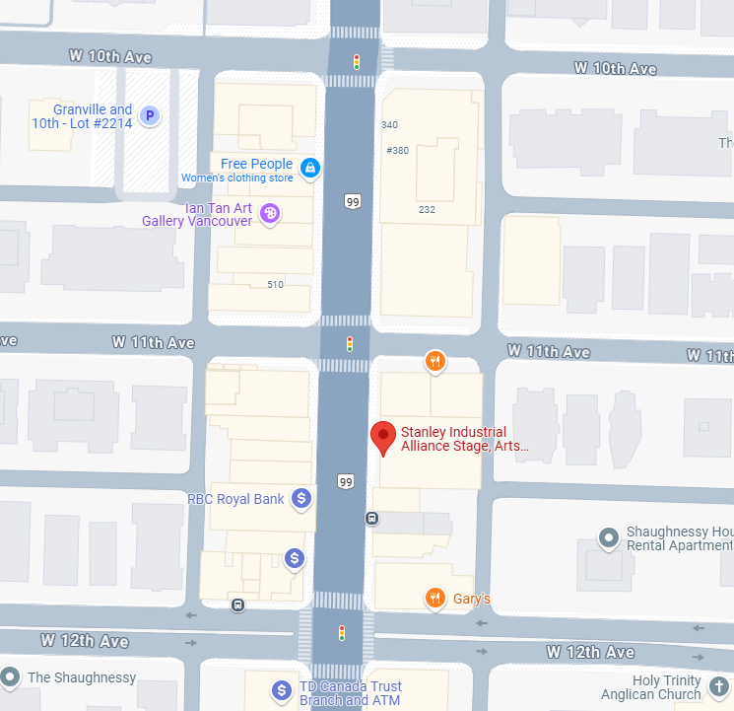
A Google Maps image of the Stanley Industrial Alliance Stage location

How to get to the Stanley Theatre

Public transportation
Nearby bus lines are: 99, 9, 10, 17.
Visit translink.ca for other trip planning options.
For more information on the neighborhood (including shopping, services, and more) visit the South Granville website.

Parking
We recommend giving yourself extra time to get to the theatre. Underground parking is available throughout the neighborhood. There are parking meters with an extended 4-hour time limit and several secure parking lots. Please note that some lots have restricted hours.

Visit artsclub.com/visit for more tips on parking.

Arriving at the Theatre

In the lobby
The lobby of the theatre will open at 6 PM for the relaxed performance. You can arrive between 6 and 6:45 PM.

If you do not yet have your ticket, you can pick it up at the box office, located to the right of the main entrance doors. Volunteers will be waiting at the front of the theatre to help guide you to the correct line. If you printed your tickets at home or already have a ticket, you can go right through the main doors into the lobby.

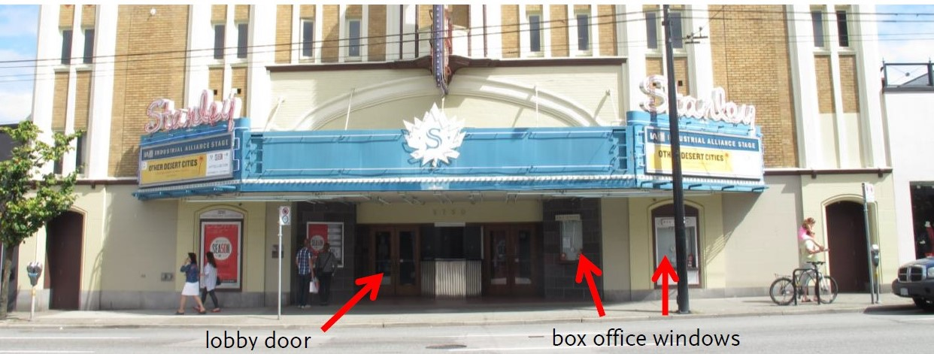
Outside the Stanley theatre
The lobby is the area where the audience waits before going into the theatre to see the show. If you would like, you can order a drink or a snack from the bar. You are also welcomed to bring your own food into the theatre.


Photo of Stanley lobby
Women’s Washroom
Accessible Washroom
Lobby Bar
Photo of the Stanley lobby

Washrooms
In addition to women’s and men’s washrooms, a single stall accessible washroom is located on the right side of the lobby beside the women’s washroom.


Photo of Stanley lobby
Men’s Washroom
Photo of Stanley lobby

Relaxation Station
If you want a break from the show, you can come out to the relaxation station in the lobby. You are welcome to enter and leave the theatre whenever you want. If you need help, look for Arts Club staff and volunteers wearing yellow buttons that say “Ask Me”.


Photo of the “Ask Me” buttons

Relaxation Station
Photo of Stanley lobby

Inside the theatre

Guests will be able to enter the theatre starting at 6:30PM.

The seats in the theatre are organized by row numbers and seat numbers, which are both on your ticket. Front of House Attendants near the doors will help you find your way. If you need to leave the theatre, you can leave and come back to your seat at any time.

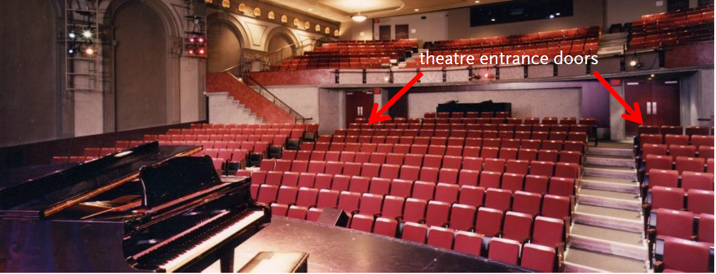
Inside the Stanley theatre

The start of the show
When the show is about to start, there will be a pre-show announcement from the front of the theatre that introduces the production.

After the show
After the play ends, the actors will come back out and take a bow. If you like, you can clap for the actors.

About the play—The Three Musketeers

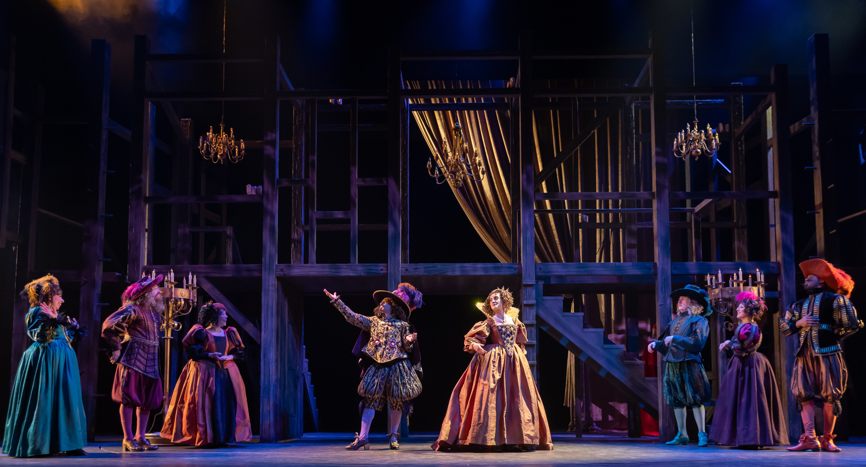
The cast of The Three Musketeers
“Maria” in The Sound of Music

What is the play about?
The Three Musketeers is a play adapted from the 1844 novel of the same name. In 17th-century Paris, a daring young d’Artagnan wishes to join the famed trio of musketeers—Athos, Porthos, and Aramis. Harnessing the skills of a swordsman and the heart of a warrior, he sets off with them to thwart a plot of the most dangerous man in France, the evil Cardinal Richelieu. Double-crossings, extravagant sword fights, and sweeping romance remind us of a time when love and honour ruled the world.
The unofficial run-time is 2 hours and 10 minutes with a 15-minute intermission.
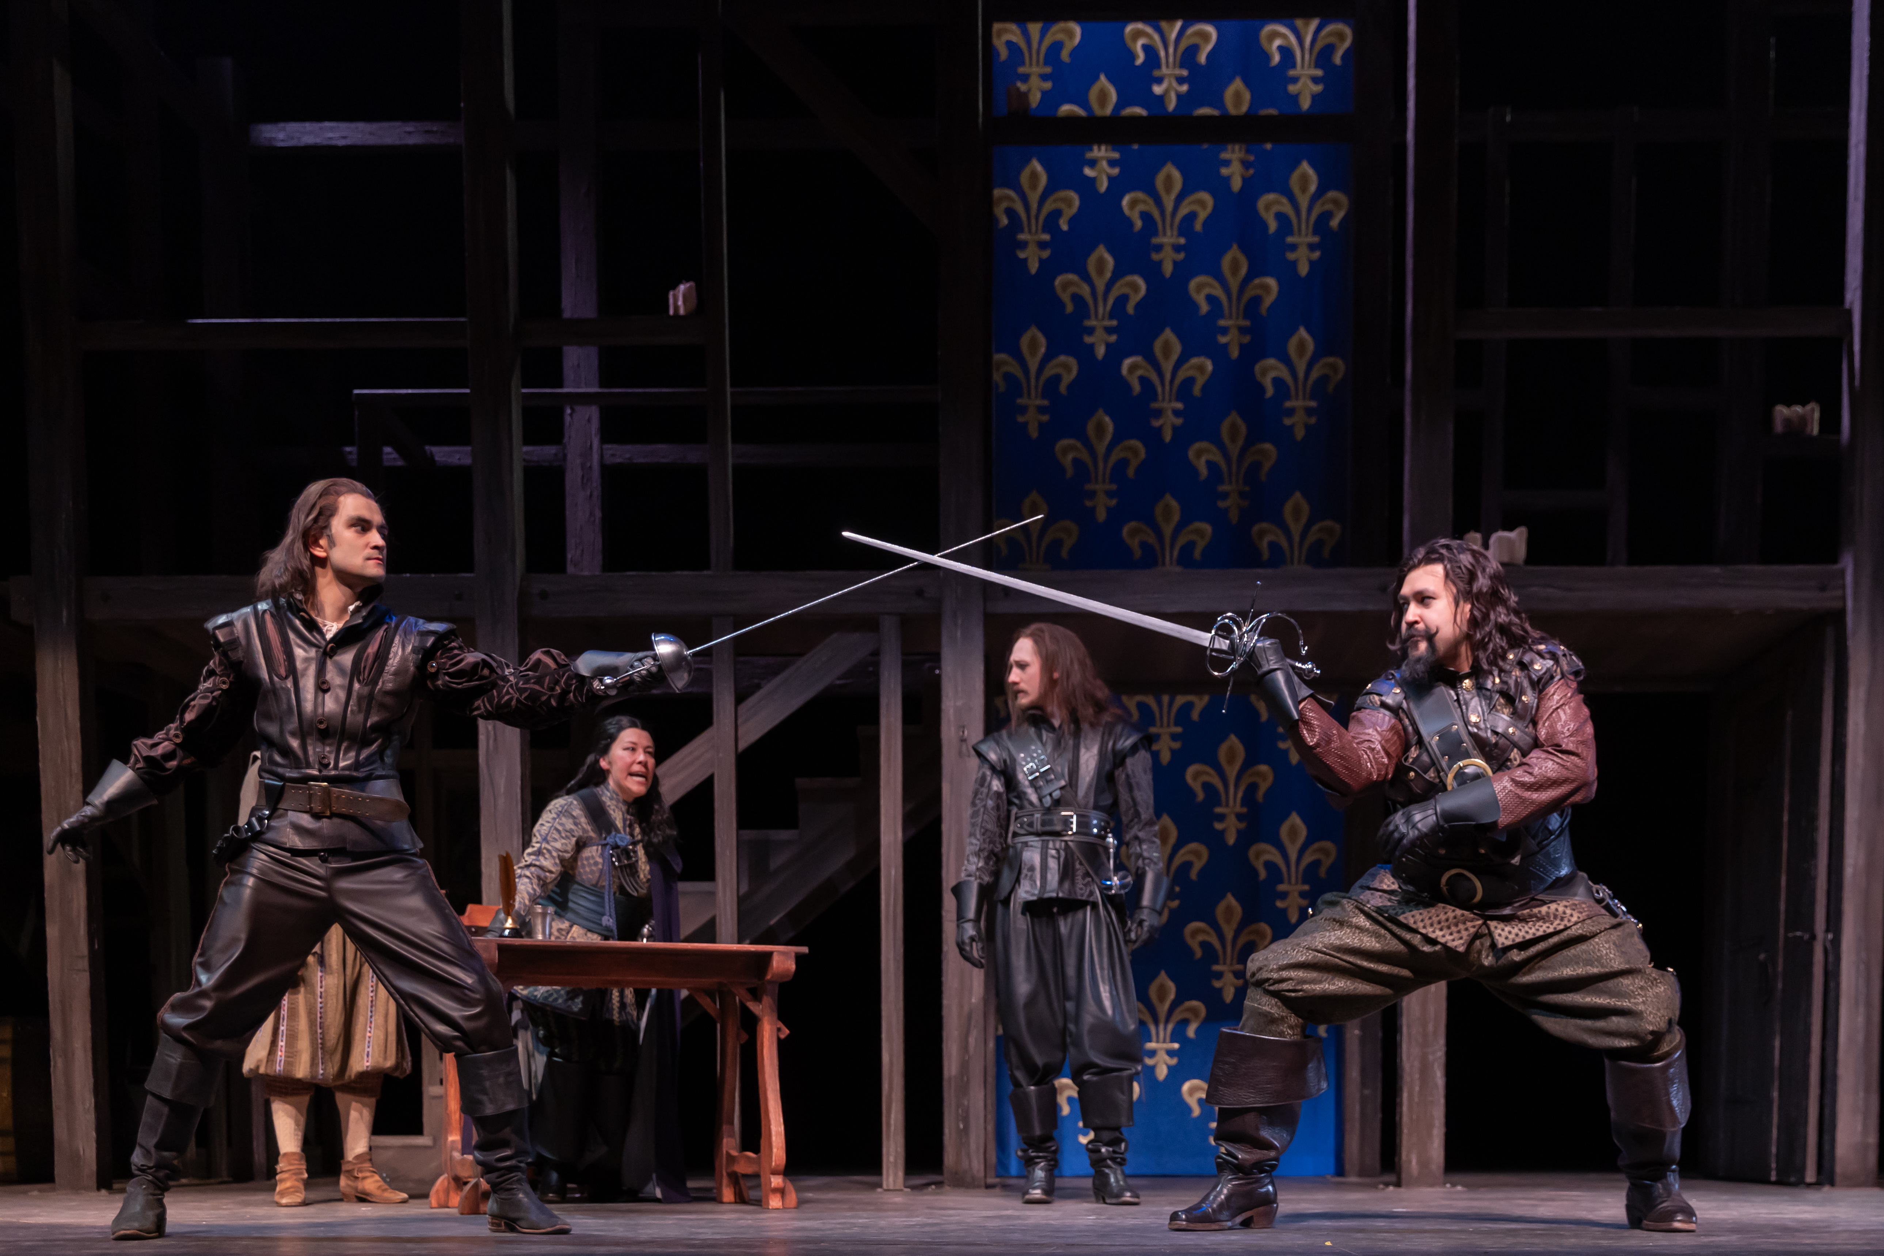
The cast of The Three Musketeers

What to expect
- Actors will be switching in and out of multiple characters.
- Some characters are fictional while others are fictional historical interpretations of real people.
- There are extravagant, colorful costumes.
- There are many sword fighting scenes and moments involving onstage violence.
- There are verbal descriptions of deaths that occur offstage.

Characters in the show
D’Artagnan - a young man yearning to be a musketeer
Athos - one of “The Three Musketeers,” he is cynical
Porthos - one of “The Three Musketeers,” he is a vain dandy
Aramis - one of “The Three Musketeers,” he is priest-like
Monsieur de Treville - Captain of the King’s Musketeers
Planchet - Treville’s servant
Cardinal Richelieu - second most powerful man in France
Rochefort - Richelieu’s spy
Milady (Lady de Winter) - Richelieu’s spy and Rochefort’s lover
Kitty - Milady’s servant and Planchet’s lover
Jussac - leader of Richelieu’s guards
Louis - King of France
Anne of Austria - Louis’ wife, the Queen
Constance Bonacieux - the Queen’s maid
Monsieur Bonacieux - Constance’s father, D’Artagnan’s landlord
Lord Buckingham - The English Prime Minister, in love with Anne of Austria
Braddock - Buckingham’s butler
Felton - Buckingham’s assassin
Ensemble: Members of the mob, Tavern Patrons, Richelieu’s guards, Patrons of the Golden Lily Inn, Guests at the Palace Ball, Richelieu’s Spies, Richelieu’s Soldiers)

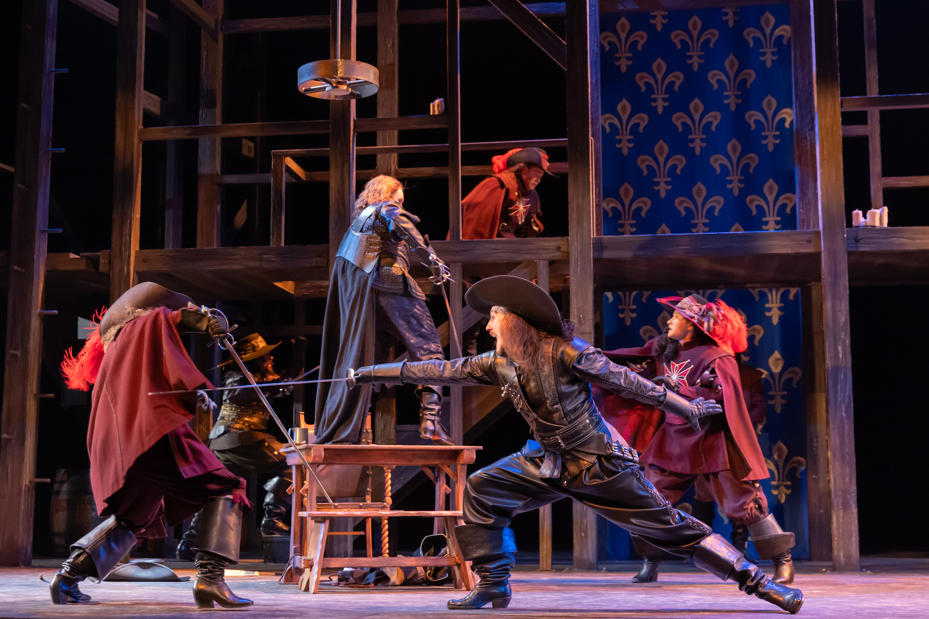
The cast of The Three Musketeers, sword fighting.

Content Advisory – Includes Spoilers
- Alcohol and drugs: One scene takes place in a tavern, where there is a drunk man who starts a fight.
- Sexual Content: Refer to a lady friend “rendezvous of a delicate nature”, talks of seducing women and having mistresses along with making love
- Strong Language: There is no swears used in the show, but the characters use crude language and insult each
- Death: Many characters die in very gruesome ways. Some by sword, poison, and hand to hand combat.
- Violence/Injury: Much of the show revolves around violence mostly inflicted by people’s swords.
- Other: Verbal descriptions of violence that takes place off-stage (e.g. hanging)

Detailed Synopsis

Detailed Synopsis:
Assembled by Desirée Pappel for the Royal Manitoba Theatre Centre

Act 1
D'Artagnan has just arrived in Paris and is longing to become a king’s musketeer. Not long after, he encounters Rochefort, who insults him, and the pair duel. During the exchange, it is said that D'Artagnan has a letter from his father recommending him to Treville. The duel stops as Milady enters. D'Artagnan is struck by her beauty, and she takes this opportunity to knock him out. She reveals her ruthless nature, as she wants to kill D'Artagnan, even though he is defenceless, because of his connection to Treville. Instead, Rochefort steals D'Artagnan’s letter to foil his attempt at meeting Treville, and it is revealed that he and Milady are in service to Richelieu.
At the musketeer headquarters, Richelieu has met with Treville. Out of spite for Richelieu, Treville says that any man who steals Richelieu’s ring would be allowed to become a musketeer. D'Artagnan enters and insists on meeting Treville despite having had his letter stolen. The Three Musketeers arrive, and we learn that they were involved in a brawl that included duelling Richelieu’s guards, but Treville forgives them. D'Artagnan finally manages to prove his identity to Treville, who tells him he cannot be given a place in the musketeers; he must earn it. Treville offers him a position with the King’s guards. Treville tells D'Artagnan to see Monsieur Bonacieux to make his living arrangements.
As Athos was wounded by Jussac during the fight, he wishes to find him to exact his revenge. D'Artagnan bumps into Athos on his way out. The two exchange insults and decide to duel. D'Artagnan offers Athos his healing potion, and the two fight. Jussac and three of his men enter. The Three Musketeers and D'Artagnan fight Jussac and his men. Jussac is killed and his men are defeated while the musketeers tell D'Artagnan he is now one of them.
Bonacieux arranges boarding for D'Artagnan, who then meets and instantly falls in love with Bonacieux’s daughter, Constance, a maid to the Queen. Constance has a message from the Queen for her father to deliver to Buckingham, but he says delivering it with Rochefort’s men around is too dangerous. D'Artagnan agrees to deliver the letter. We learn that the Queen Anne and Buckingham are in love and that Richelieu has been spying on them since he saw them together one night. Anne tells Buckingham to leave but sends him off with a diamond set as a gift and the hope that he will escape Richelieu.
When Richelieu learns that Buckingham has returned to England, he is frustrated as he wanted to use him to discredit the Queen. Rochefort informs the Cardinal of the diamond set Anne gifted Buckingham before he left; this was a gift originally given to her by the king. Richelieu tells King Louis that he is concerned about the Queen’s recent melancholy, and although the King reacts coldly, Richelieu convinces him to cheer her up by throwing a ball 7 where she will wear the diamond set. Milady is contacted and it is arranged for her to steal two diamonds from the set and return them to Richelieu. At this point, it is revealed that the Queen previously rejected Richelieu’s advances.
Late one night, D'Artagnan returns home with The Three Musketeers. Constance emerges from the house with another letter from the Queen for Buckingham, asking him to return the diamond set. D'Artagnan and the Three Musketeers agree to deliver the letter. D'Artagnan and Constance kiss before he departs. As the men journey to England, they are intercepted at a bar. A brawl breaks out and the Three Musketeers help D'Artagnan escape with the letter. When D'Artagnan meets with Buckingham to retrieve the diamond set, it is discovered that two of the stones are missing.
It is the night of the King’s ball. Richelieu reveals the missing stones and tells the King that they were found in England. When the King confronts Anne, she shows him that no diamonds are missing from the set. Louis is angry with Richelieu, but he comes up with a lie to explain the diamonds he presented to the King. D'Artagnan tells Constance that Buckingham replaced the missing diamonds before returning the set to Anne. The young couple agree to meet tomorrow night and D'Artagnan gifts her a wallet given to him by his mother. Unknown to them, their exchange is witnessed by Richelieu.
D'Artagnan and The Three Musketeers discuss love. Athos tells of when he was a count and fell in love with a beautiful, smart girl, whom he married. One day, he discovered that she was a criminal who escaped execution for a murder she committed. He says he hanged her for her crime despite his deep love for her. When Constance is supposed to meet D'Artagnan, she is ambushed by Rochefort who takes her to prison for betraying her country. In the struggle, she drops D'Artagnan’s wallet. D'Artagnan arrives and learns that Rochefort has taken Constance to the Bastille. He vows to rescue her.
Act 2
D'Artagnan and The Three Musketeers are arguing over rescuing Constance when Treville informs them that his spy, Planchet, who is in a relationship with Milady’s maid, Kitty, has discovered that Constance has been moved to a secret location. Treville tells D'Artagnan and The Three Musketeers to leave in order to protect themselves from Richelieu’s wrath over the failed diamond scheme. D'Artagnan decides to go into Milady’s chambers to find a clue that will lead him to Constance. Kitty agrees to let D'Artagnan into Milady’s chambers while she is away, but Milady returns. She believes that D'Artagnan is Rochefort, reveals her love for him and gifts him a medallion, before discovering that it is D'Artagnan. A struggle ensues and a fleur-de-lys brand is revealed on Milady’s shoulder. They fight, and D'Artagnan narrowly escapes.
Rochefort tells Richelieu that D'Artagnan and The Three Musketeers have fled Paris. Even though Milady wants to go after D'Artagnan, she is charged with finding a way to 8 assassinate Buckingham for Richelieu. He tells her it will be arranged for her to kill D'Artagnan upon her return to France while she stays at a Convent in Bethune. Richelieu then gives Milady a letter stating that her actions are in the interest of France.
The Three Musketeers have been hiding for several weeks. D'Artagnan finally arrives, and after a discussion, Athos realizes that Milady is his wife. Planchet arrives and tells the men that the Queen arranged Constance’s rescue, and she is now at the convent in Bethune. At this moment, a spy for Richelieu enters and a fight occurs.
Milady arrives in Bethune and discovers that Constance is also there. Constance enters and discusses her identity with Milady, who poisons Constance’s wine. Constance then realizes who Milady is, and a struggle ensues, ending with Constance being poisoned by Milady as D'Artagnan arrives. Constance dies in D'Artagnan’s arms. Athos then goes after Milady. He finds her at an inn where he then kills her.
Aramis, Porthos, D'Artagnan, and Treville learn from Planchet that Buckingham has been killed. Athos then arrives and announces Milady’s death and gives D'Artagnan the letter Richelieu wrote for her protection. D'Artagnan goes to Bonacieux to give him the news of his daughter’s death, but Rochefort has already killed him for refusing to give up D'Artagnan’s location. D'Artagnan kills Rochefort in a fight during which Rochefort is seeking to avenge Milady. Richelieu arrives to arrest D'Artagnan, but D'Artagnan gets out of this predicament by using the letter Richelieu wrote for Milady. D'Artagnan also bargains for the Cardinal’s ring. Richelieu then offers D'Artagnan the job as captain of his guards, but he refuses. D'Artagnan gives the ring to Treville, who finally makes him an official musketeer. The Three Musketeers announce their retirement, but they decide to stay when Planchet tells them the Queen has been kidnapped and needs their help again.

Glossary
Intermission: A 15-minute pause halfway through the show
Lobby: The entrance area in the front of the theatre where the bar, washrooms, and relaxation station are located
Relaxation station: An area of the lobby where you can sit at any time during the show. You can also watch the play on a TV monitor in this area
Row: Row numbers are located on the side of each line of seats
Seat: Seat numbers are located on the seat, just below the cushion
Section: The area of the theatre where your seat is located. Your ticket will also tell you if you are on the right, centre, or left side of your section
Lines: The words that the actors speak
Cue: Something said or done that lets an actor know to begin their speech or performance
Props: An object used on stage by actors in a performance
Set: An artificial setting for the scene of a play
Stunt: An unusual or difficult action used in a show to portray a physically dangerous moment
Front of House Attendant: An Arts Club employee who is there to help you find your seat in the theatre and answer your questions
Will call: When you choose “will call” for your tickets, that means you can pick them up at the box office window before entering the lobby

PRODUCTION PHOTO CREDITS
Photo by Nanc Price for The Citadel Theatre’s production of The Three Musketeers (2024), a co-production with Arts Club Theatre Company, featuring Anita Wittenberg, Chris. W. Cook, Nadien Chu, Farren Timoteo, Alexandra Lainfiesta, Garett Ross, Bahareh Yaragi, and Paul-Ford Manguelle.
Photo by Nanc Price for The Citadel Theatre’s production of The Three Musketeers (2024), a co-production with Arts Club Theatre Company, featuring Daniel Fong, Nadien Chu, Braydon Dowler-Coltman, and Alexander Ariate.
Photo by Nanc Price for The Citadel Theatre’s production of The Three Musketeers (2024), a co-production with Arts Club Theatre Company, featuring Farren Timoteo, Alexander Ariate, Darren Martens, Braydon Dowler-Coltman, John Ullyatt, and Morgan Yamada.

