TEACHER RESOURCE GUIDE
FORGIVENESS
By Mark Sakamoto
Stage adaptation by Hiro Kanagawa
A joint production with Theatre Calgary
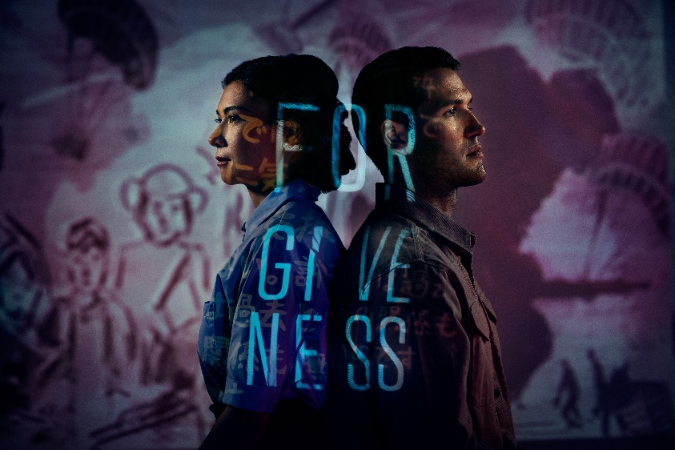
Image description: A Japanese woman and a white man are standing back-to-back. A projection displayed on their bodies shows the word ‘FORGIVENESS’. Behind them are projected illustrations of parachute soldiers as well as children

2022.23 season
Stanley Industrial Alliance Stage
January 12 –February 12, 2023

Table of Contents
Welcome 3
About The Arts Club Theatre Company 3
About The Stanley Industrial Alliance Stage 3
Learning Objectives 4
BC Curriculum Connections 4
Timeline of Major Events of the Asia-Pacific War and the History of Hong Kong 5
Japanese Canadian Historical Timeline: Pre WWII through Post WWII 4
The Post War Years 6
Synopsis 7
About the Playwright 7
About the Author 8
Character List 9
Discussion Questions 10
Activities 11
Drama 11
Social Studies 13
Language Arts 14
Resources 15
Sources 15
Image Bank 17
Quote Bank 23

Welcome
This guide was created for teachers and students. It contains an overview of the play's story as well as informative resources and activities for teachers and students. The guide aims to provide background knowledge and critical perspectives on the play that will yield fruitful discussion and foster an understanding and appreciation of theatre arts.
If you have any questions, comments, or suggestions for the guide, please contact our Education & Community Engagement Manager Hila Graf hgraf@artsclub.com.
This study guide was written by Amy Collisson and Braden Griffiths.

About The Arts Club Theatre Company
The Arts Club of Vancouver was founded in 1958 as a private club for artists, musicians, and actors. It became the Arts Club Theatre in 1964 when the company opened its first stage in a converted gospel hall at Seymour and Davie Streets. Now in its 59th season of producing professional live theatre in Vancouver, the Arts Club Theatre Company is a non-profit charitable organization that operates three theatres: the Granville Island Stage, the Stanley Industrial Alliance Stage, and the Newmont Stage at the BMO Theatre Centre. Its popular productions range from musicals and contemporary comedies to new works and classics.
Learn more about the Arts Club Theatre Company at artsclub.com

About The Stanley Industrial Alliance Stage
The legendary Stanley Industrial Alliance Stage is a newly renovated art deco theatre that originally opened in 1931 as a cinema and Vaudeville House. Now beautifully updated, this 620-seat theatre has been home to musicals such as My Fair Lady, Swing, and Sweeney Todd, revitalized classics such as Hamlet, and comedies ranging from Easy Money to Art. The restoration of the venue received a 1999 City of Vancouver Heritage Award.

Learning Objectives
- Explore personal narrative through the lens of relationship, time, and place (geography).
- Explore the mediums and technologies that might help us to tell our own stories or share the stories of others.
- Engage with historically relevant narratives of Canadians with varied lived experiences and consider how those narratives inform the present.

BC Curriculum Connections
DRAMA 9
Explore relationships between identity, place, culture, society, and belonging through dramatic experiences.
DRAMA 10–12
Examine the influences of social, cultural, historical, environmental, and personal context on drama. Experiment with a range of props, processes, and technologies.
SOCIAL STUDIES 10 & HISTORY 12
Assess the significance of people, places, events, or developments, and compare varying perspectives on their significance at particular times and places, and from group to group.
ENGLISH
Construct meaningful personal connections between self, text, and world.

Timeline of Major Events of the Asia-Pacific War and the History of Hong Kong

1842
By the Treaty of Nanking, China first cedes the island and peninsula of Hong Kong.

1843
By Royal Charter, Hong Kong becomes a separate British colony.

1895
Shimonoseki Treaty. After its defeat in the Sino-Japanese War, China cedes Taiwan to Japan.

1898
New Territories area is leased to Britain for ninety-nine years.

1905
Japan defeats Russia in the Russo-Japanese War. The Treaty of Portsmouth forces Russia to give up its claim in southern Manchuria to Japan and recognizes Japan as the dominant power in Korea.

1910
Japan “officially” annexes Korea.

1926
Hirohito, after five years as regent, becomes the 124th Emperor of Japan.

1931
The Japanese army launches an invasion of Manchuria.

1932
The Japanese army seizes Manchuria and establishes the puppet state of Manchukuo.

1933
The League of Nations declares that Manchukuo an illegitimate state; Japan withdraws from the League, keeping troops in Manchuria it expands control in the area by gaining control of much of North China.

1936
The Japanese Army gains primacy in Japanese political life.

1937
After the “Marco Polo Bridge Incident,” Japan launches an invasion of China. Japan captures Peking (now Beijing) and Shanghai. After the capital, Nanking (now Nanjing) falls, Japan's military commits the Nanking Massacre.

1939
World War II begins in Europe with the Nazi blitzkrieg of Poland.

1940
Japan moves into northern Indo-China. Japan joins the Axis Alliance with Germany and Italy.

1941
Tojo Hideki becomes prime minister of Japan. Canada, agreeing with the British assessment of Hong Kong’s strategic importance, sends 1,975 troops that arrive on November 16. On December 7, Japan raids Pearl Harbor. Malaya, Philippines, and Hong Kong are attacked. Hong Kong is surrendered to Japan. Of the 1,975 Canadians, 290 are KIA; 1,685 are interned in POW camps; 264 die in internment.

1942
Japan gains control over much of southeast Asia (Hong Kong, Philippines, Vietnam, Laos, Cambodia, Thailand, Burma, Malaya, and Dutch East Indies).

1945
The first atomic bomb is dropped on Hiroshima on August 6. The Soviet Union declares war on Japan on August 8 (as agreed to by the Potsdam Treaty that ended the war in Europe). The second atomic bomb is dropped on Nagasaki on August 9. With Japan’s surrender on August 15, World War II ends. The formal surrender agreement was signed on September 2.

Japanese Canadian Historical Timeline: Pre WWII through Post WWII
Adapted from full timeline, available here:japanesecanadianhistory.net

1877
Manzo Nagano, the first Japanese individual known to land and settle in Canada. Abandoned ship in New Westminster and subsequently ran a gift shop, Japanese food store and hotel in Victoria, BC.

1890s
Issei, Japanese immigrants, establish stores, boarding houses and businesses along streets near Hastings Mill, especially along Powell Street. This neighbourhood becomes the major settlement of Japanese Canadians until WWII.

1902
Tomekichi Homma, a naturalized Canadian citizen, applies to be included on the voters' list. After refusal, and appeal, a BC judge bars Asians from voting. Japanese Canadians are also barred from holding office or becoming teachers, lawyers, accountants, pharmacists and architects.

1907
Anti-Asian Riot in Vancouver.

1914
The outbreak of World War I.

1916
After being rejected in BC, approximately 200 issei volunteers travel to Alberta to join the Canadian expeditionary force. Veterans are promised the right to vote.

1931
Japanese WWI vets finally receive the right to vote; the only Japanese Canadians to be enfranchised.

1936
Japanese Canadian Citizens League is formed; sends a delegation to Ottawa to petition for the franchise. The petition is unsuccessful.

March - Aug. 1941
Compulsory registration of all Japanese Canadians over 16 years is carried out by the RCMP.

December 7th, 1941
Japan attacks Pearl Harbor. Canada declares war on Japan. Under the War Measures Act, all Japanese nationals and those naturalized after 1922 are required to register with the Registrar of Enemy Aliens.

December 8th, 1941
1,200 fishing boats are impounded and put under the control of the Japanese Fishing Vessel Disposal Committee. Japanese language newspapers and schools closed. Insurance policies are cancelled.

December 16th, 1941
P.C. 9760 is passed requiring mandatory registration of all persons of Japanese origin, regardless of citizenship, with the Registrar of Enemy Aliens.

Feb. 7th, 1942
All male "enemy aliens" between the ages of 18-45 are forced to leave the protected coastal area before April 1. Most are sent to work on road camps in the Rockies. Some are sent to Angler.

Feb. 26th, 1942
Notice is issued by the Minister of Justice ordering all persons of "the Japanese race" to leave the coast. Cars, cameras and radios confiscated. Dusk-to-dawn curfew is imposed.

March 4th, 1942
B.C. Security Commission is established to plan, supervise and direct the expulsion of Japanese Canadians.
P.C. 1665 Property and belongings are entrusted to the Custodian of Enemy Alien Property as a "protective measure only".

March 16th, 1942
First arrival at Vancouver's Hastings Park holding center. All Japanese Canadian mail is censored from this date.

June 29th, 1942
P.C. 5523 - The Director of Soldier Settlement is given authority to purchase or lease farms owned by Japanese Canadians. He subsequently buys 572 farms without consulting the owners.

October 1942
22,000 persons of whom 75% are Canadian citizens (60% Canadian born, 15% naturalized) have been uprooted forcibly from the coast.

January 23rd, 1943
Order in Council grants the Custodian of Enemy Alien Property the right to dispose of Japanese Canadian properties in his care without the owners' consent.

August 4th, 1944
Prime Minister King states it is desirable that Japanese Canadians are dispersed across Canada.
Applications for "voluntary repatriation" to Japan are sought by the Canadian government. Those who do not must move east of the Rockies to prove their loyalty to Canada. "Repatriation" for many means exile to a country they have never seen before.

September 2nd, 1945
Japan surrenders. Atom bomb is dropped on Hiroshima.
All internment camps, except New Denver are ordered closed and settlements of shacks bulldozed. B.C. Security Commission office in New Denver closes in 1957.

The Post War Years

January 1st, 1946
On the expiry of the War Measures Act, the National Emergency Transitional Powers Act is used to keep the measures against Japanese Canadians in place.

April 1947
The Citizenship Act extends the franchise to Canadians of Chinese and South Asian origin but excludes Japanese Canadians and aboriginal peoples.

March 31st, 1949
Restrictions imposed under the War Measures Act are lifted and franchise is given to Japanese Canadians.

1967
Canadian government announces a point system for new immigrants. "Race" is no longer a criterion for immigration.

Redress Efforts in the 80s

January 1984
The National Association of Japanese Canadian Council meeting in Winnipeg unanimously passes resolutions seeking an official acknowledgement and redress for the injustices committed against JC during and after World War II. The Council also calls for a review of the War Measures Act to ensure that no Canadians will ever again be subjected to such wrongs.
May 9th, 1986
Price Waterhouse Associates assesses income and property losses at not less than $443 million in 1986 dollars.

April 1988
Rally on Parliament Hill, Ottawa by supporters of Redress.

Sept. 22, 1988
Acknowledgement, apology and compensation.

1996
The Census of Canada shows a Japanese Canadian population of 77,130.

2002
125th anniversary of the first Japanese to arrive in Canada.

Synopsis
Forgiveness is Hiro Kanagawa’s stage adaptation of Mark Sakamoto’s award-winning family memoir Forgiveness: A Gift from My Grandparents. The play centres on the real-life experiences of Mark’s grandfather Ralph MacLean and grandmother Mitsue Sakamoto who both suffer tremendous deprivations during World War II: Ralph as a prisoner in a Japanese POW camp, and Mitsue as a victim of the Japanese Canadian internment. In order to rebuild their lives and their families after the war, Ralph and Mitsue must find the grace and generosity necessary to forgive those who have wronged them. Their journeys of healing culminate in 1968--more than two decades after the war--when Mitsue’s son Stan and Ralph’s daughter Diane begin dating, and Ralph is invited to Mitsue’s home for dinner.

About the Playwright
Hiro Kanagawa is a well-known and well-regarded character actor with a diverse and extensive resume. Also, an accomplished playwright and screenwriter, he is the recipient of the 2017 Governor General’s Literary for Drama for his play Indian Arm.

Hiro’s distinct talents were cultivated over a lifetime of wide-ranging experiences in a variety of locales. Born in Sapporo, Japan, he grew up in Guelph, Ontario and Sterling Heights, Michigan before returning to Japan for high school. Showing an early talent in a variety of arts, he went on to study at a series of prestigious East Coast schools: Middlebury College, the Skowhegan School of Painting and Sculpture, and the Tyler School of Art at Temple University. He trained in classical guitar, sculpture, performance art, and theatre along the way, honing his skills as both a creator and performer.

Hiro moved to Vancouver in 1990, attracted by the burgeoning film and television production in the city. Since then he has become a mainstay of the industry with close to 170 credits in projects ranging from blockbuster features to indie films and hit series to cult favorites

Although perhaps best known as an actor, Hiro is an award-winning playwright and sought-after story consultant. He was story editor on several critically acclaimed Canadian television series: Da Vinci’s Inquest, Da Vinci’s City Hall, Intelligence, and Blackstone. His plays Tiger of Malaya and The Patron Saint of Stanley Park have been performed across Canada. His most recent play, Indian Arm received the 2015 Jessie Richardson Award for Outstanding Original Script and the 2017 Governor-General’s Literary Award for Drama.

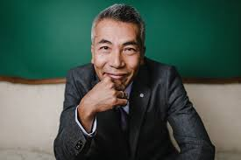
Image description: Hiro Kanagawa, dressed in a grey suite, smiling at the camera.

About the Author
Mark Sakamoto is a Canadian lawyer and writer. He is most noted for Forgiveness: A Gift from My Grandparents, a family memoir which was published in 2014.

Originally from Medicine Hat, Alberta, he is the son of a Japanese Canadian father, Stan Sakamoto, and a Scottish-Canadian mother, Diane MacLean. He studied political science at the University of Calgary before moving to Halifax to study law at Dalhousie University. Sakamoto worked on the political staff of former Liberal Party of Canada leader Michael Ignatieff. He is currently the executive vice-president for Think Research, a Canadian software company innovating in health data, and has served on the boards of the Ontario Media Development Corporation and the Trudeau Centre for Peace and Conflict Studies.

During World War II, his paternal grandparents were affected by the Japanese internment in Canada, while his maternal grandfather was captured by the Japanese as a prisoner of war. Their stories of struggle and hardship formed the basis of his book Forgiveness: A Gift from My Grandparents. To write the book, Sakamoto interviewed his grandparents about how they forgave those formative experiences to embrace and connect with each other when their son and daughter fell in love and married. The book was a shortlisted finalist for the Edna Staebler Award in 2015.

Forgiveness was selected for the 2018 edition of Canada Reads, where it was defended by Jeanne Beker. It ended up winning the contest on March 29, 2018

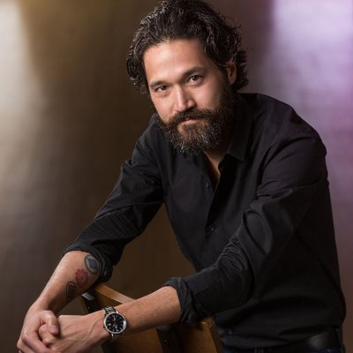
Image description: Mark Sakamoto is sitting on a chair and looking at the camera. He has a black beard and he’s wearing a black shirt.

Character List

MITSUE Nisei woman, teens to late forties. Full of hope and dreams. She possesses inherent goodness and grace and lives as if these things matter. If she has a fault, it is a fierce clarity about what is right. Though she surely raised her voice in anger from time to time, it is said of her today that no one once ever heard her do it. (pronunciation: Me-tsoo-eh)

HIDEO Nisei man, twenties to late forties. Educated and progressive, but speaks with an accent, having been sent back to Japan as a child. Adores Mitsue, but is disillusioned by the internment. (pronunciation: He-day-oh)

STAN Sansei man, childhood to twenties. Mitsue and Hideo’s second son. A “people person,” he has inherited his mother’s innate goodness.

RON Sansei man, childhood to twenties. Mitsue and Hideo’s eldest son. A Japanese Canadian prairie boy with dreams of hockey and rock and roll.

KATO Japanese POW camp commandant, thirties. Arrogant and sadistic, but believes himself to be a worldly and educated man. (pronunciation: Kah-toe)

PAT Nisei man, Mitsue’s brother. Wants to be accepted as fully Canadian and bristles at his own Japanese-ness. YOSUKE AND TOMI Issei couple, late forties to sixties, Mitsue’s parents. They aspire to middle class respectability in Canada for themselves and assimilation for their children.

ICHIRO Nisei man, twenties. One of Mitsue’s suitors. Aspires to a fully assimilated life in Canada.

MIYOKO Nisei girl, teens. Mitsue’s best friend. Trying to be a typical Canadian teen despite having a strict Japanese father.

MRS. YAMAMOTO Issei woman, sixties. Kindly dress shop owner and would-be matchmaker to Mitsue and Hideo.

RALPH Grindstone boy, childhood to early twenties. Like Mitsue, he has an innate sense of morality and fairness and continues to believe in these things through the horrors of war. Signs up for war in search of escape from a small and abusive life at home. Spends the rest of his life searching for the meaning of his suffering.

DEIGHTON Grindstone boy, childhood to early twenties. Ralph’s best friend. Naive, good-time-Charlie.

COOPER Grindstone boy, childhood to early twenties. Ralph and Deighton’s friend. Coarser, more crudely male.

PHYLLIS Ralph’s long-suffering wife, forties. Trying her best to support Ralph through his PTSD. Trying her best to not disapprove of her daughter dating a Japanese Canadian.

DIANE A Prairie girl, twenties, Ralph’s daughter. Not a hippie, not a rebel, just happened to fall in love with a Japanese guy.

MORTIMER A Canadian officer from the stiff-upper-lip military academy, thirties. He does his best to keep himself and Ralph alive.

ADAMS A straight-talking Southerner, twenties, has probably seen horrible things that only Americans fighting in the Pacific will ever see.

MRS. RUTT Sugar beet farmer, middle-aged. Not consciously cruel or racist, but entirely comfortable with housing a Japanese family in a chicken coop.

MR. ARCHIBALD A tailor who Mrs. Yamamoto entrusts with valuable items from her dress shop and who later takes her shop over

Discussion Questions
As Hiro and Mark's characters seek peace and a place to call home, they perpetually struggle with their identities and within the global conflict that uprooted so many individuals... the following are a few questions that are foundational to their journeys and that might plant the seeds for a worthwhile discussion after having attended Forgiveness.
- What does it mean to be Canadian?
- “Work is freedom”
“Is work freedom for slaves?”
(Kanagawa, pg. 90)
- “What is more sad? To never have a (hometown), or never see your (hometown) again?”
(Kanagawa, pg. 103)

Activities

Drama

Warm up: Buffalo, Farmer, Landowner
(Power Dynamics)

Many of the characters in Forgiveness find themselves in situations where their "power" has been taken away. Mitsue and her family must uproot their lives, along with so many other Japanese Canadians, as they are forced to build a new life in another province; Ralph must struggle to survive under the tyrannical rule of the POW Camp Commandant, Kato. Neither individual is afforded much power to decide their future and their fate.
This exercise invites students to engage in play and, afterward, into a conversation about what it means to have power, and what it feels like to have none.
All students will participate in a large open space. The instructor will assign the following roles:
- Farmer | One or Two Students.
- Landowner | One Student.
- Buffalo | Everyone else.
(IMPORTANT NOTE: The Landowner role should be assigned in secret and the Landowner should only be introduced partway through the exercise.)
- The “Buffalo" are instructed that they must follow the hand of the farmer, with no exceptions, unless they are not safe.
- The "Farmer" without words, and with their hand(s) extended, will direct the buffalo around the room. It is very important that this is done silently. Where the "Farmer's" hand leads, the "Buffalo" must follow.
- The "Landowner" is then introduced. The "Farmer" continues leading their "Buffalo" but now must follow the silent guiding hand of the "Landowner".
Debrief Questions:
- How did it feel being the Buffalo?
- The Farmer?
- The Landowner?
- How did it feel for the farmers when the Landowner was introduced?
- Possible prompt: How does this exercise mirror the experience of the characters in Forgiveness?
- Or, more broadly, how does this exercise mirror the experience of individuals in a Colonial Society.
Core activity: Pictures, Prose, Projection
Enhancing our stories with images

Hiro Kanagawa suggests the use of projected images and animation to support Mitsue and Ralph in telling their stories throughout Forgiveness. The use of projection has become an integral part of the modern theatre-maker's toolbox. One could argue that the projections are the third core storyteller in this production. The following exercise is, ideally, enacted with the support of an in-class projector... but, there are options for those spaces that do not have access to such technologies.

Using historical images from the era (see image bank below) or text from the play (see page 24), students will devise short tableaux sequences that respond to pictures/text that capture something of the lived experiences of Canadians during WWII, both at home and on the frontlines.
Instructions:
- Divide the class in groups of 3 – 5 students.
- Each group will be given a historical image from the era (see pages 18 – 23 for images)
- In their groups, students will create a sequence of 3-5 tableaux images.
- These sequences should tell a story, beginning, middle, and end... with one of the tableaux recreating the historical image provided.
- If the drama space has a projector available, it is suggested that, in addition to the image provided, students do some gentle research to find images that support each of the tableaux that they are creating.
- These images should be projected during the performance of their tableaux sequences.
- For older students: the tableaux being created should be representational as opposed to literal re-creations of the projected images.
- Pieces can be performed twice: once without projection, and once with.
- Debrief: Compare and Contrast - How did the projections enhance the story? What did you prefer (with projection, or without)? Was the image/animation distracting?
Guiding Questions ~ Devising Tableaux:
- What happened in the lives of the characters prior to this photo being taken? What led them to this moment?
- What happened after this photo was taken?... What events transpired in the lives of these individuals in the days, months or years following this moment in time?
Scaffolding Up
- In addition to each group receiving an image from the era, each group will also receive a piece of text from Kanagawa's play (see page 24).
- Using the text as a foundation for inspiration, students should create a tableaux sequence that responds to BOTH the text and the image provided.
- OPTIONAL: One student from each group has the option of performing the provided text as their peers enact the tableaux sequence that has been devised.

Social Studies
The Envelope Exercise
Constructing a Narrative from historical images
Materials:
- Multiple copies of Image Bank (see below, pages 18 – 23)
- Several envelopes (depending on class size)
Prep:
- Photocopy the Image Bank
- Cut out the images and place them (in desired combinations) in envelopes. (Curation of multiple combinations will create more varied story results. However, even if the instructor provides the same images in each envelope, no two stories will be the same.)
Instructions:
Divide the class to work in small groups of 4-5 students. Each group receives one envelope (full of images). Students will then reveal one image at a time and discuss the following questions: When did this image take place? (Year, Month, Day, Hour; specificity will lead to better narrative clarity) What is happening in the image? Who is present? And what do those individuals appear to be doing? Though these images capture real people and places, within this exercise, there are no wrong answers. If students are struggling, there might be some reassurance found in the fact that all of the provided images are related to the historical context of Forgiveness. Once they have discussed the individual images and catalogued their guesses as to the content, students will create a hypothetical narrative based on the images they have discussed. (In a Drama class: these narratives might be performed... perhaps with projection)
Tips for creating a new historical narrative:
Estimate the chronological order of the images. Consider the similarities between the images received. Consider the characters in the images provided, what relationships might those characters share? Allow students to remove one of the images from their story continuum. Base the story on factual information learned from this guide and the production. Stories can be shared with the class and/or documented/recorded for assessment after the lesson.

Language Arts
Hideo's Proposal
Perspective Poetry
During the first act of Forgiveness, Hideo explains to Mitsue that he intended to plan a more romantic proposal that would include a poem. Afraid that the war will separate them, Hideo makes an impromptu decision to propose to Mitsue.
“I was saving this for beautiful day in spring when sakura are blooming. I was going to write poem for you. But I have no poem, no beautiful words. Only my love and my promise. Mitsue Oseki. I will devote my life to you. Will you marry me?" - Hideo (Kanagawa, page 63 )
Assuming Hideo wasn't so pressed for time... Pretending that Hideo did write a poem for Mitsue... What would the poem say? Remember, when they first meet, Hideo tells Mitsue he is trying to improve his English, so he might be trying to impress her with language.
Here are some quotes that help us understand Hideo:
“Ohhh I like it, Mitsue Oseki. Smart. Modern. Individual. Canadian. A Canadian woman for a Canadian life. A Canadian family.” - Hideo (Kanagawa, page 50)
“I’m good with numbers, Mits. I will improve my English, I can get a good job. My wife… my wife will be an educated, independent woman.” - Hideo (Kanagawa, page 50)
This poem could be Free Verse, however, there is a rich tradition of various Japanese poetic forms to draw from (Haiku, Renga, Kanshi, etc.). For further information on the various forms see:
https://www.masterclass.com/articles/a-guide-to-japanese-poetic-forms#10-types-of-japanese-poetry

Resources
Minoru: Memory of Exile, NFB short film: https://www.nfb.ca/film/minoru-memory-of-exile/
Wartime Animated Shorts by Philip Ragan, NFB short films re: Canada’s War Efforts: https://www.nfb.ca/channels/wartime-animated-shorts-philip-ragan/
Lesson Plans “Canada's "Forgotten Heroes" and the Hong Kong Veterans Commemorative Association”: https://www.hkvca.ca/teacherszone/en/lessons/Mar%2025%2009%20Ten%20Lessons%20in%20English.pdf
Apology to Japanese Canadians of WWII, Sept. 22, 1988: https://www.rcinet.ca/en/2016/09/22/history-sept-22-1988-apology-to-japanese-canadians-of-wwii/
Joy Kogawa poetry: http://www.joykogawa.ca/poetry.html
Born in Vancouver, British Columbia, Joy Kogawa was sent to an internment camp for Japanese Canadians during World War II, and her writing often focuses on the lasting scars of racism.

Sources
1948 The Stanley Theatre. Archives - CVA 1184-2324 (miss604.com - Archived Photos of the Day)
A crowded dining hall in an internment camp in Slocan. (British Columbia: An Untold History)
Canadian Forces Map of Hong Kong Front, 1941. (Hong Kong Veterans Commemorative Association)
Canadian prisoners of war in Hong Kong. (The Globe and Mail)
Canadian Soldiers Stationed in Hong Kong. (The Canadian Encyclopedia)
Character List. (Theatre Calgary | Audition Notice)
Confiscated Boats, Bamfield, BC 1941-1942. (Saanich News)
Elementary students at Pine Crescent Elementary School. (PolicyNote.ca)
Forgiveness, Novel Cover Image. (Good Reads)
Gordon King, Rally for redress, Parliament Hill, 14 April 1988. (Ottawa Japanese Community Association)
Hiro Kanagawa Bio and Awards. (hirokanagawa.com)
Hiro Kanagawa Profile. (hirokanagawa.com)
Hiroshi Okuda, Registration Certificate, Stamped "Canadian Born". (Saanich News)
Jacquelyn Ruth Robinson Letters. (The Walrus)
Japanese Canadian children on their journey to internment camps in the Interior. (British Columbia: An Untold History)
Japanese Canadian Farmers. (JapaneseCanadianHistory.net)
Kanagawa Photo. (hirokanagawa.com)
Liberated Canadian prisoners from Hong Kong. (Legion Magazine)
Mark Sakamoto Bio. (Adapted from: Wikipedia - Mark Sakamoto)
Mass drop of the 1st Battalion. (JunoBeach.org)
Modern Day Sugar Beet Field. (Twitter: Hilleshög Seed, LLC)
Parade on Powell Street, between 1936 & 1938. Photographer Karl Haspel. CVA AM1663 - CVA 300-136 (Heritage Vancouver)

Plan of Vancouver School Districts and Properties, 1938. (The Vancouver Archives)
PM Brian Mulroney; NAJC President Art Miki sign the Japanese Canadian Redress Agreement. (DiscoverNikkei.com)
Projection room of the Paramount Theatre. (The Galt Museum)
Royal Rifles of Canada Recruitment Poster; Between 1942 and 1945. (The Globe and Mail)
Ryutaro Nakagama and his wife Nobuko. (The Galt Museum)
Sakamoto Photo. (CBC.ca)
San Wan War Cemetery, HONG KONG. (Commonwealth War Graves)
Synopsis. (Theatre Calgary | Audition Notice)
The Cherry Blossoms Bloom in Kitsilano. (kitsilano.ca)
The Nakagama's Grocery Store in Lethbridge. (Downtown Lethbridge)
The Tashme internment camp, near Hope. (British Columbia: An Untold Histor

Image Bank
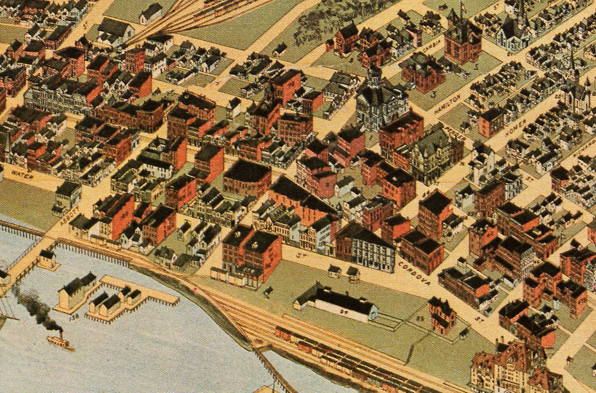

City of Vancouver, 1898
https://www.vancouverarchives.ca/2013/02/22/the-map-and-plan-digitization-project/

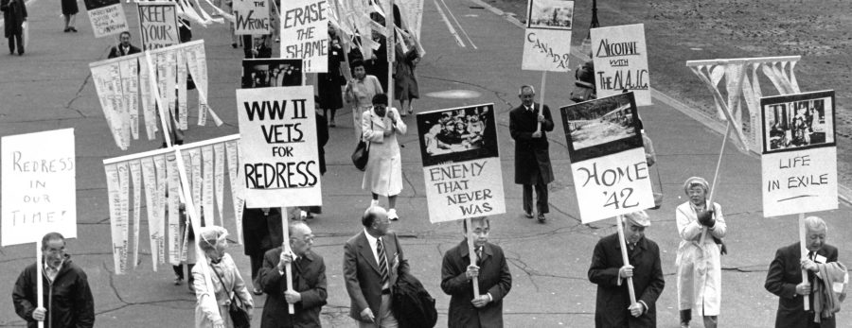
Rally for Redress, Parliament Hill, 14 April 1988
https://canadianart.ca/?agenda=inheriting-redress-the-ottawa-japanese-community-association-archive/

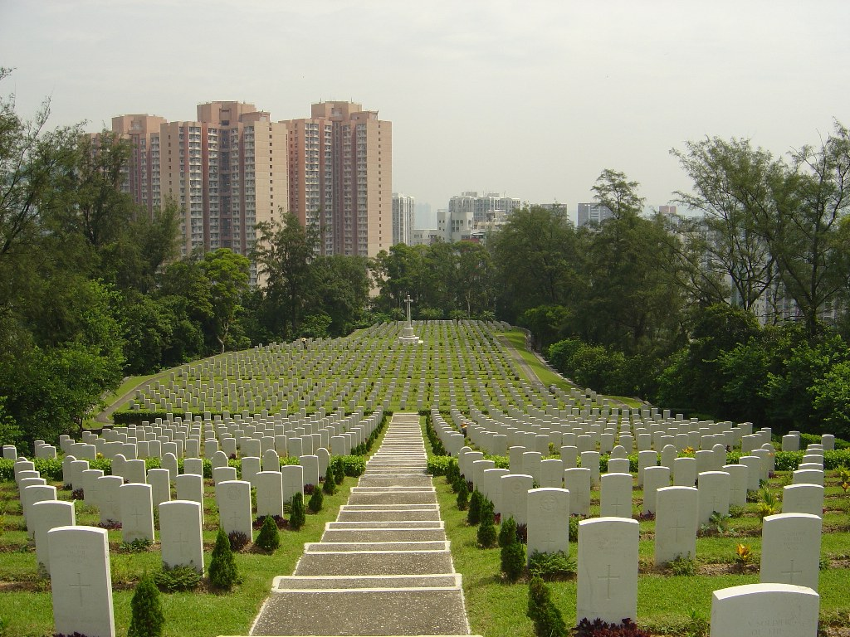

Sai Wan War Cemetery
https://www.cwgc.org/visit-us/find-cemeteries-memorials/cemetery-details/2000320/sai-wan-war-cemetery/

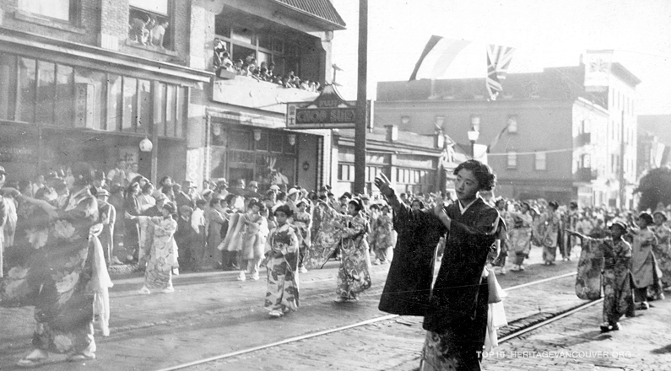
Parade on Powell Street, between 1936 & 1938
https://heritagevancouver.org/top10-watch-list/2017/9-powell-street-area-nihonmachi/

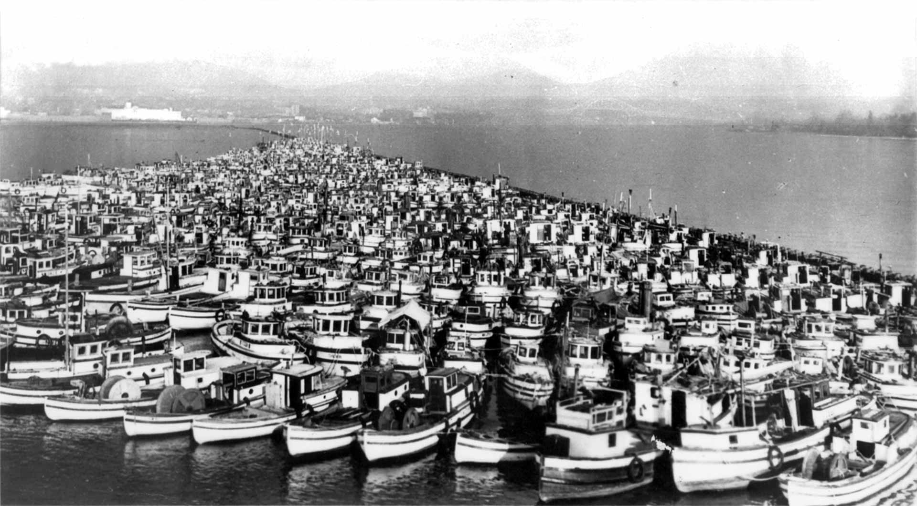
Confiscated boats from Japanese Canadians, Bamfield Harbour, BC.
https://japanesecanadianhistory.net/

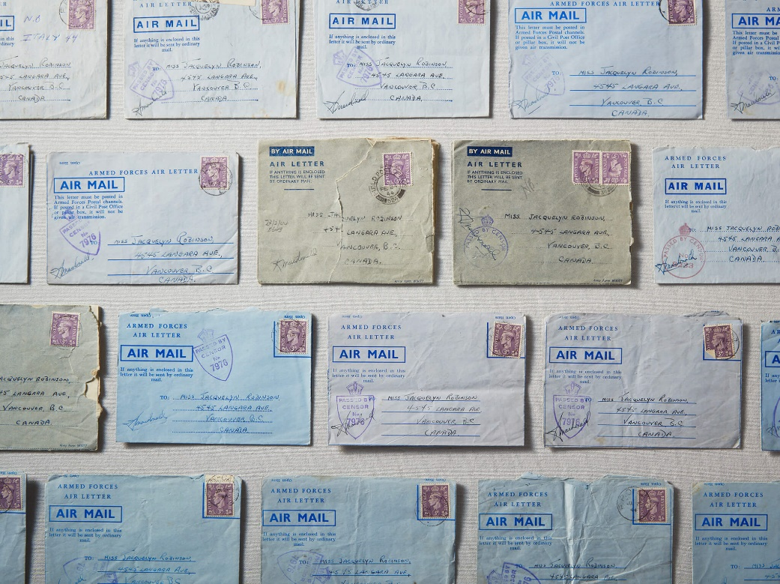

Love Letters from the Battlefield, photo by Vicky Lam
https://thewalrus.ca/love-letters/
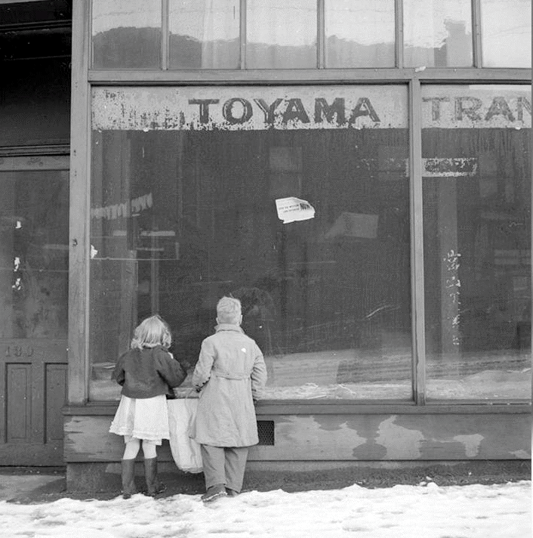
Two children looking into the window of a Japanese store forced to close after the forced relocation of Japanese nationals.
https://www.saanichnews.com/entertainment/photos-gallery-explores-broken-promises-during-japanese-canadian-internment-in-1940s/

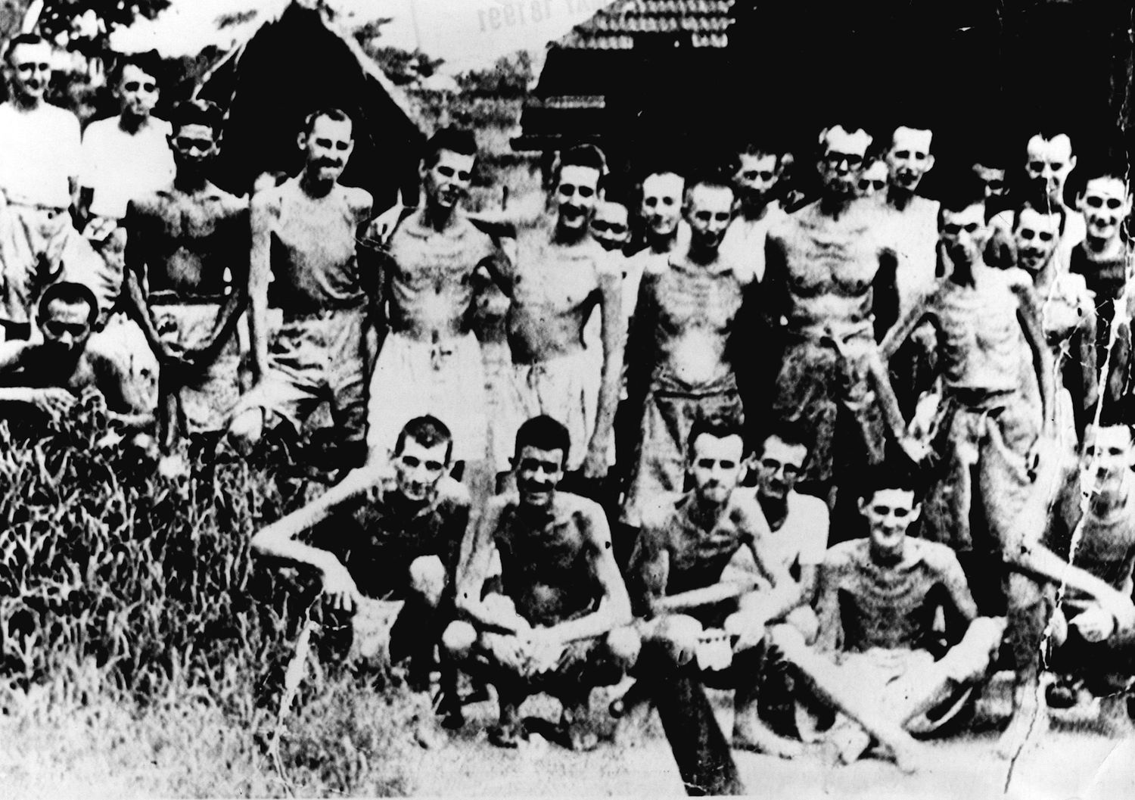

Canadian prisoners of war (POW)
https://www.theglobeandmail.com/opinion/article-the-three-battles-of-canadas-hong-kong-veterans/

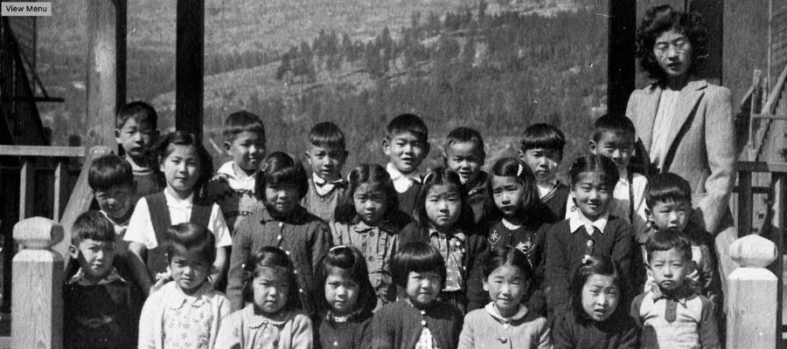

Elementary students at Pine Crescent Elementary School, Bay Farm, BC
https://www.policynote.ca/japanese_dispossession/

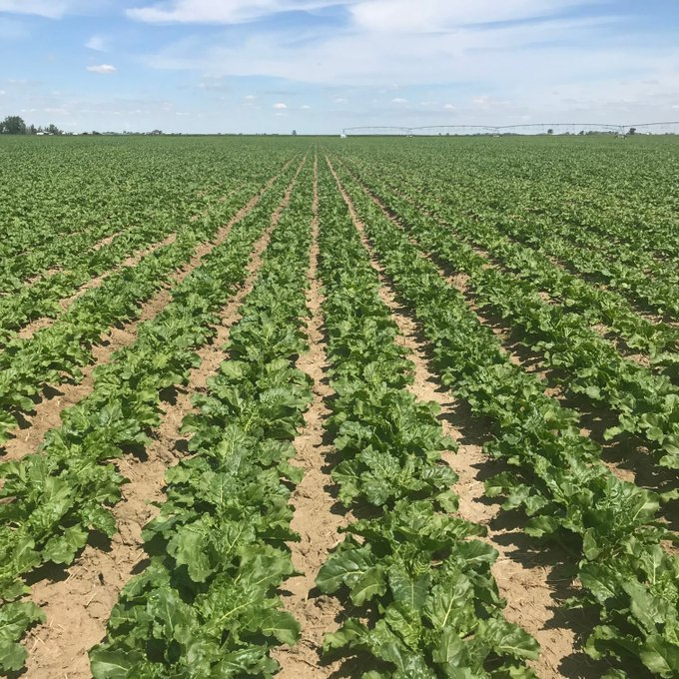

Sugar Beet Field
https://twitter.com/hilleshogseed/status/1273013863848558596
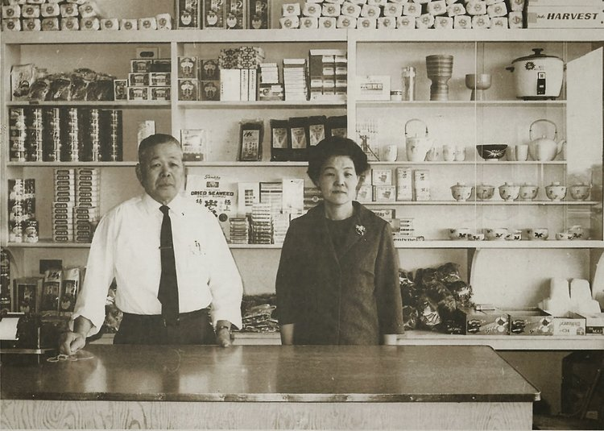
Ryutaro Nakagama lost his property and grocery business that he had operated for over a decade in Steveston, British Columbia when the Canadian government relocated Japanese-Canadians to southern Alberta in 1942 to work in sugar beet production.
https://www.galtmuseum.com/articles/2014/01/entrepreneurs-and-innovators-part-6.html

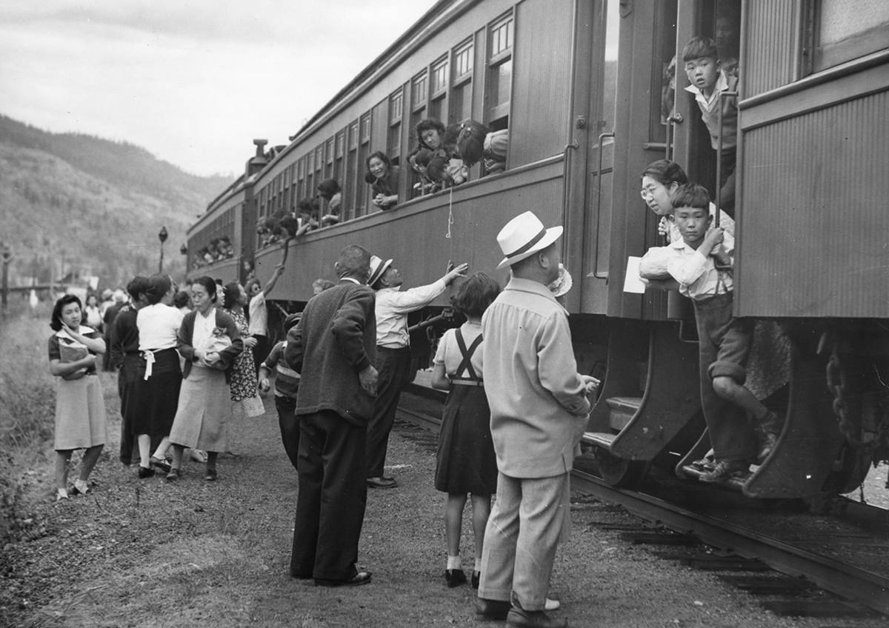

Displaced Japanese Canadians leaving the Vancouver area (possibly Slocan Valley) https://www.saanichnews.com/entertainment/photos-gallery-explores-broken-promises-during-japanese-canadian-internment-in-1940s/

Quote Bank

MITSUE Oh, Miyoko. It’s times like this I miss you most. I feel so at home working for Mrs. Yamamoto, but then I get on this bus and all the little sideways glances and dirty looks make me feel like I don’t belong. How dare I be on this bus, in their presence, in their line of vision, in their city, their province, their country. If only you were here I wouldn’t mind so. If you were here I bet we wouldn’t even be going home right now, Miyoko, we’d have gone straight to the Stanley to see a movie. And we’d sit wherever we pleased, too! (Kanagawa, pg. 38)

ICHIRO I’m not gonna do anything funny, Mits. Just close your eyes for me. Okay. Now picture a house, like the ones you see on your bus ride home. The ones you dream of living in. A nice yard, a dog, kids skipping rope and playing hockey in the driveway. Can you see yourself living there? Can you see us? I can. I know I got a shot, Mits. With you by my side, I know I can do it. A Canadian life. With kids who grow up Canadian. Who will never have to feel they don’t belong. Tell me you can see it.

MITSUE It’s like a dream. Something I won’t even dare to think about having. (Kanagawa, pg. 41)

RALPH We called them “hellships.” And for good reason. Same as anywhere, Japan had a labour shortage with all their able-bodied men at war. So they shipped us POWs to Japan as a slave labour force. Over a hundred thousand of us. For transport they used unmarked cargo vessels, dozens of them were sunk by Allied forces who had no way of knowing these ships were full to the gunwales with our own soldiers. From Hong Kong, three hundred of us were packed into the hold of a ship designed for hauling coal. The Japs didn’t bother washing the coal dust out. We were packed worse than sardines--there wasn’t enough space for all of us to lie down at the same time. Not that you exactly wanted to. There were no toilets, no clean water, no light, no air. Hellship? (He nods.) Only thing missing were the flames of damnation. Which could come at any moment from an American plane, a torpedo. We were down there in that darkness for seventeen days. (Kanagawa, pg. 90)

MITSUE When I got off the train, I couldn’t bring myself to go straight to Celtic. I decided to walk to Powell St. and went through Chinatown which felt somehow normal and anonymous and safe. And then I walked by Hideo’s parents’ house and thought I saw a Japanese man on the steps. But another man came out and they started speaking in Cantonese. I didn’t bother asking if I could have a look inside... I don’t know what I expected to find when I got to Powell. Familar faces, sounds, smells? The special music of nikkei English and Japanese. What I didn’t expect was...emptiness. An emptiness I could see and feel from a block away. If you feel that way about Powell St. today, now you know why...I headed downtown and got up the courage to get on the Granville bus. My heart was in my throat as we crossed the bridge. At the last second I got off at Broadway and walked up the street past the Stanley—a John Garfield movie called “We Were Strangers” was playing. It wasn’t about us.” (Kanagawa, pg. 113)

