TEACHER RESOURCE GUIDE
Father Tartuffe: An Indigenous Misadventure
A co-production with Touchstone Theatre
By Herbie Barnes
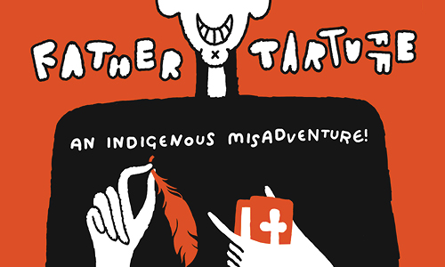
Image description 1: "FATHER TARTUFFE, AN INDIGENOUS MISADVENTURE!" in white bubble text. Behind is an illustrated priest holding a orange feather and a orange bible. The top of the priest's head is cut off so only his grin can be seen.
2023.2024 season
Granville Island Stage
February 22–March 24, 2024

This show is generously sponsored by:

Table of Contents
Pre Show Resources………………………………………………………………………………………………………………………2-11
Welcome 3
About The Arts Club Theatre Company 3
Learning Objectives 3
Content Advisory 3
Synopsis 3
Characters 7
Context: Historical Timeline 8
Context: The Indian Act 10
Context: Farce 11
Context: Tartuffe/The Imposter/The Hypocrite 11
About the Playwright: 11
BC Curriculum Connections: 12
First People Principal of Learning 12
Drama 10/11/12 12
Social Studies 10/11/12 12
English Language Arts 10/11/12 13
Glossary: 13
Discussion Questions Pre Show: 14
Post Show Resources……………………………………………………………………………………………………………………..14-23
Discussion Questions Post Show: 14
Activity 1: Comedic Scenes, How Different Can They Be? 15
Activity 2: Is it a Crime to Speak In Rhyme? 22
Sources 23

Welcome
This guide was created for teachers and students. It contains an overview of the play's story as well as informative resources and activities for teachers and students. The guide aims to provide background knowledge and critical perspectives on the play that will yield fruitful discussion and foster an understanding and appreciation of theatre arts.
If you have any questions, comments, or suggestions for the guide, please contact our Education Coordinator, Mikenzie Page, mpage@artsclub.com.
This study guide was written by River Ironeagle-Mindel and Mikenzie Page.

About The Arts Club Theatre Company
The Arts Club of Vancouver was founded in 1958 as a private club for artists, musicians, and actors. It became the Arts Club Theatre in 1964 when the company opened its first stage in a converted gospel hall at Seymour and Davie Streets. Now in its 60th season of producing professional live theatre in Vancouver, the Arts Club Theatre Company is a non-profit charitable organization that operates three theatres: the Granville Island Stage, the Stanley Industrial Alliance Stage, and the Newmont Stage at the BMO Theatre Centre. Its popular productions range from musicals and contemporary comedies to new works and classics.
Learn more about the Arts Club Theatre Company at artsclub.com.

Learning Objectives
Through the narrative, the play aims to
- Engage with historically relevant narratives of Indigenous families lived experiences and consider how those narratives inform the present, through a comedic lens.
- Explore the concept and form of adaptations, reflecting on how to both subvert and re-create certain tropes and narrative patterns.
- Explore the impacts of culture, colonialism, and society in a theatrical production.

Genre: Comedy
Show Dates: February 22–March 24, 2024
Age Range: Recommended for grades 9-12
Venue: Granville Island Stage

Content Advisory
This production contains coarse language, racial slurs, and satirical comedic situations that may be offensive to some (including physical depictions of coercive sexual situations and satirical references to colonialism, residential schools, misogyny, religion, and generational trauma.) Father Tartuffe also includes water-based fog and haze. Please contact our box office for more information.

Synopsis
The show opens in 1967, in the interior of a “standard 1960’s government issued house”. Sitting around the room, are various members of a First Nations family arguing about their recent guest, Father Tartuffe. We learn the “holy priest”, Father Tartuffe, has been living in their home at the request of Orin, the patriarch of the family, to teach them the “Christian creed and ways of life”. Elise, Darlene, Dennis, and Maryanne all plead with Granny, the strong-willed matriarch, to see Father Tartuffe for the scoundrel and liar he is. Granny reminds that the house and land they live on was once hers, and if they continue their campaign against Tartuffe, she will take it all back. Granny exits, condemning her family for their mistrust of Tartuffe.
As Dennis and Maryanne protest Granny’s harsh words, Elise tells them she will speak to Orin, her husband once he returns from Montreal.
Valant, Maryanne’s boyfriend, enters the house, looking for Maryanne. They embrace and Valant informs Maryanne that he will be back tomorrow to ask her father for her hand in marriage. As Valant departs and the family celebrates, Darlene begins to criticize Orin and his blind trust of Tartuffe. Elise interrupts and defends Orin, explaining that he’s trying to fit into this new white man’s world and that the family needs to support his ambitions. Dennis retaliates by questioning why they need to abandon their culture and beliefs to fit into this new world.
Cathy, Orin’s childhood best friend, enters after being away for the last five years. Everyone rejoices at seeing Cathy again and Darlene fills her in on everything she’s missed. Darlene explains that Orin had a regular job with the band until he heard about a job, preparing for the 1967 International and Universal Exposition in Montreal. He leaves for weeks at a time and Elise comments that “the more time he spends in Montreal the more he wants what the white man has.”. Darlene then begins to explain how Orin has also found God, through Father Tartuffe. The family debriefs Tartuffe’s creepy behaviour especially around Elise. Cathy resolves to speak to Orin and talk some sense into him, as his car pulls up to the driveway.
Orin enters and rejoices at the sight of Cathy. They discuss Orin’s work on Canada’s centennial before Orin decides to lead them both in prayer, much to the surprise of Cathy. Darlene enters as they pray and Orin immediately begins to ask of Tartuffe, although his own wife has been ill. Frustrated at his one-track mind, Darlene exits, and Cathy digs for more information regarding this mysterious Tartuffe.
Orin explains how the pair met in Montreal, as Tartuffe found him and returned his “lost” wallet. As Orin continues his story, it becomes clear to Cathy how Tartuffe has been scamming and lying to Orin. When Cathy begins to question Orin, he threatens to leave so she quickly changes the topic to Maryanne’s upcoming proposal from Valant. Orin scoffs at the idea of his daughter marrying a Metis man as he hopes for her to one day leave the reserve. Exasperated, Cathy leaves, warning Orin of his foolish behaviour.
As Cathy leaves, Maryanne enters to greet her father. Orin checks the room to make sure they are alone before asking Maryanne her thoughts on Tartuffe. As Maryanne tries to avoid the question, Orin tells Maryanne he wants her to marry Tartuffe to which she proclaims she “would rather be dead.”. Darlene, who has been eavesdropping on the conversation, disagrees with this marriage and condemns Orin’s patriarchal behaviour in deciding who his daughter should marry. They argue and eventually Maryanne concedes to Orin, who leaves for a smoke after a tense conversation.
Darlene tries to convince Maryanne to stand up for herself to her father until Valant bursts into the room. He has heard Maryanne will be marrying Tartuffe and has come to see if it’s true. After a series of miscommunications, Darlene conspires with the lovers to go along with Orin’s plan, for now, until they can convince him to not force Maryanne to marry Tartuffe.
As the lovers depart, Dennis storms in threatening Tartuffe. Darlene tells him to mind his business and leave it to Elise, as Tartuffe is obsessed with her. Darlene tells Dennis to leave but unbeknownst to her, he hides under the table to spy on their interaction.
Father Tartuffe enters in a dramatic fashion, speaking nonsensical Latin, much to Darlene’s exasperation. Darlene mentions Elise was hoping to speak to him, which immediately brightens Tartuffe’s mood due to his romantic obsession with her. As Darlene exits, Elise enters. Tartuffe, still unaware of Dennis hiding beneath the table, confesses his passion and desire for Elise. She rejects his advances to which Tartuffe blames her for “inviting” his unholy desires. Elise agrees to keep his advances a secret if he openly supports the marriage of Maryanne and Valant to Orin when Dennis leaps out of his hiding place. Dennis puts Tartuffe in a headlock and promises to expose him to everyone.
Orin enters and Dennis tells him of Tartuffe’s advances on Elise. Orin questions Elise about the incident and they argue, ending with Elise storming out. As Orin begins to question Tartuffe about the incident, Tartuffe recovers convincing Orin that Dennis is the one lying. Orin turns on his son and kicks him out of the house.
Orin and Tartuffe are left alone, with Orin begging Tartuffe to save his family’s souls. Orin begs Tartuffe to spend all his time with Elise and never leave her side, to fill her with the spirit of the Lord. Tartuffe “humbly” accepts but laments that he is not good enough to help her and is much “too poor”, thus prompting Orin to bequeath Tartuffe all his worldly possessions. They leave to go draw up the paperwork.
Darlene, Elise, and Maryanne enter and are frantically trying to come up with a plan to prevent Maryanne from marrying Tartuffe. Maryanne questions why her father would make her do this and Darlene explains her and Orin’s experience in residential schools. She explains that while some people reject the church entirely like her and Elise, and that others like Orin are more “pulled in”. However, Darlene believes that Orin is doing the best he can and trying to provide a better life for his children, in his own way. Cathy enters and helps cheer Maryanne up with everyone else.
Orin enters and Maryanne runs to him, begging him to let her stay with her family. Orin then reveals to his family that he has sent Tartuffe to town to see a lawyer. Orin refuses to hear anyone’s opinions but Cathy, who condemns his decision. Elise offers to prove that Tartuffe is a liar and thief, which Orin gladly accepts. Cathy, Darlene, and Maryanne exit leaving Orin and Elise alone. Elise prompts Orin to hide under the dining table just as Tartuffe enters.
Elise tells Tartuffe they are alone, which immediately sparks his interest. She convinces him to check all the doors as she needs him to believe they are alone, when she tells him a “secret”. Tartuffe starts off as suspicious, checking the spot where Dennis previously hid, but relaxes quickly once Elise “confesses” her desire for him. As Tartuffe begins to advance on Elise, she realizes Orin must be asleep under the table. A chase begins as Tartuffe attempts to seduce Elise while she flees, banging on the table to wake up Orin. Elise convinces Tartuffe to leave the room and do a final check for her husband. Tartuffe agrees and leaves the room.
Orin crawls out from under the table, in shock and anger. As Orin begins to apologize to Elise, Tartuffe re-enters and drops his pants before realizing that Orin is in the room. Orin yells at him and kicks him out of the house to which Tartuffe retorts that he is kicking Orin and his family out. Tartuffe storms out, leaving Orin to reveal the mistake he has made to his wife. Orin tells Elise that he has signed everything they own over to Tartuffe, just moments ago.
Cathy, Darlene, and Maryanne enter. Orin shamefully tells them what he has done and apologizes as he was only trying to provide a better future for her. The three comfort him as Dennis storms in, offering to tear Tartuffe in pieces and feed him to the birds. Cathy attempts to calm him by explaining they fight fire with water or sand, but not more fire. She challenges him to “Understand everything we teach. From our medicines to our history to the way we treat people regardless of who they are.”.
Suddenly all the doors on stage lock and a note is slid from under one of the doors. It is a note from Tartuffe, telling them to keep the noise down as he is expecting company. The family realizes they are trapped in their own living room, except it’s not theirs anymore. It is Tartuffe’s.
Tartuffe enters with a man in a suit. He introduces him as Mr. Turner, one of the big executives working on the Centennial. Tartuffe reveals to Mr. Turner that Orin has “misrepresented” himself as living on the Reserve, which is why he was hired for this role as the committee needed a “real Indian”. He proves this by showing Mr. Turner the deed to the house which is now in Tartuffe’s name.
Suddenly, a window opens, and Valant enters, out of breath. He embraces Maryanne, then reveals to everyone he has just returned from Montreal. Valant tells the story of how he drove to Montreal to ask Prince Charles for help, as the monarchy has promised to begin to take care of the Native people. Valant presents a note written by Prince Charles, that states because the house is on Crown land, it is actually property of the Queen and therefore cannot be sold without her permission. Tartuffe’s papers are null and the house is returned to Orin’s possession. Mr. Turner accepts this and leaves.
Orin thanks Valant for what he is done and asks for his forgiveness, offering him anything he could want in the future. Valant responds that all he wants is permission to marry Maryanne, which Orin joyfully gives. As the family celebrates, Tartuffe throws a temper tantrum. Granny enters questioning what has happened. Orin confesses that he fell for Tartuffe’s schemes but Granny does not believe him. Cathy and Elise beg her to see through his lies but Granny again refuses, asking “You believe he is being untrue. But first answer me this. Who are you?”. Granny continues to demand the truth and Cathy begins to understand. Cathy reveals to everyone that she is a lesbian and has been living with her partner, Nancy, for the last three years. Orin confesses to everyone that he is lost and doesn’t know how to be a good father. He is ashamed that he might leave nothing for his daughter and son. Granny begins to speak, revealing she never believed Tartuffe but wanted to see how far her family would go before they were willing to speak up and take care of each other. She also reveals she has been documenting everything Tartuffe has done and the authorities are outside at this moment to take him away. She swings her purse at him and kicks Tartuffe out of their home.
As everyone celebrates, Granny reminds them they need to give thanks. Everyone reluctantly bows their head to pray as she looks through her purse, eventually pulling out sweetgrass. The show ends with a poignant final line…
GRANNY
No, no family raise your head to the Creator. We pray without shame.
What did you expect?!! (in Ojibway) Chi Miigwetch Creator for all

Characters
Granny: The family patriarch. Granny runs the family, having owned the land and home they live in. She seems sold on Father Tartuffe
Orin: Granny’s only son. He has been away on a well-paying new job to work for the government. Orin wants to fit into the new world where First Nations people are equal but this often clouds his judgement. He is a good man but naïve.
Elise: Orin’s wife and the stepmother to both Dennis and Maryanne. She is a strong, smart, powerful native woman who does everything to keep her husband happy. The real brains of the family but lets Orin believe he is in charge.

Darlene: - Elise’s sister, she is a strong, take the trouble from everyone type woman. Takes care of everyone.

Dennis: Orin’s Son. A rebel without a clue, will grow to be a warrior but is still just a kid with a bad temper.

Cathy: Orin’s best friend. Been away for several years working in Chicago. Was Orin's closest friend before she left.

Maryanne: The darling daughter of Orin. She will do anything to keep her father happy. She is pure and innocent.

Valant: Maryanne’s loving Métis boyfriend who’s madly and truly in love with Maryanne. Doe eyed.

Father Tartuffe: An over the top, bigger than life phony of a priest.

Context: Historical Timeline

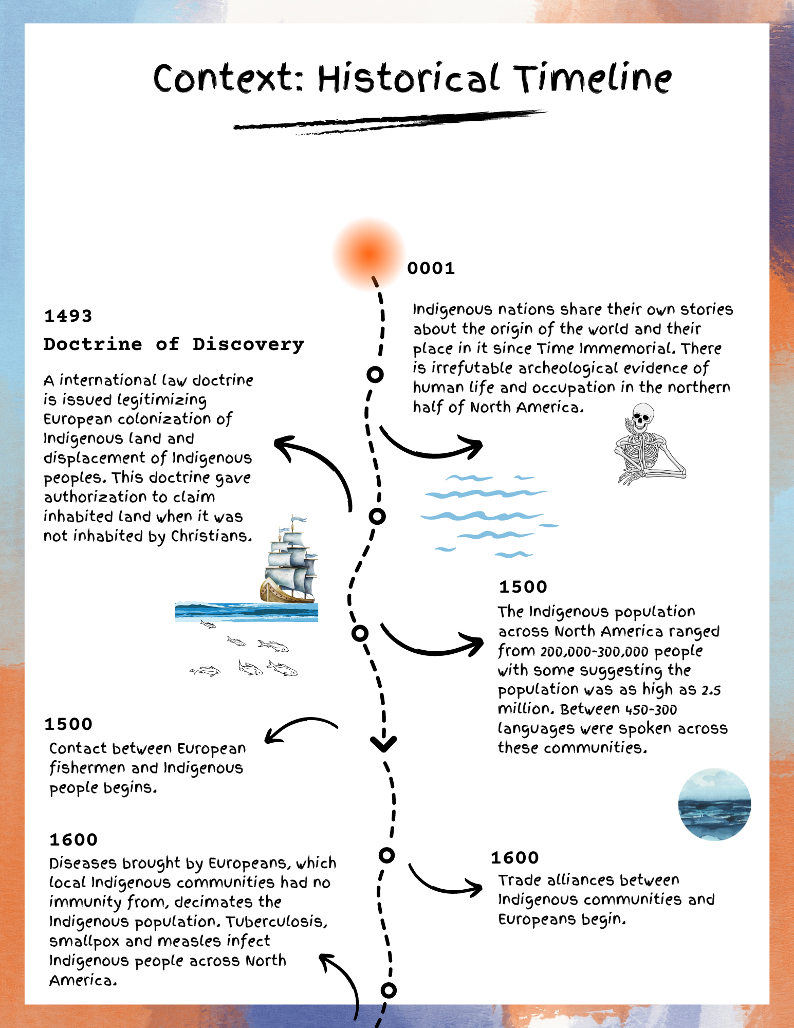

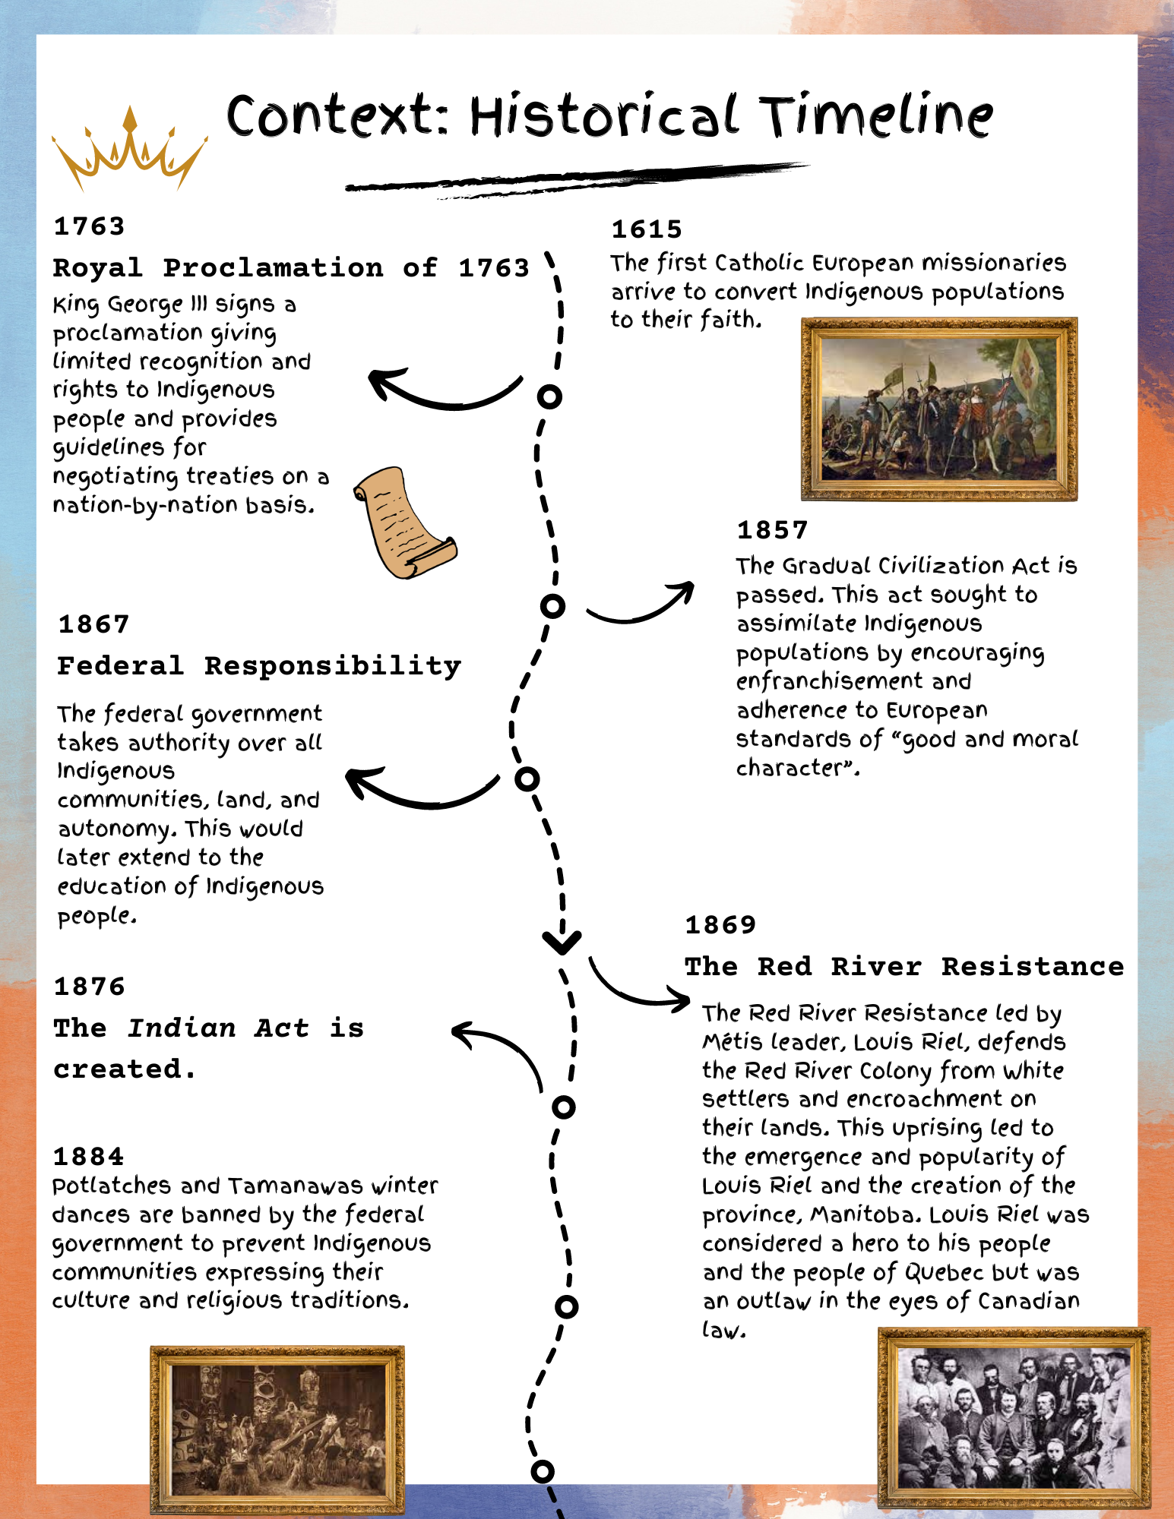

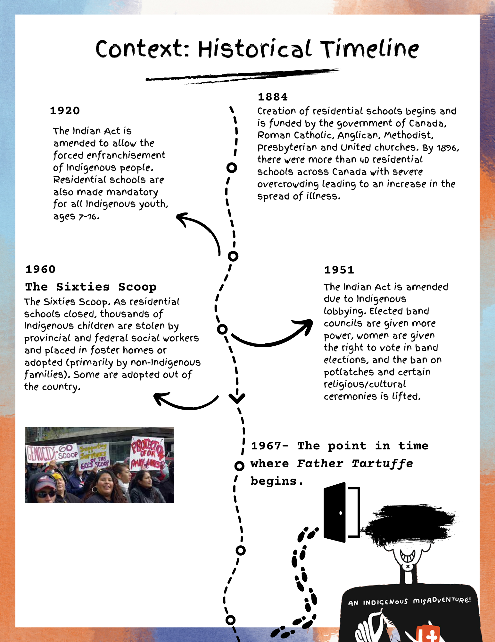

Context: The Indian Act
The Indian Act is the primary Canadian federal law that governs matters of Indian status, bands, and management of reserve land. It was first introduced in 1876, with several discriminatory policies and laws intended to terminate the cultural, social, economic, and political distinctiveness of Indigenous peoples, while assimilating them into mainstream Canadian life.

The Indian Act gave sweeping legislative power to the Department of Indian Affairs and its Indian agents. This power gave them extreme control over Indigenous peoples, restricted their freedoms, banned cultural and religious practices/ceremonies, and allowed government officials to determine Indigenous rights and benefits based on “good moral character”.

In 1951, the Act was revised with changes allowing cultural and religious practices/ceremonies however many discriminatory laws remained especially towards First Nations women and children. The 1951 revisions also gave the government control over child welfare which led to the “Sixties Scoop”, where Indigenous children were taken from their homes by provincial child welfare agencies, to be placed in foster homes where they would be adopted by white families.

In 1969, Prime Minister Elliot Trudeau’s government proposed a “White Paper” policy that would eliminate the Indian Act and abolish the Department of Indian Affairs. This policy was overwhelmingly rejected by Indigenous peoples across Canada and was countered with the “Red Paper '' created and presented by Harold Cardinal, the then president of the Indian Association of Alberta. Many Indigenous people wanted to maintain their legal distinction/status and many scholars pinpoint this time in history as when the federal government began to turn away from assimilation policies and instead create policy geared toward constitutionally protected rights for Indigenous people.

It’s important to know that since the first piece of legislation has been passed, Indigenous people have resisted oppression and the systematic denial of their rights and continuously fought for active participation in establishing their rights. The Indian Act is a controversial yet paradoxical document that has enabled human rights violations, generational trauma, and cultural disruption for generations of Indigenous families. Despite this controversy, the document is historically and legally significant as it acknowledges and affirms the historical and constitutional relationship between Indigenous peoples and the Canadian government. For this reason, efforts to eliminate the Indian Act have been met with widespread resistance.

“We do not want the Indian Act retained because it is a good piece of legislation. It isn’t. It is discriminatory from start to finish. But it is a lever in our hands and an embarrassment to the government, as it should be. No just society and no society with even pretensions to being just can long tolerate such a piece of legislation, but we would rather continue to live in bondage under the inequitable Indian Act than surrender our sacred rights. Any time the government wants to honour its obligations to us we are more than happy to help devise new Indian legislation.”
- Harold Cardinal
Cree writer, political leader, teacher, negotiator, and lawyer.

Context: Farce

A farce is a dramatic comedy that usually involves miscommunication, deception, and ridiculously absurd situations. While different from satire, farce can also serve as a subversive function to comment on the state of the world around us. Farces can include clowning, buffoonery, slapstick humor, physical comedy, mistaken identities, unlikely scenarios, highly exaggerated characters and situations, and more!

Context: Tartuffe/The Imposter/The Hypocrite
Tartuffe is a theatrical comedy written by French playwright Molière and was first staged at Versailles in 1664. Tartuffe or The Imposter caused the largest scandal of Molière’s career and was denounced by the Church, Archbishop of Paris, and Parisian Parliament as an open attack on religion. While Tartuffe was well received by the King and audiences, the play challenged religious ideas of morality and mocked the hypocrisy of the upper classes. By having Father Tartuffe, a hypocritical fraud, pretend to be a “holy man” and use religion for his own personal gain, Molière scandalized devout audiences. The play was banned for five years, and the Church threatened to excommunicate anyone caught performing, reading, or watching the play.
Molière appealed to the King over those five years and eventually was granted another public performance with a heavily re-written version of Tartuffe. The play only had a single performance before it was banned by the Parliament of Paris. However by 1669, the Church, Archbishop, and many of Molière’s detractors had lost their influence and the ban was lifted, finally allowing public performances to happen. Tartuffe was an immediate hit and has remained popular for centuries after.

About the Playwright:
Herbie Barnes
Herbie Barnes is an accomplished playwright, performer, director and arts educator whose 30-year-career spans stages across North America. He is currently the Artistic Director of Young People’s Theatre in Toronto, Canada. He was among the generation of young Indigenous artists in the 1990s breaking down barriers to forge professional careers in Canadian theatre.
An Anishinaabe theatre artist from Aundeck Omni Kaning First Nation on Manitoulin Island, Herbie Barnes was raised in Toronto. His theatre career began in 1989 with Debajehmujig Theatre Group, touring Ontario with the first run of Drew Hayden Taylor’s Toronto at Dreamer’s Rock. Since then, he has collaborated with some of North America’s largest theatre companies and was nominated for a John Hirsch Director’s Award. His new play, Bent Boy, was workshopped at YPT and shortlisted for the Sharon Enkin Plays for Young People Award in 2020. Herbie has also facilitated various programs as an artist educator for elementary to university-aged students at various schools and companies.

BC Curriculum Connections:

First People Principal of Learning
- Learning ultimately supports the well-being of the self, the family, the community, the land, the spirits, and the ancestors.
- Learning recognizes the role of indigenous knowledge.
- Learning involves generational roles and responsibilities.
- Learning involves recognizing that some knowledge is sacred and only shared with permission and/or in certain situations.

Drama 10/11/12
Big Ideas
- Drama communicates ideas, emotions, perspectives through movement, sound, imagery, and language.
- Active participation in theatre creates personal and cultural connections which offer insight into the human experience.
Curriculum Connections
- Explore and create dramatic works to express ideas and emotions.
- Reflect on dramatic works and make connections with personal experiences.
- Communicate ideas through a theatre production; Explore First Peoples perspectives and knowledge, other ways of knowing, and local cultural knowledge to gain understanding through dramatic works

Social Studies 10/11/12
Big Ideas
- The impact of contact and colonialism continues to affect the political, social, and economic lives of B.C. First Peoples.
- Social justice initiatives can transform individuals and systems.
- Historical and contemporary injustices challenge the narrative and identity of Canada as an inclusive, multicultural society.
Curriculum Connections
- Use Social Studies inquiry processes and skills to ask questions; gather, interpret, and analyze ideas; and communicate findings and decisions.
- Assess and compare the significance of people, places, events, or developments at times and places, and determine what is revealed about issues of social justice in the past and present (significance).
- Assess how underlying conditions and the actions of individuals or groups influence events, decisions, or developments, and analyze multiple consequences (cause and consequence).
English Language Arts
Big Ideas

- First Peoples texts and stories provide insight into key aspects of Canada’s past, present, and future.
- First Peoples voices and text play a role within the process of Reconciliation.
- The exploration of text and story deepens our understanding of diverse, complex ideas about identity, others, and the world.

Curriculum Connections
- Recognize and analyze personal, social, cultural contexts, values, and perspectives in texts, including culture, gender, sexual orientation, and socio-economic status.
- Recognize and appreciate how different forms, formats, structures, and features of texts enhance and shape meaning and impact.
- Think critically, creatively, and reflectively to explore ideas within, between, and beyond texts.

Glossary

Adaptation: A piece of text/work that has been altered to make it suitable for film, television, or theatrical production.
Auntie: An Auntie is a beloved, trusted woman, who may be officially related or not. Indigenous people value their women and are often leaders within their communities.
Crown Land: Physical land colonized by the British Crown and considered “property” by the State or Commonwealth government.
Elder: An Elder is an individual who plays a key role within their community. They are knowledge keepers and ensure cultural continuity. Indigenous peoples value their elders and Elders are often leaders within the community.
Indian: Historically used as an umbrella term for Indigenous peoples of Canada, typically used in legal documents such as the Indian Act. Today it is considered outdated and offensive.
Indian Act: In 1876 the Federal Government enacted many colonial laws restricting Indigenous peoples’ rights to their culture and language, the act was meant to assimilate Indigenous peoples into Canada’s segregated society. E.g. “Kill the Indian to save the Man.”
Louis Riel: The founder of Manitoba, Louis Riel was a political leader for Métis people in Canada and was wrongfully executed for “treason”.
Métis: The French word for mixed. The Métis people have a specific history, culture, and language. Born from Indigenous and Euro-American ancestry, Louis Riel is a famous example.
Native: Like the word Indian, Native was used to describe someone who was Indigenous. Considered outdated.
Ojibway: A specific group of Indigenous peoples in eastern Canada around the great lakes, with a specific history, culture, and language.
Red Man: Derogatory term for an Indigenous person.
Residential Schools: Residential schools were government sponsored religious schools (usually run by Catholic nuns and priests) that were established to assimilate Indigenous youth and children into Euro-Canadian society. Abuse was widespread at these schools, and they have left a long-lasting negative intergenerational impact on Indigenous communities. The last residential school (Gordon Residential School in Punnichy, Saskatchewan) in Canada closed in 1996.
Rez Dog: Reservation dog, a staple on many reservations. A mix of domesticated and wild dogs, they are often taken care of by their community.
Sentinel: A guard meant to keep watch.
Status: The Indian Act introduced Status Cards, which registered Indians under the Indian Act. Status is the legal standing of an Indigenous person who is registered under the Indian Act.
Sycophant: A person who tries to please someone to gain personal advantages.
Wendigo: A malevolent entity within Ojibway history/culture. The name itself is not meant to be spoken aloud, in fear of manifesting one.
World Expo 67’: The Expo 67’ was a World’s Fair held in Montreal, April-June 1967. It is considered important to Canadian history as Expo 67’ was the centerpiece of the centennial celebrations of the Confederation.
Zhoonya: Ojibway for Money

Discussion Questions Pre-Show:
- What is an adaptation? What are famous adaptations you have heard of?
- Are you familiar with Moliere and the original production of Tartuffe? If not, why do you think we create adaptations based on theatre pieces that are hundreds of years old?
- What pieces of media (TV shows, movies, and theatre!) are Indigenous created or prominently feature Indigenous artists? How often are these pieces comedic? How often are these stories tragic?
- Father Tartuffe is set in Canada in 1967. What do you know about this time in Canadian history?

Discussion Questions Post-Show:
- “Aren’t we in a better place today than yesterday?
Father Tartuffe, pg. 14
- Why do you think the playwright chooses to tackle difficult topics (e.g. the continued legacy of residential schools and colonization) in a comedic way?
- How do you think the character of Tartuffe has changed from the original play to this adaptation?
- Rhyme was used to describe “proper English” throughout the play. Why would being seen as proper be important to an Indigenous family in 1967?

Activity 1: Comedic Scenes, How Different Can They Be!
Recommended for Drama 10-12.
Throughout the narrative of Father Tartuffe, characters are constantly in motion through comedic and hilarious hijinks! In this exercise, students will explore different aspects of comedy through recreating one of the scenes from Father Tartuffe.
Materials: Scene excerpts/pictures (see below), space for students to move, and slips of paper labelled 1, 2, or 3 in a container.
Part 1: Exploring Comedy in 3 Different Levels!
- Divide the class into groups of 3—5. Offer them the choice of the scenes below. From there, groups will pick out one of the slips of paper which are numbered with a different challenge to recreate or re-block the scene.

- Challenge 1: Recreate the scene using only music, mime, and gesture! No talking aloud!
- Challenge 2: Block and direct the scene using one word from each line. You are also allowed enough physical movement to make the scene clear.
- Challenge 3: Using only your voices, create and direct the scene as if you are doing voice-over work. Sound effects are encouraged!

- Give students 30 minutes to create their scene (or feel free to stretch this out depending on the time available).
- Allow groups to present their recreated scenes. We offer to have them perform once then receive feedback from there classmates through the questions below!

- What did you enjoy/made you laugh during the scene?
- What did you want to see more of throughout the scene?

- Give the groups 10—15 minutes to rehearse their scenes with this new feedback.
- Have them come back together and perform again, incorporating suggestions and also giving them a second opportunity to try something new!

Part 2: Reflection and Discussion.
- What did you notice about blocking and recreating the scene three different ways? How did it vary from group to group?
- How did the different styles of comedy differ from each other? How were these styles of comedy similar and different to other forms of comedy? (think stand-up or slapstick!).
- How did each group bring their own directing style to each scene? How do different productions vary depending on the director?

*These excerpts/pictures are to be used for educational purposes only and cannot be distributed.
Using the picture below, have participants recreate the infamous table scene with Tartuffe, Elise, and Orin with Challenge 1, 2, or 3, writing their own script for it. Encourage discussion of boundaries and explain the role of an intimacy director in theatre/film.
Intimacy director: An intimacy director, is a member of a theatre, film, or television crew (more commonly known on sets as an intimacy coordinator) who ensures the well-being of actors and actresses who participate in any intimate scenes (e.g. a kiss or a physical theatre table scene where one character is attempting to avoid the other!) The intimacy director of Father Tartuffe is Lisa Goebel!
Image description 2:The title page of Tartuffe in a 1793 edition. The picture on the side depicts the infamous table scene from the original Tartuffe.
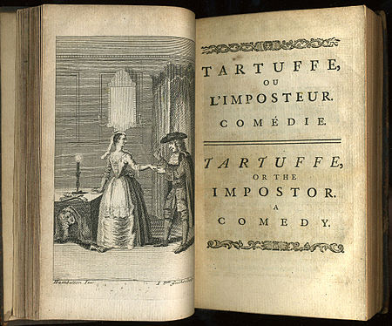

SCENE 16: BEHIND CLOSED DOORS

All four doors close at the same time. Everyone is startled and one by one they go over and try the doors. All are locked.

DENNIS
It’s locked…

CATHY
Mine too…
MARYANNE
I didn’t know we had locks on these doors.

A note is slipped under the door.

DENNIS
A note?

MARYANNE
From who?

DENNIS
Who do you think?

MARYANNE
Tartuffe?

ORIN
Yes, Tartuffe! The good Father Tartuffe is now sending notes under the door!!

DENNIS opens the letter and matter of factly says

DENNIS
It’s from Tartuffe…Ah Ha!!

Everyone turns and stares at DENNIS like he’s an idiot.

ORIN
…read it.

DENNIS
“Dearest Orin and family. I am just writing to let you that I will be expecting company any time now. We will be discussing business so could you please keep the noise down.”. What kind of balls does this guy have?
ORIN
Mine. No, we are trapped in here.

CATHY
We need some sort of plan.

ORIN
Why?

ELISE
I don’t want to lose my home, Orin.

ORIN
It’s too late. We are trapped in our own living room.

DARLENE
It’s not ours anymore.

MARYANNE
Right! It’s Tartuffe’s.

DENNIS
Shut up, Maryanne.

ORIN
So what do we do?

They all look around at each other.

CATHY
We don’t even know what we are fighting against.

SCENE 17: A PRINCE OF A NOTE

VALANT
Hello, Orin. Sorry to come in this way. But the doors are locked.

MARYANNE
Valant, my love!!

VALANT
Maryanne, you are so beautiful.

MARYANNE
Valant, you handsome angel!

They run to each other.

VALANT
Who is he?
MARYANNE
That is my father’s boss. Or ex-boss. Standing next to my father’s friend... or ex-friend. In our home or... ex-home.

VALANT
That is what I thought might happen. That’s why I drove to Montreal to get help.

ORIN
Who would help us in Montreal?

VALANT
The Prince.

MARYANNE
What?

VALANT
Prince Charles.

They all are shocked and amazed.

VALANT
Yes, he is here for the party and I know my history. The Queen promised the people that she would take care of them so I explained what this... creep was doing to you. He told me/

MARYANNE
You talked to him?

VALANT

I walked right up to him at an art exhibit and told him you needed help. I followed him all over that art Gallery until he promised to help. He sat right down and wrote it on the back of this painting.

He pulls out a Norval Morrisseau painting and hands it to Orin. He reads the back.

PRINCE CHARLES
“To whom it may concern, it has come to my attention that some wrong-doings have been going on here in the colony. Canada is celebrating 100 years as a union and if it is to continue to grow it can not do it without everyone being included. I know times were tumultuous. Harms were done in the name of the crown and in the name of God but these wrongs can not go on. I am in line to be King and when that day comes I will ensure that my Indigenous Brothers and Sisters will live in a world where they are accepted for who they are and will be able to control their destiny. I do not wish any harm on her Royal Majesty the Queen but understand there will come a time to fulfill my duty, I mean how long can she go on? With this understanding I can easily state that the home that is spoken of in this conversation is in fact on crown land and therefore owned by the Queen and therefore can not be sold without her permission. Therefore the house is still in possession of Orin Wabagisic. My hope is that this clears all confusion and I can return to enjoying the art gallery in peace. His Royal Highness The Honourable Prince of Wales.

SUIT MAN
Well, that clears that up. Orin, I will see you first thing Monday morning.

He turns and walks out.

ORIN
Valant, you saved my life, my home, my family. I have been horrible to you. Please, my boy, forgive me and if there is anything I can do for you in the future, please ask.

VALANT
I want only one thing from you Orin, the only thing I have always wanted; permission to marry your daughter.

ORIN
If that is what she wants, that is what she will have.

MARYANNE
It is, father! It’s all I want.

ORIN
So be it!!

Everyone screams and hugs while FATHER TARTUFFE stands there shocked.

FATHER TARTUFFE
WAIT!!! She was promised to me!! What about me!!!!

ACTIVITY 2: Is It a Crime to Speak In Rhyme?
Recommended for Drama 10-12, Literary Studies 10-12, and Social Studies 10-12.
In the beginning of Father Tartuffe, Granny only speaks in “proper rhyme”, while her words describe her intentions and the necessity to speak “proper English”. In this activity, students are encouraged to join in on the conversation with rhyme, rhythm, and repetition.

Materials: Pencils, pens, and paper.

Part 1: The Conversation
- Students are paired in groups of 2. Feel free to give them a topic to rhyme about (e.g. their pet peeves, icks, or their current obsession). Once paired, students are instructed to rhyme to one another for 3 minutes improvised rhyme conversation.
- Once the 3-minute mark has been reached, raise the stakes. Participants can switch partners. Now in their new pairs, they are to only “understand” and respond to one another unless they speak in proper rhyme. Give them 5 minutes to try out this exercise!
- After the final conversation form a circle, Rhym a quick story using rhymes alphabetically (I.e. “All of fall” “Burnie lived in port Alberni” “Caught some fish with his pal Trish”)

Part 2: Character Reflections
- Each student is to pick a character from the play Farther Tartuffe.
- Write a short poem based on the POV of their chosen character, Students are encouraged to rhyme with one another.
- Any performers? Read aloud 1 or 2 poems by a volunteer(s) and have other students guess which character the poems POV is in.

Part 3: Reflection and Discussion
- How did your chosen character shape your poem?
- Rhyming was seen as proper English to Granny. Why was it important to be seen as proper as an Indigenous person in 1967?
- Was it difficult to communicate in a way you’re not used too?

SOURCES:
BC curriculum:
https://curriculum.gov.bc.ca/curriculum
About the Playwright
https://www.youngpeoplestheatre.org/herbie-barnes/
Context: Tartuffe/The Imposter/The Hypocrite
https://en.chateauversailles.fr/discover/history/great-characters/moliere#:~:text=Le%20Tartuffe%20(or%20The%20Impostor,that%20raged%20for%20five%20years
https://en.wikipedia.org/wiki/Moli%C3%A8re
https://nac-cna.ca/en/englishtheatre/studyguide/tartuffe/background#:~:text=The%20popular%20version%20of%20Moli%C3%A8re's,to%20present%20it%20in%20public.
https://en.wikipedia.org/wiki/Tartuffe
https://medium.com/lantern-theater-company-searchlight/moli%C3%A8res-controversial-tartuffe-667dca83bd39
Context: Farce
https://www.studysmarter.co.uk/explanations/english-literature/literary-devices/farce/\
Context: Historical Timeline
https://www.thecanadianencyclopedia.ca/en/timeline/first-nations
https://www.thecanadianencyclopedia.ca/en/timeline/indigenous-suffrage
https://www.ictinc.ca/blog/a-brief-timeline-of-the-history-of-indigenous-relations-in-canada
https://www.thecanadianencyclopedia.ca/en/article/residential-schools
https://www.thecanadianencyclopedia.ca/en/article/sixties-scoop
https://www.thecanadianencyclopedia.ca/en/article/louis-riel
Context: The Indian Act
Cardinal, Harold. The Unjust Society. 2nd ed. Vancouver: Douglas & MacIntyre, 1999. 140.
https://indigenousfoundations.arts.ubc.ca/the_indian_act/
https://www.thecanadianencyclopedia.ca/en/article/indian-act
Harold Cardinal participates in a First Nations meeting in Calgary, April 1975. As leader of the Indian Association of Alberta, Cardinal worked with other political leaders in Alberta and nationally to improve conditions for First Nations people. PHOTO BY GLENBOW ARCHIVES, NA-2864-27196 /Postmedia
https://calgaryherald.com/opinion/columnists/smith-how-harold-cardinal-helped-lead-a-crucial-rethinking-of-indigenous-relationships-with-canada
Glossary :
https://www.thecanadianencyclopedia.ca/en/article/indigenous-elders-in-canada
https://www.cbc.ca/radio/unreserved/the-mom-that-you-tell-secrets-to-aunties-on-the-role-they-play-and-what-their-own-aunties-mean-to-them-1.6442574#:~:text=In%20many%20Indigenous%20cultures%2C%20that,be%20officially%20related%20or%20not.
https://parks.canada.ca/culture/designation/evenement-event/expo-67
https://thecanadianencyclopedia.ca/en/article/residential-schools-in-canada-plain-language-summary
https://www.thecanadianencyclopedia.ca/en/article/residential-schools

