

TEACHER RESOURCE GUIDE
You used to call me Marie…
By Tai Amy Grauman
A Savage Society & NAC Indigenous Theatre Production
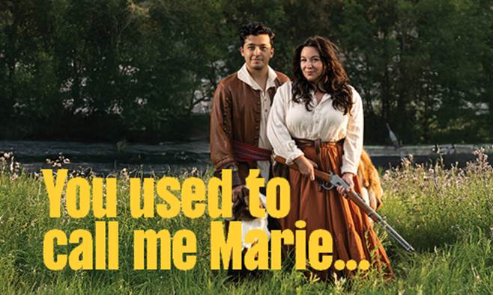

2025.2026 Season
Olympic Village Stage at the BMO Theatre Centre
September 25–October 12, 2025


This show is proudly sponsored by

Table of Contents
Pre Show Resources………………………......……..............................……….............…..………3-32
Welcome……………………………………………………………………………….………………......................…3
About The Arts Club Theatre Company…………………………………………………………….....…………...3
About Savage Society……………………………………………………………………………………….............…3
About the NAC Indigenous Theatre…………………………………………………………….....……...………...4
About this Land: Sen̓áḵw sən̓aʔqʷ, The Village of False Creek…………………………………………..…….4
Attending the Show/Theatre Etiquette……………..…………………………………......……...……..……………5
Learning Objectives…………………………………………………………………………….............….....………….6
Connection to BC Curriculum……………………………………………………………………………………......…....6
Show Content…………………………………………………………………………………………………..........………9
Content Advisory………………………………………………………………………………..............…….……………10
Context: Who are the Métis?……………………………………………………………………….………….………..11
Context: Métis Foundational Values ……..……………………………………………………..…………………..13
Context: Métis Symbols and Traditions …...……………………………………..…..............………………..15
Context: The Fur Trade and the Métis …...……………………………………………………......………………..18
Context: Languages of the Métis and You used to call me Marie...……………………….............………..18
Context: The Scrip System and the Métis …...………………………………………………….....………………..22
Context: Métis Governance in Alberta - 1900s to Today …...…………………………………………………..23
Glossary………………….…………………………………………………………………………...................…..……23
Brief Synopsis………………………………………………………………………………………………....…….………..24
Detailed Synopsis………………………………………………………………………………………………...………….25 - 29
About the Playwright: ……………………………………………………………………………………………….………29
Playwright’s Notes: …………………………………………………………………………………….……………………29
Setting……………………………………………………………………………………………...................……………30
Characters………………………………………………………………………………..................……………………30
Pre -Show Discussion Questions ................................................................................................ 32

Post Show Resources...…………………………………………………………………………………….…33 - 48
Post Show Discussion Questions…...……………………………………………………………………………………………..32
Literacy Extension Activities: Read and Respond …...…………………………………………………………………..33
Activity #1…………………………………………………………………………………………………………………………………….39
Activity #2…………………………………………………………………………………………………………………………………….42
Further Learning………………………………………………………………………………..………………………………………44
Resources…………………………………………………………………………………..……………………………………………….45
Works Cited ………….…...……………………………………………………………………….……………………………………..46

Welcome
This guide was created for teachers and students. It contains an overview of the musical's story as well as informative resources and activities for teachers and students. The guide aims to provide background knowledge and critical perspectives on the musical that will yield fruitful discussion and foster an understanding and appreciation of theatre arts.
If you have any questions, comments, or suggestions for the guide, please contact our Education & Community Engagement Coordinator, Mikenzie Page, mpage@artsclub.com.
This study guide was written by Mikenzie Page in collaboration with Kimberley Fraser-Airhart, mimikwas Métis Education Consulting.
Content and thematic advisory written by Sophie McNeilly.

About The Arts Club Theatre Company
The Arts Club of Vancouver was founded in 1958 as a private club for artists, musicians, and actors. It became the Arts Club Theatre in 1964 when the company opened its first stage in a converted gospel hall at Seymour and Davie Streets. Now in its 62nd season of producing professional live theatre in Vancouver, the Arts Club Theatre Company is a non-profit charitable organization that operates three theatres: the Granville Island Stage, the Stanley BFL Canada Stage, and the Olympic Village Stage at the BMO Theatre Centre. Its popular productions range from musicals and contemporary comedies to new works and classics.
Learn more about the Arts Club Theatre Company at artsclub.com.

About Savage Society
Telling their own stories sourcing traditional and contemporary perspectives, Savage Society was created in 2004 for members to produce their own stories as practicing Indigenous Theatre and Film Artists. Artistic Director Kevin Loring is a member of the Nlaka’pamux Nation from the Lytton First Nation in British Columbia.

Savage Society develops work that reflects our world view, sourcing traditional stories and cosmologies and our contemporary realities as Indigenous people for both professional and community settings.
Savage Society operates on the unceded territories of the xʷməθkwəy̓əm (Musqueam), Skwxwú7mesh (Squamish), Səl̓ílwətaʔ/Selilwitulh (Tsleil-Waututh), S'ólh Téméxw (Stó:lō), sq̓əc̓iy̓aɁɬ təməxʷ (Katzie), Qayqayt, kʷikʷəƛ̓əm (Kwikwetlem ), Kwantlen and sc̓əwaθenaɁɬ təməxʷ (Tsawwassen) Nations.
Learn more about Savage Society and their work at https://savagesociety.ca

About the NAC’s Indigenous Theatre
The National Arts Centre (NAC is Canada’s bilingual, multi-disciplinary home for the performing arts. The NAC presents, creates, produces, and co-produces performing arts programming in various streams, including the NAC Indigenous Theatre stream.
For half a decade, NAC Indigenous Theatre has brought powerful stories to the stage, from the languages of the North to the traditions of the West Coast.
Want to learn and engage further? Check out the NAC’s Indigenous Theatre website HERE.

Sen̓áḵw sən̓aʔqʷ : The Village of False Creek
The Olympic Village Stage at the BMO Theatre Centre stands near the village originally known as Senakw. We ask you to reflect on your relationship with these lands, by learning the history of the nations to whom these lands belong. The area of False Creek was home to Senakw before Granville Island, and the land was home to over 150 people before they were displaced. We remember Senakw and we encourage you to remember Senakw as well. The Arts Club believes we as a community share an obligation to uphold and support our Indigenous neighbours and artists. We recognize our original storytellers and their cultures that cultivate and inspire us, and we send love to our Indigenous creatives whose stories and art we are so thankful to shine the spotlight on.
The Arts Club Theatre Company also would like to acknowledge the traditional, ancestral, and unceded territories of the xʷməθkʷəy̓əm (Musqueam), Sḵwx̱wú7mesh (Squamish), and səlilwətaɬ (Tsleil-Waututh) Nations, nations who hold such an important history to this land as its original stewards. We would like to ask those visiting or living here to share their thanks by supporting local Indigenous artists and communities. Acknowledging is always a start to supporting; as we step forward, we wish to be better partners, healers, and helpers to our Indigenous neighbours.
Sen̓áḵw’s Story
https://senakw.com/place

Attending the Show
Arriving at the Theatre
Please arrive at the theatre at least 30 minutes before the show to pick up and distribute tickets. Buses may unload passengers in the loading zone in front of the theatre, but engines must be turned off while doing so. They will have to find alternate parking for the duration of the show.
Theatre Etiquette
In order to ensure an enjoyable show for all audience members, please share these general theatre etiquette guidelines with students and participants.
· Please turn off mobile phones and other electronic devices for the duration of the show. If you are concerned about missing an emergency call, please leave your name or device and seat location with an usher and they will alert you.
· No outside food or drink is allowed in the theatre.
· Please be modest with your use of fragrances so that audience members with allergies can also enjoy the performance.
· If you must leave the theatre during the performance, you will be seated again at the intermission or another appropriate interval.
· Reactions are welcome and the best part of live theatre! We do ask that you please respect your fellow audience members and the performers by refraining from talking during the performance.
· If you have a complaint about another guest, please tell an usher or the Audience Services Manager rather than approaching the person yourself. They will be happy to address your concerns.

Learning Objectives:
After viewing You used to call me Marie…and working through the following activities, students will:
- Discover innovative, creative ways of theatrical creation and storytelling, based in memory, history, repetition, and place.
- Develop a better understanding of the complexity of Métis identity through different generational perspectives, while engaging with Métis history, music, culture, and language.
- Explore ideas and themes of perspective, resilience, and community through live music, dialogue, puppetry, dance, and action.

Connections to BC Curriculum:

First People Principles of Learning
- Learning ultimately supports the well-being of the self, the family, the community, the land, the spirits, and the ancestors.
- Learning is holistic, reflexive, reflective, experiential, and relational (focused on connectedness, on reciprocal relationships, and a sense of place)
- Learning is embedded in memory, history, and story.
- Learning involves recognizing the consequences of one’s actions.
- Learning recognizes the role of Indigenous knowledge.
- Learning involves patience and time.
- Learning involves generational roles and responsibilities.
- Learning involves recognizing that some knowledge is sacred and only shared with permission and/or in certain situations.
GRADE
8 | Arts Education 8  Big Ideas  - Dance, drama, music, and visual arts are each unique languages for creating and communicating.  - Individual and collective expression can be achieved through the arts.  - Creative growth requires patience, readiness to take risks, and willingness to try new approaches. | Social Studies 8  Big Ideas  - Exploration, expansion, and colonization had varying consequences for different groups.  - Changing ideas about the world created tension between people wanting to adopt new ideas and those wanting to preserve established traditions.  - Contacts and conflicts between peoples stimulated significant cultural, social,and political change. | English Language Arts 8  Big Ideas  - Texts are socially, culturally, and historically created.  - People understand text differently depending on their worldviews and perspectives.  - Exploring stories and other texts helps us to understand ourselves and make connections to others and to the world.
9 | Arts Education 9  Big Ideas  - The arts provide opportunities to gain insight into the perspectives and experiences of people from a variety of times, places, and cultures. (Arts Education 9)  - Music uses a unique sensory language for creating and communicating (Music 9)  - Identity is explored expressed, and impacted through drama experiences (Drama 9) | Social Studies 9  Big Ideas  - The physical environment influences the nature of political, social, and economic change.  - Disparities in power alter the balance of relationships between individuals and between societies.  - Emerging ideas and ideologies profoundly influence societies and events. | English Language Arts 9  Big Ideas  - Texts are socially, culturally, and historically created.  - People understand text differently depending on their worldviews and perspectives.  - Exploring stories and other texts helps us to understand ourselves and make connections to others and to the world.
10 | Arts Education 10  Big Ideas  - Active participation in drama creates personal and cultural connections and reveals insights into the human experience (Drama 10)  - Individual and collective expression is rooted in history, culture, and community (Instrumental Music 10)  - Traditions, perspectives, worldview, and stories can be shared through aesthetic & theatrical experiences (Theatre Production 10 & Studio Arts 3D 10) | Social Studies 10  Big Ideas  - Worldviews lead to different perspectives and ideas about development in Canadian society.  - Historical and contemporary injustices challenge the narrative and identity of Canada as an inclusive, multicultural society.  - Global and regional conflicts have been a powerful force in shaping our contemporary world and identities. | English Language Arts 10  Big Ideas  - First Peoples texts and stories provide insight into key aspects of Canada’s past, present, and future (EFP Literary Studies 10)  - The exploration of text and story deepens our understanding of diverse, complex ideas about identity, others, and the world (Creative Writing 10)  - Self-representation through authentic First Peoples text is a means to foster justice (EFP Literary Studies 10)
11 | Arts Education 11  Big Ideas  - Choreographers, directors, writers, designers, and musical directors collaborate through critical reflection, creative co-operation, and the exchange of ideas. (Dance Choreography 11, Directing and Script Development 11, Drama 11, Composition & Production 11)  - Music reflects aspects of time, place, and community (Instrumental Music 11)  - Artists use movement, sound, imagery, and language to provide unique aesthetic experiences (Theatre Company 11) | Social Studies 11  Big Ideas  - Cultural expressions convey the richness, diversity, and resiliency of B.C First Peoples (Explorations in Social Studies 11)  - Indigenous peoples are reclaiming mental, emotional, physical, and spiritual well-being despite the continuing effects of colonialism (Explorations in Social Studies 11)  - The implementation of economic theories has profound effects on social and political decision making and movements ( Explorations in Social Studies 11) | English Language Arts 11  Big Ideas  - Writers write for authentic audiences and real world purposes (Creative Writing 11)  - First Peoples literature plays a role within the process of Reconciliation (EFP: Literary Studies + New Media 11)  - Voice is powerful and evocative (Spoken Language 11)
12 | Arts Education 12  Big Ideas  - Purposeful choices enhance the quality, artistry, and authenticity of musical/theatrical/artistic processes (Composition & Production 12)  - Aesthetic experiences have the power to transform our experience (Drama 12)  - An artist’s intention transforms materials into three-dimensional art (Studio Arts 3D 12) | Social Studies 12  Big Ideas  - The identities, worldviews, and languages of indigenous peoples are renewed, sustained, and transformed through their connection to the land (Contemporary Indigenous Studies 12)  - Interactions between belief systems, social organization, and languages influence artistic expressions of culture (Comparative Cultures 12)  - Geographic and environmental factors influenced the development of agriculture, trade, and increasingly complex cultures (Comparative Cultures 12) | English Language Arts 12  Big Ideas  - Oral and other texts are socially, culturally, geographically, and historically constructed (English First Peoples 12)  - Creative writers are observant of the world (Creative Writing 12)  - The examination of First Peoples cultures and lived experiences through text builds understanding of Canadians’ responsibilities in relation to reconciliation (English Studies 12)

Show Content:
Genre: Play with music; Historical fiction.
Show Dates: September 25–October 12, 2025
Age Range: Ages 13+
Venue: Olympic Village Stage at the BMO Theatre Centre

Content Advisory:
This production contains flashing lights and water-based haze and fog. Please contact our box office for more information (604) 687-1644.
Pregnancy/Childbirth:
●●●●○
Depictions of pregnancy and childbirth, and miscarriage.
- Iskwewo and her various incarnations are frequently pregnant, and births occasionally occur onstage. The first Iskwewo is described as cutting herself open to deliver her child and dying in the process, and while not depicted graphically, it does occur onstage.
- One of Iskwewo’s incarnations is pregnant as a young teenager.
- One of Iskwewo’s incarnations suffers multiple miscarriages

Death:
●●●●●
- Onstage death of an animal: At several points in the show, animals die. Characters frequently hunt for the purpose of food. At the end of the play, an incarnation of Iskwewo euthanizes her sick horse. All animals are depicted by human performers using masks and puppetry.
- Residential schools and onstage death of children: Incarnations escape from their residential school. They accidentally consume poisonous berries and die onstage.

Violence:
●●●○○
Usage of guns. Characters will often carry and shoot rifles.
- Depictions of armed conflict. Incarnations of characters are involved in various battles.
Thematic Advisory
- Colonialism and its impact on Indigenous people, including loss of land, issues of religious control, cultural genocide, starvation and poverty.
- Resistance of oppression, both violent and peaceful.
- Women’s issues, including discussions of misogyny and violence against Indigenous women.

Who are the Métis?
Métis people are one of the distinct Indigenous nations in Canada. The Métis Nation emerged through a historical ethnogenesis in the late 1700s, forming a unique Indigenous nation that celebrates a collective sense of identity and history. Métis people celebrate traditions, values, languages, culture, governance, politics, and history that are distinct from both First Nations and Euro-Canadian settler ancestors (Rupertsland Institute, 11).
In 2003, the Métis National Council achieved the recognition of the National Definition of Métis with the Supreme Court of Canada. This definition has 4 key components:
- those who self-identify as Métis;
- are of historic Métis Nation Ancestry;
- are distinct from other Aboriginal peoples;what does
- and who are accepted by the Métis Nation.
The Métis have a generational Homeland that spans across present-day Western Canada (including northern sections of the present-day United States, specifically parts of Northern Montana; parts of North Dakota; and parts of Minnesota). The Métis Homeland encompasses parts of the Northwest Territories; parts of British Columbia; Alberta; Saskatchewan; Manitoba; and parts of Ontario (Rupertsland Institute, 13).
As this nation developed, the first generations of Métis peoples established important connections with fur trade companies like the Hudson’s Bay Company (HBC), the Northwest Company (NWC), XY Company, and the American Fur Company (AFC). - Wood, 6
Métis people were interpreters and guides, and acted as a bridge between First Nations and European kin. Métis today still continue to celebrate their multilingual heritage, speaking several First Nations and European languages, as well as revitalizing their own Indigenous language: Michif. Michif is a language rooted in the land, with various forms and pronunciations that are related to the communities in which it is spoken. Most versions draw on both Cree and French in varying degrees, whereas some communities also draw on Anishinaabemowin and other languages in the area.

In the face of discrimination, traditions, values, and ways of being have been fought for and maintained through Métis resilience. As educators and students explore this guide, we hope that by understanding more about the distinct kinship and culture of the Métis people will counter the reduction of Métis identity (Rupertsland Institute, 11).

LOUIS
You’re Catholic right?

MARIE
Yes.

LOUIS
I didn’t see you at mass last Sunday.

MARIE
I went to mass at my church last Sunday.

LOUIS
Where is that?

MARIE
In my Aunt Beatrice’s kitchen.

LOUIS
That’s not a church.

MARIE
Who’s to say that’s not a church?

- You used to call me Marie, pg. 19

“Problems arise when we take for granted that our interpretation of reality is the only one, or the best one. It is very easy to judge other people based on our personal, limited perspective.”  -Western and Northern Canadian Protocol, Our Way is a Valid Way (Winnipeg: Manitoba Education: 2013) | What does identity mean to you?  What does perspective mean to you?  Where do you get your beliefs and opinions from?  Whose perspective influences your core values, ideas, and beliefs?  Why do the words we use to describe identity matter?  Who decides what makes something sacred or meaningful?  Who decides what a “church” is?
Métis Foundational Values

If you would like to dive more into these values, we encourage you to check out this free, authentic digital resource written and published by Métis educators:

Rupertsland Institute, Métis Culture and Traditions: Foundational Knowledge Themes.

As you view the play, how do these values inform the decisions the characters make? How are they integrated into the play?

Community, Networking, & Kinship  Kinship is often described in Indigenous communities as the network of relationships that exist across human and more-than-human communities (Campbell, M., 2007, as cited by Gaudet, C., 2019).  This definition of kinship is more expansive and refers to family, extended family, friends, trading partners, and those in their community. It also includes one’s relationship to nature, the spiritual world, human and non-human, living and not living (Rupertsland, 17). The value of networking is illuminated in the rich history and contemporary legacy of Métis trading.  In what ways do the values of community, networking, and kinship connect and intersect, or differ?  Does networking need to have an underlying economic incentive? Why or why not?  Who is in your community?  What does partnership mean to you, in your life? (e.g sports teammates, band members, theatre troupe, etc.) | Traditional Stories  This guide dives more into oral tradition below in the section titled “The Languages of the Métis and You used to call me Marie..”  Traditional stories were and are today shared orally, which was how Michif was initially developed before becoming a written language. Sharing stories included the sharing of family history, cultural stories, traditional teachings, and intergenerational ways of thinking and being. Trusted storytellers are traditionally trained in community, and they must be given permission to share any sacred stories by a Knowledge Holder.  What stories were you told growing up? What was your favourite?  What stories have you heard about the Métis people? What stories have you heard about other Indigenous people?  Who is sharing these stories?  Why does it matter who shares distinct cultural knowledge? | Mobility & Adaptability  With their position as independent middlemen during the fur trade, mobility was a necessity alongside its place as a foundational value of the Métis people.  From innovative and versatile creations, such as the Red River Cart (which drastically changed the facilitation of transportation), to developing networks of trails that would become Canadian highways (Rupertsland Institute, 46), mobility was essential.  Families were constantly on the move, for the following possibilities…  - Planning for hunts;  - Celebrating traditions;  - Networking during the fur trade with other Indigenous communities and European companies;  - And, travelling to mobilize political resistance (as seen during some stories of You used to call me Marie…).  How are Métis perspectives included, or not included, in what you have learned about the fur trade?  What does adaptability mean to you?  How has the idea of mobility changed through history? (e.g. with the invention of cars) | Resilience  Resilience can be defined as positive adaptation over adversity (this is a commonly accepted definition across many academic circles). As with many communities across Canada’s complex past, the Métis Nation has had to fight and resist for their rights as a distinct Indigenous nation, amidst colonization.  Racialized policies and practices (including residential schools, the Sixties Scoop, forced relocations, and more) continue to impact lives across Métis and other Indigenous communities. (Rupertsland Institute, 35)  What does resilience mean to you? What does it make you think of? (e.g. imagery, specific words, etc.)  What is surviving?  What is thriving?  LOUIS  I don’t know how long I’ll be gone.  MARIE  Until our people are thriving.  -You used to call me Marie, pg. 36

Métis Symbols and Traditions
  Image description: An image of the Métis Flag. The flag has a blue background with a white infinity symbol in it. The bottom flag has the same infinity symbol but with a red background.  Métis Flag  The Métis flag features a white infinity sign on a blue or red background. The infinity symbol is often said to represent the birth of the Métis through the coming together of European and First Nation peoples, as they emerged with a unique and distinct culture. The infinity symbol, which also refers to a quantity without end, in this situation symbolizes the faith that the Métis culture will exist forever (Wood, 2022). | 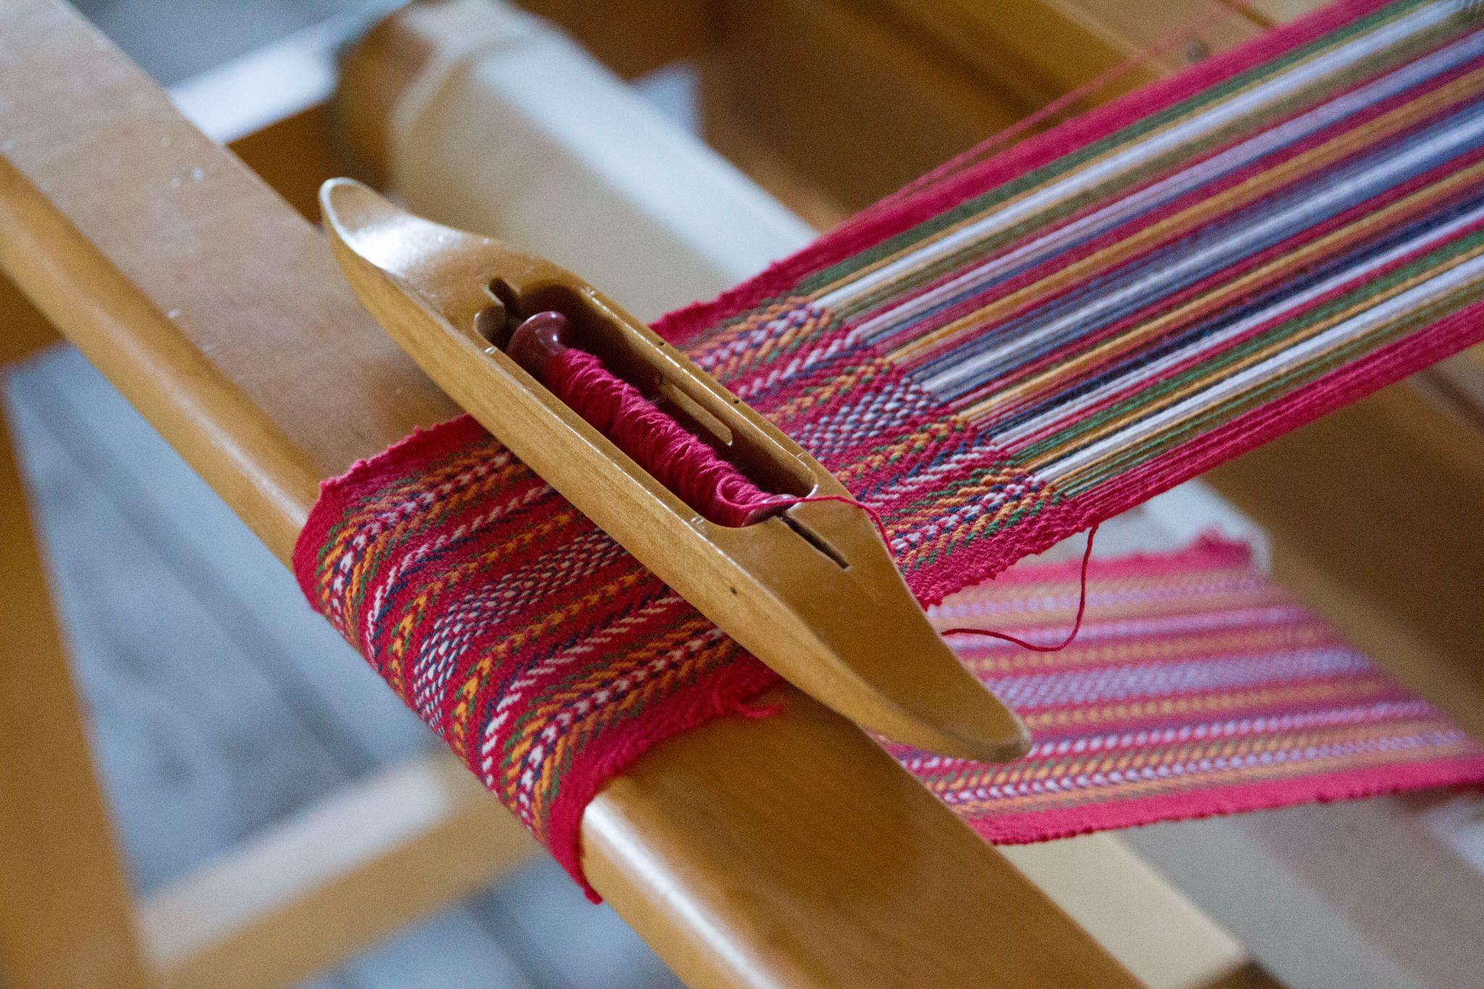  Image description: A photograph of a Metis sash in the process of being created. It is a close up photograph. Métis Crossing, “Métis Crossing’s Infinity Sash in 2018." Photograph credit to Rupertsland Institute, 2021.  Métis Sash  One of the most prominent symbols is the brightly coloured, woven sash. In the days of the voyageur, the sash was both a colourful and festive item of clothing and an important tool worn by the hardy tradesmen. Now it symbolizes pride and identity for Métis people. Manitoba and Saskatchewan have both created “The Order of the Sash” which is bestowed upon members of the Métis community who have made cultural, political or social contributions to their people. (Wood, 2022) | 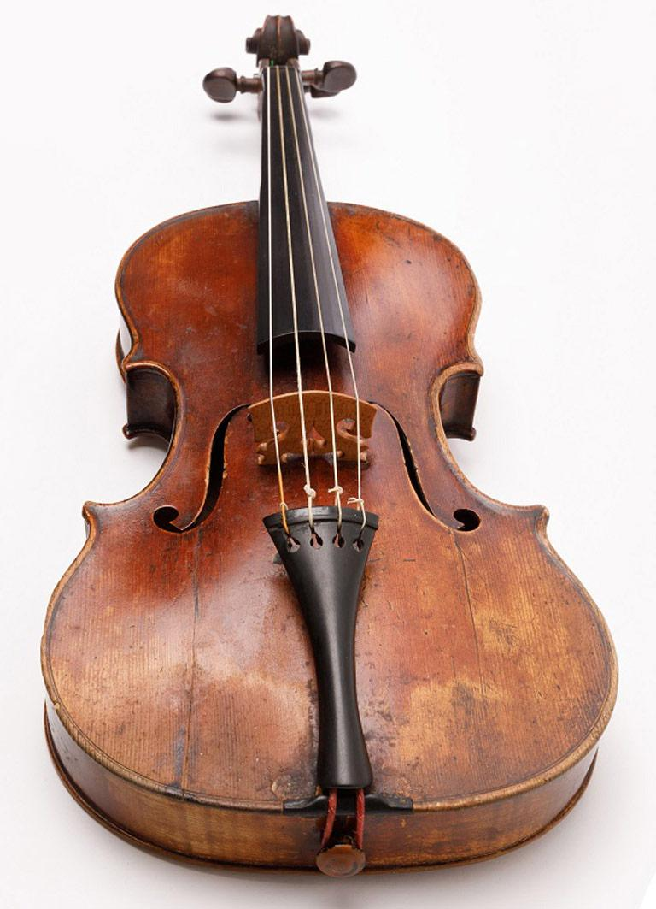  Image description: A photograph a historical Métis violin created sometime between 1795 and 1805. Photograph credit to the Manitoba Museum.  Fiddle Music/Jigging  It is the primary instrument for accompanying the Métis jig. The famous ‘Red River Jig’ has become the centrepiece of Métis music. This unique dance was developed by the Métis people, combining the intricate footwork of First Nations traditional dancing with the instruments and form of European music (Wood, 2022).
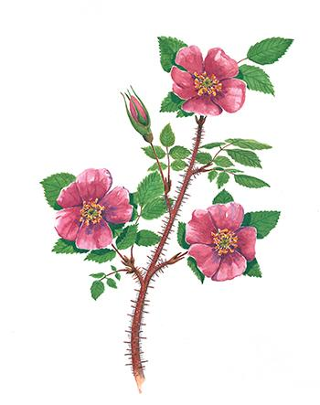  Image description: An illustrative drawing of the Wild Rose.  Wild Rose  Also known as the “prickly rose”, this flower has been the floral emblem for present-day Alberta since the 1930s. Known for its resilience and adaptability in the face of harsh winters, this iconic pink flower also grows scarlet berries which are a necessary food source for birds in the winter.  Learn more about Métis kinship with the Wild Rose from Métis knowledge holder, Krista Leddy, below.  “Wild Rose - The Story of Ourselves”  Visiting the Land, Rupertsland Institute | 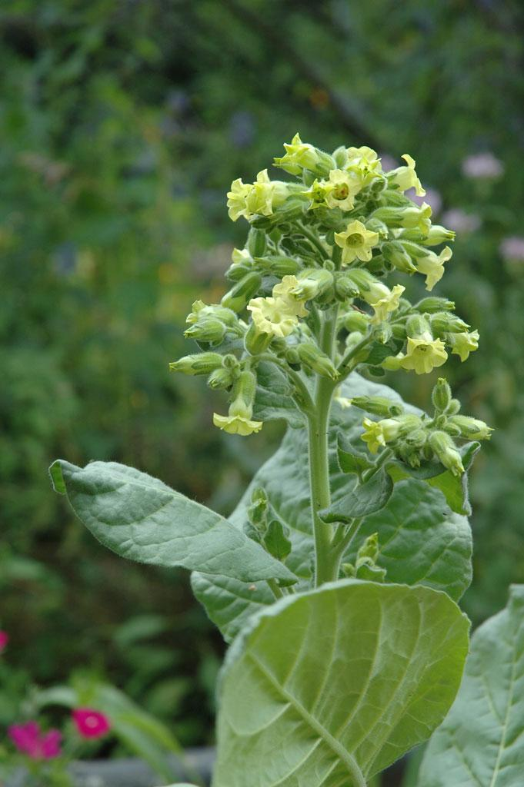  Image description: A photograph of a traditional tobacco plant. Copyright @ Prairie Moon Nursery  Tobacco  Tobacco is one of the four sacred medicines used in healing and cultural ceremonies. Tobacco can be offered for many reasons and many different contexts.  “It is appropriate when asking for assistance from an Indigenous elder, knowledge keeper or person to offer tobacco. When the person accepts the tobacco, they are agreeing to help in some way. Offering tobacco is a respectful way of asking for assistance and not as a symbol of gratitude after help is provided.  When someone accepts tobacco they are agreeing to listen openly and without judgement and to support you as best they can. It is appropriate to offer tobacco when asking for a song, an opening prayer, a teaching, Indigenous knowledge, or for advice. This should not replace remuneration or honoraria.”  Carleton University, “Tobacco Offering Protocol” Indigenous Gathering Site  Check out a link below to learn more, find educational resources, and learn about potential supports for Métis students in your classroom:  Métis Nation British Columbia  BC Métis Federation | 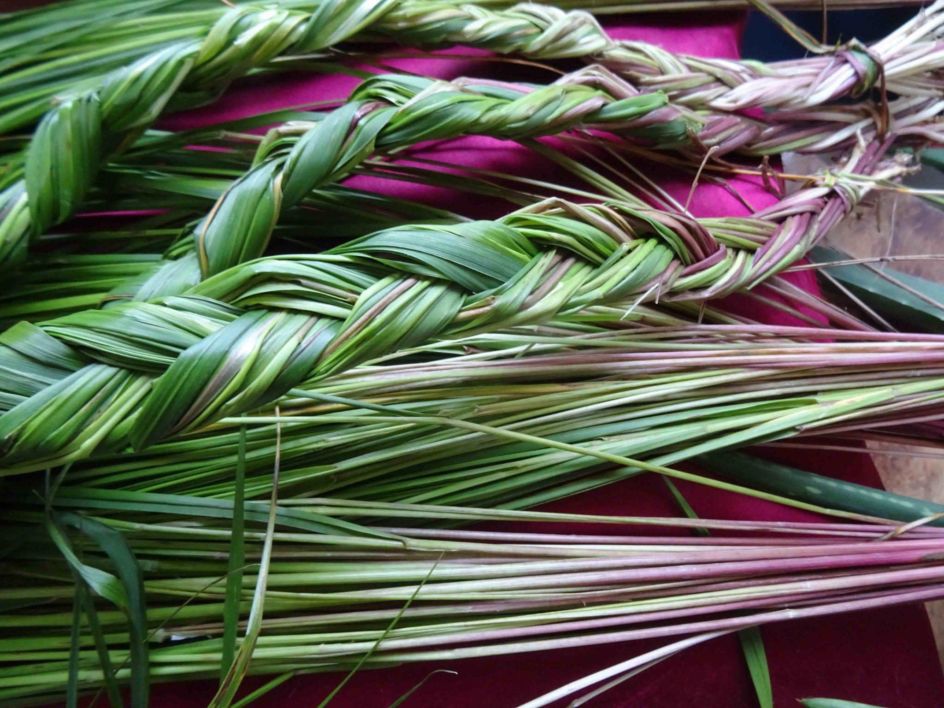  Braided sweetgrass from Bella Coola, British Columbia. (photo by Nancy J. Turner)  Sweetgrass  Sweetgrass is one of the four sacred medicines and can be used for smudging, as material for baskets, and other cultural ceremonies/traditions. Known for its sweet scent, sweetgrass can have different significance across different communities/cultures. The Mi’kmaq of present-day Eastern Canada make sweetgrass baskets while the Siksika (Blackfoot) have used sweetgrass to treat saddle sores on their horses.  “The Sweetgrass Teachings tell us that when we plait sweetgrass, we collect 21 strands. The first seven are the generations that preceded us: they walked the journey to bring us to where we stand today. The second seven strands represent the seven sacred teachings.”  -Florence Glanfield, PhD, MEd, BEd, BSc, University of Alberta  Even though there can be similarity in the use of the same sacred herbs, each culture has their own distinct stories, traditions, and connections to these plants. It reminds us not to reduce the Métis identity to mixedness and not to reduce Indigenous identity to a monolith stereotype.

The Fur Trade and The Métis

As discussed throughout this guide, educators and students are encouraged to think critically about whose voice is telling the story. Across Canadian curriculum and history texts, Métis history has often been reduced to a harmful narrative suggesting that people who are of European and First Nations mixed ancestry, once “rebelled”, and participated in the fur trade. There may be some information on Louis Riel, but the voices and perspectives of the Métis people on their own history is lacking. Without lived experience and authentic perspective in our history books and curriculum, there is a huge loss of understanding, knowledge, and nuance of Métis history, culture, and traditions. However as Métis voices begin to be uplifted in educational institutions and resources become available, it is clear there is a much deeper history and nationhood story to be told. Why were the Métis so essential to the fur trade?

Their traditional harvesting practices (which include hunting and trapping, which you will see in You used to call me Marie…) were key for survival, allowing the Métis to supply necessary resources during the fur trade. By following and moving with the cycles of the land, specifically along traplines, the Métis had a deeper understanding of the land and their community, and how it would provide for their needs. This allowed them to become leaders in transportation across land and water (Rupertsland Institute, 40), alongside providing essential support and services such as…

- Translation
- Working as guides
- Providing labour work and carpentry (could be building boats, canoes, or Red River Carts)
- Transporting goods and navigating community relationships at the trading posts.
- Farming and ranching
- Land navigation and so much more… (Rupertsland Institute, 40)

All of these supports and services weren't just necessary to the survival of Métis but also to the survival, and growth of the entire fur trade.

The Gabriel Dumont Institute of Native Studies and Applied Research in Saskatchewan works to promote the renewal and development Métis culture through research; materials development, collection, and distribution; and the design and delivery of Métis specific educational programming. Check out their timeline (ending in 2016, 5 years before the final scene in You used to call me Marie…) below…

TIMELINE HERE

The Languages of the Métis and You used to call me Marie…

Did you know two out of five British Columbians speak at least two languages? (Statistics Canada, 2022) The most common languages after English are Punjabi, Mandarin, Cantonese, and Tagalog. According to the First Peoples’ Cultural Council, there are 36 First Nations languages indigenous to British Columbia, which belong to 7 distinct language families and include 96 different dialects! (FPCC, 2025)

Language is how we communicate, express ourselves, and understand other people. Lots of people understand the feeling of frustration when they don’t understand or can’t express themselves as fully as they want. Sometimes we even say theatre can be a “language” in the way it helps folks express themselves and enhance!

It’s important though to understand that language can be the foundation of culture and community and the recognition of First Nations, Inuit, and Métis languages can be a powerful tool in reconciliation and revitalization. There are four languages traditionally spoken by the Métis in Alberta and throughout You used to call me Marie… (Rupertsland Institute, 17).

- Michif
- nehiyawewin (Cree)
- English
- French

Multilingualism (as discussed earlier) is deeply connected to Métis identity and culture. While the role of Métis in facilitating trade agreements is well-known and often studied in classrooms, lesser known are their contributions during WWII (Rupertsland Institute, 19). Despite ongoing racism, displacement, and other racially biased policies, it’s estimated over 4000 Indigenous men enlisted during WWII. Métis and other Cree-speaking soldiers would communicate messages to each other while going undetected by enemy lines as the languages weren’t Latin-based and not easily translated. These soldiers were called code-talkers (Rupertsland Institute, 19) and their significant contributions have only recently begun to come to light. Due to their invaluable work, the Western Allies were protected and their opposition were never able to crack the code (The Canadian Encyclopedia, 2022).

As many folks who speak multiple languages have experienced, it isn’t always possible or easy to translate something from one language to another. It doesn’t always convey the same meaning, feeling, or deeper understanding as it does within its original context. With Métis languages, it is essential and necessary to consult respected Métis community members, and trusted resources/sources.

Language can be deeply personal, complex, and tied to identity.
- What influences you linguistically? (e.g. family, media, friends, language classes, etc.)
- How does language help shape identity?
- Do you ever change or adjust how you speak in different environments?
  - Why or why not?
- What does communication and being understood mean to you?
- How is your way of communicating different from people in your community? (e.g. grandparents, parents, friends, teachers, classmates, team members, after-school program workers)

Have you often heard First Nations, Métis, or Inuit elders/community members speak first in their language and then translate into English terminology? This is a “common, and important, pedagogical approach that preserves Métis languages and lifeways.” (Rupertsland, 19).

Why do you think this is such a common approach?

What does hearing something in its original language offer?

What are the efforts in your local community to preserve and revitalize local Indigenous languages?
- What do you think preservation and revitalization could look like? Think locally, provincially, and even nationally!

Nehiyawewin is another name for the Cree language, which is part of the Algonquian linguistic group (Rupertsland Institute, 22) Cree languages are the largest Indigenous language group in Canada with approximately 85,000 speakers across ten distinct dialects, each with its own distinct linguistic qualities (Statistics Canada, 2021).
Nehiyawewin is an oral language and is similar to Michif in its origins as an oral language that was later made into a written language. The earliest written forms of Michif date back to the early 1900s (Papen, 2007).

The study of language contact is called contact linguistics and delves into the close interactions between two or more languages. This can also involve examining the historical, social, and locational context of languages, which can be how we see dialects, jargon, slang, etc. emerge! Michif is a contact language created as Cree and Obijiway women married settler men. These communities developed a new, distinct language that was “neither Indigenous nor European but distinctly Métis” (Rupertsland Institute, 24). As seen during You used to call me Marie…, language can also be used as a judgement of class, status, and identity as discussed between Marie and Louis.

MARIE
What?

LOUIS
Michif.

MARIE
What’s Michif?

LOUIS
It’s the halfbreed language. It’s what you use.

MARIE
No I don’t!

LOUIS
Marie…

MARIE
I speak Cree!

LOUIS
No you don’t.

MARIE
I speak Cree and French.

LOUIS
Okay.

He goes back to skinning his rabbits.

MARIE
How would YOU know I’m not speaking CREE?

-You used to call me Marie…, pg.22

The language we use is ever changing and evolving. Languages are constantly influencing each other and at times, replacing each other when one language has a higher social position. Canada has suppressed many Indigenous languages through colonial policies like The Indian Act, residential schools, and other assimilation tactics. This has led to language endangerment and extinction which requires necessary efforts (learn more about these efforts from the Language Revitalization Fact Sheet from the First People’s Cultural Council) towards revitalization and preservation. Michif has its own intrinsic value as a unique language. Michif is not a “hybrid language” or “mixed language,” but rather should be celebrated for its distinctness and representation of Métis cultural identity (Rupertsland Institute, 2021).

What institutions decide what languages are “lesser”?

Historically some languages are given more institutional rights than others.
- Can you think of other examples of when language rights have been taken away from other communities?
- Why are language rights important?

Truth and Reconciliation Commission's Calls to Actions (2015)

“ 13. We call upon the federal government to acknowledge that Aboriginal rights include Aboriginal language rights.”

“Indigenous Languages Act” received Royal assent on June 21, 2019. Bill C-91 states: “The Government of Canada recognizes that the rights of Indigenous peoples recognized and affirmed by section 35 of the Constitution Act, 1982 include rights related to Indigenous languages.

The Scrip System and Impacts for Métis Communities

Following generations of political advocacy in the forms of both petitions and battles, the newly forming Government of Canada finally recognized their responsibility to set lands aside in their colonial plans for the Métis Nation. Within the Manitoba Act, 1.4 million acres of land for the children of Métis families, however, once the lands granted were exhausted, the government established the Scrip System.

The Scrip System was said to be intended to ensure that Métis families would have access to land. Despite the collective advocacy of the Métis Nation for decades prior, the Scrip System addressed Métis as individuals, rather than the collective, across what was then known as the North-West Territories.

Important to Note: Métis were not formally included in the Treaty system. Treaties were established between Canada and various First Nations as collectives. Métis were not recognized as a collective until recently.

The two types of scrip created for this process were land scrip and money scrip. The convoluted process to redeem scrip allowed for a wide range of issues, including fraudulent impersonation of Métis families in receiving the entitled land.
“Where studies have been done, between 90-98% of these coupons end up in the hands of the white land speculators.” - Zachary Davis (YouTube)
Losing access to their lands not only resulted in being dispossessed of their physical home, it also meant losing access to medicines and other community knowledge and care systems. Displaced Métis families were pushed to living on lands set aside for road development, resulting in the name “Road Allowance People.” Canadian leadership at the time pushed through an amendment to the criminal code effectively making it impossible to prosecute the fraud. The impacts of one of Canada’s greatest land swindles continues to impact Métis families today.
Learn more here:
Scrip | Indigenous Peoples Atlas of Canada
Homeland History - Rupertsland Institute
Métis Governance in Alberta - 1900s to Today
After a period of hiding in plain sight, Métis communities began to gather again in both informal and formal settings across the Homeland. In Alberta, Métis gathering under the title L' Association des Métis d'Alberta et les Territories du Nord-Ouest in 1928, and later the name Métis Association of Alberta, to petition for recognition of rights of Métis title to lands and resources that were not surrendered through scrip (nor through any process).
Learn more about the history of Métis Nation Governance here: Rupertsland Institute, Métis Nation Governance
In Alberta, this advocacy led to a unique victory for Métis, the establishment of the Metis Settlements in 1940. As of 1990, these 8 tracts of land have been fully governed by the Metis Settlements General Council.
Learn more about the Metis Settlements of Alberta here
Approximately 5% of Métis people in Alberta access the Metis Settlements, while most continue to gather and be represented by the newly emerging Otipemisiwak Métis Government.
Learn more about the Otipemisiwak Métis Government here
Across Canada, there are multiple Métis Nations who represent historically connected Métis communities at all levels of Government. In BC, Métis are supported by two representative bodies: the Métis Nation British Columbia, and the BC Métis Federation.
Check out a link below to learn more, find educational resources, and learn about potential supports for Métis students in your classroom:
Métis Nation British Columbia
BC Métis Federation

Glossary:
Half-Breed: A name reclaimed for use by some Métis individuals that originates in a racially based, derogatory reference describing their Indigenous and European ancestries. While it is important to honor how individuals reference their identity internally to their community, educators are encouraged to use the term Métis when describing people of the Métis Nation.
Michif: The name of an Indigenous language that emerged from historical Métis communities that draws, in varying degrees by dialect, from the French and Cree languages spoken by ancestors of Métis. Sometimes, Métis call themselves by the name of their language, for example, “I am a Michif.”
Red River Cart: A wagon-esque mode of transportation made with only materials from the plains and geographical area around. This cart would then be attached to an animal (horses, oxen, and mules).
Traplines: The route in which the traps would be set (Rupertsland Institute, 22) whereas trapping is the action of harvesting furs from caught animals along the trapline.

Cree-Michif | Pronunciation Support for English Speakers | English Translation
iskwewo | isk-wey-yo  Click to Hear | woman
napew | nah-pay-yo  Click to Hear | man
mistatim | mih-stah-tim  Click to Hear | horse
Ke Sa Ge Tin  (also spelled kisâkihitin) | key-sah-gih-tin  Click to Hear | I love you

Brief Synopsis
Music plays and ponies dance as the epic story of Marie Callihoo and generations of Alberta’s Métis women unfurls through time. Follow Marie, Iskwewo, Napew, and Mistatim (“horse” in Michif) in intertwined celebrations of love and resilience as the Métis Nation emerges across the plains. Robust in scope yet intimate, You used to call me Marie…explores the fur trade and political uprisings in the 1930s to the present through era-spanning dance and live music, from Métis fiddle tunes to contemporary country.

Detailed Synopsis
The play opens with the entire ensemble coming together to tell the story of the Star people and the story of Creation. Through movement and music, they explain the story of Iskwewo, Napem, and Mistatim the horse. Iskwewo tells Mistatim the story of a dream she had where she falls from the star world into a big pool of water to build the land, when she is startled by Napew. He offers her a knife as she is struggling to pull a piece of sweetgrass and tobacco up from the ground. They speak, fall in love, and Napew asks her to marry him. They dance and Mistatim watches them when suddenly the ground cracks beneath them. The garden falls to the ground and for a moment they are suspended in time. Iskwewo tells Napew to come find her. He promises he will and she falls into the body of water, Mistatim jumping behind her. The ground closes and Napew begins to dig through the now closed earth frantically.

Iskwewo, now pregnant with their child, begins to build the plains, rivers, trees, and berries. In her sweetgrass and tobacco garden, while Napew still digs, Iskwewo uses a knife given to her by Napew to cut her stomach open to let her daughter out. Just before she dies, she takes out her sweetgrass and tobacco heart from Napew and plants it in the garden. She dies while he is still digging. The story ends and the Star people fall.

Marie Rose, Achakosak, and Jean Louis

It is the 1700s, off the North Saskatchewan river. InRouse and Jean Louis meet and speak in the garden. They discuss InRouse’s horse when suddenly they are suspended in time. Once again, they are Iskawewo and Napew for a brief moment, before they are pulled back to their present moment. InRouse asks Jean Louis to come back and find her. A star descends between them and in nine months, Jean Louis returns to a pregnant InRouse, confessing his love, as the play travels into the next story.

Marie, Star, and Louis

French settlers have arrived and the land has begun to look trampled, bloody, and covered in mud. It is the early 1800’s and Marie is 15. She is waiting for the Suntraveller to arrive and speaking to the audience about her hopes and dreams for him to bring prosperity back to her starving home. Louis rides into her village and Marie greets him. Louis remarks he hasn’t met many of their men yet and Marie tells him not many made it through the harsh winter. The pair bicker when suddenly they are suspended in time. Once again, they are Iskawewo and Napew for a brief moment, before they are pulled back to their present moment. Time passes and although the pair have a rocky start, they eventually fall in love. Louis gives Marie a horse named Star and the trio gallop across the plains. Suddenly they hear a buffalo which they end up shooting with Marie getting dangerously close (in Louis’ perspective) to the buffalo before ending her pain. Marie carves out the buffalo’s heart and both her and Louis take a bite of it. She also tells him she will be bringing the heart back to her garden to bury there to help the tobacco grow. Marie asks Louis to marry her and they are wed.

Time passes and it is winter. Marie is 6 months pregnant and Louis runs on stage. He tells her they need to leave and move into the fort immediately as some English men have begun to attack and take daughters and women. Once they have moved into the fort, Marie is desperate to leave and give birth in her garden which she eventually does.

Time passes and it is spring. Marie is nine months pregnant again and returning from hunting. Louis is furious as women have continued to keep disappearing, even right outside the fort. Marie tells Louis her village is abandoned but still, their sweetgrass and tobacco grows. Louis tells Marie they need to sell Star and she refuses.

Time passes and it is autumn. Marie has lost her child and the couple are now burying her. It is revealed Marie has lost a few pregnancies. Louis tells his child he loves them, before placing them in the grave. Suddenly they are attacked and Marie and Louis are forced to defend themselves against attacking forces. Their story ends as music plays, leading the ensemble into the next scene.

Marie, Rose, and Louis
It is summer, 1885. Another Marie is seven months pregnant and her Louis is preparing to leave, to fight with Louis Riel and the other Métis men from across the prairies and plains. Marie promises to wait for him and Louis tells her he loves her. Suddenly they are suspended in time. Once again, they are Iskawewo and Napew for a brief moment, before they are pulled back to their present moment. Battle sounds and fiddle music play and Rose, their horse, returns from battle without Louis. Marie meets the riderless horse with their newborn child and the entire company begins to sing as the set transitions into the next story.
Marie, Mistatim, and Louis
It is the end of autumn, sometime in the 1920s. Twelve year old Marie and fourteen year old Louis are at a residential school. Louis waits outside for Marie and it is revealed she is three months pregnant. Marie reveals the nuns know she’s pregnant and fears for the safety of the baby, knowing what has happened to other girls before. Louis suggests they run away, and although frightened, Marie accepts and the pair escape. As they run, it begins to snow and the pair find a garden to rest and eat. They find some berries and while unsure of their safety, they eat them. As the two begin to get sicker, being poisoned by the berries, they discuss their future daughter’s name. Marie sees a glowing white horse as she gets more ill. Louis, making a ring of sweetgrass and tobacco, asks Marie to marry him. She accepts and in the snowy garden, they privately marry each other. Suddenly they are suspended in time. Once again, they are Iskawewo and Napew for a brief moment, before they are pulled back to their present moment. As Marie dies, Louis is also able to see Mistatim and remarks that he knows “they come from the stars, and that’s where [they] go back to when their lives are over”. Louis also dies and the audience is sung into the next story.
Alberta Rose, Mistatim, and Johnny
It is summer, sometime in the 1930s during the Great Depression. Treaty 6 lands are full of abandoned farms and starving people. Johnny is teaching Rose how to read and write and secretly begins to teach her English, French, and Cree. They talk about the stories of generations before them before Johnny shares some dried gopher with Rose. She tells him that she hopes with the scripts, they won’t have to hunt gophers anymore. She tells him that once the drought is over, she is going to make the garden full again.
Johnny writes “Will you marry me?” on the ground and helps Rose sound it out until she realizes. Making a ring out of a piece of tobacco sticking up from the ground, the two are wed. Amidst the dancing and celebration, a star descends between Rose and Johnny, revealing Rose is pregnant. Unfortunately she miscarries and her and Johnny are suspended in time. Once again, they are Iskawewo and Napew for a brief moment, before they are pulled back to their present moment.
Time passes and Rose is pregnant again. Johnny, overjoyed, reveals his plan to leave home and gather with the other Métis men from across the plains to fight for a better future, past the scrip system. Rose asks him to stay, as she is worried about miscarrying again. Johnny promises she will be fine and leaves, swearing to be back in a week.
One week and three days later, Johnny returns and the pair reunite. Rose tells him she had a dream about their child where she swallowed a star and the star’s name was Marie. Johnny points out “we already have so many Maries” but Rose insists, promising “that’s what she wants to be called.”
Time continues to pass and the couple live their lives simultaneously apart. Johnny continues to petition the Albertan government for Métis rights while Rose runs their community, keeping people alive through the drought. Johnny continues to advocate for land grants while Rose continues to have miscarriages.
Years pass and Johnny returns home. It is revealed Rose has lost ten babies, all girls. She has a heart attack and dies in his arms. For the rest of his life, Johnny continues fighting. Music plays and the scene transitions.
Marie, Star, and John
It is spring, 1995. Marie enters the apartment building, wearing jogging gear. She is attempting to open the door to what she believes is her apartment but her key won’t turn in the knob. John, who actually lives in the apartment, greets her. It is awkwardly revealed Marie got lost using the back door entrance and thought it was her apartment. John offers her directions and Marie walks away, calling her sister about the “most gorgeous man she has ever seen.”
Later, at Marie’s apartment, John knocks on the door and invites her to join him at his family’s place the next day to see their horses. The next day, they are at his family property in the garden when the pair are suspended in time. They are Iskawewo and Napew for a brief moment, before they are pulled back to their present moment. The pair get to know each other and a horse named Star approaches Marie. Marie pets Star and the two seem to instantly bond.
Time passes and Marie is nine months pregnant, standing in the garden. Star closely follows her while John checks the traps. He remarks how he won’t need to trap or hunt anymore as he has a “good job” now. Marie asks him if he will ever show their daughter a trapline if she asks. John responds that he doubts their daughter will ever ask.
Alberta Marie Rose, Star, and John
Time passes and music plays as the tobacco and sweetgrass weave together and begin to grow. It is now autumn, 2021. Star, an older and weaker horse enters. She is joined by Rose, who has come home after two years away. Alberta Rose greets Star affectionately and before picking some tobacco and sweetgrass to light, then pray.
John enters, frightening Rose. He begins to tease her and asks why she finally came home. Rose admits she came back to say goodbye to Star, who needs to be put down. John explains he knew and that her dad told him. The pair bicker over Rose’s new name, identity, and life in Nashville when Rose tells John she should be the one to shoot Star, even though she is reluctant to let her go.
John asks Rose why she doesn’t come home very often and she admits it’s because it’s too hard to leave. He asks her if leaving was worth it and Rose reveals she doesn’t know yet. The pair discuss Rose’s music which has been inspired by the previous generations, women, and their stories seen onstage over the story. John offers Rose his jacket from the cold when she notices the ring on his finger. Rose realizes John is now engaged and the pair share a moment while John points out that “she left”.
Star, very sick and in pain, begins gasping for breath and Rose asks John to give her the gun. Reluctantly, he does, however Rose is overcome by emotion and struggles to shoot her childhood horse. John approaches her and offers to have them pull the trigger together. The pair counts down and when Rose pulls the trigger, they are suspended in time. Once again, they are Iskawewo and Napew for a brief moment.
ISKAWEWO: She says “Napew, You found me.”
NAPEW: He says “I told you I would.”
END OF PLAY

About the Playwright
Tai Amy Grauman (MFA) is Métis Cree from Ardrossan Alberta. She is a Callihoo and Beauregard from St. Paul des Métis from her paternal lineage and a Turner from Winter Saskatchewan from her maternal lineage. Tai is a writer, actor, director and producer. She has been involved in over 20 theatre productions across the country. Her work is all about Métis women’s love stories. Her play You Used to Call Me Marie… has been produced all over Canada and toured Métis communities across Alberta and Saskatchewan. Her show Where Have All the Buffalo Gone is also touring across Alberta, Saskatchewan, and Manitoba. Tai’s adaptation of R and J, Rose and James: A Métis Scottish Love Story is also travelling to Scotland this year.

Playwright’s Notes
You Used to Call Me Marie… has in fact changed my life. She became a “Métis caravan” tour across the prairies in 2022. She became my Master’s thesis in 2023. She became my first professional production, which toured to the National Arts Centre. And finally, she had me elected as the first Provincial Women’s Representative at the Métis Nation of Alberta in 2023. Marie was a reminder to me, that Métis women’s stories are not erased from history—they just haven’t been found yet.
So, for tonight’s purposes, Marie is a story on a stage. She is history embodied, and a reminder that women’s stories are in fact everywhere, as are our ancestors. I hope she reminds you of the women you come from, who they were, and what they did. And here is a reminder that you are loved by your ancestors, even if you haven’t found them yet.
I hope the magical Métis ponies visit you in your dreams.
-Tai Amy Grauman
Setting:
Across the Métis Homelands.
Time Periods (in order of appearance)
Creation
1700’s (very beginning of colonization)
1840
1885
1920’s
1930’s
1995
Present day

Characters:

Iskwewo: A Métis woman in her 20s-30s. She is gentle, kind, and radiates love. She has loved Napew her whole life.

Napew: A Métis man in his 20s-30s. He is gentle, soft spoken, and fiercely protective. He has loved Iskwewo his whole life.
Mistatim: A Mare, sometimes a spirit which can only be seen by Iskwewo, sometimes she is a real horse. When she is a spirit, she is completely white.
InRouse Farouge: A 18 year old woman. She is Plains Cree and speaks Cree. InRouse is a trapper and provides for her village by selling pelts to French Voyageurs.
Jean Louis: A voyageur in his 30s. His father was French and his mother was woodlands Cree. Jean Louis speaks Michif and French and is employed by the Northwest Post.
Achakosak: A bush pony who is strong but not very fast.
Marie Rose LaSeganais Callihoo: A swampy/ plains Cree and French girl who first appears at age 15 and later at age 30. She is blunt and has a big mouth and even bigger heart.
Louis Kwarakwante Callihoo: A Mohawk boy who begins the story at 25 and appears again later, at 40. He grew up in Kanawake and is a fighter, survivor, and leader.
Star: A large strong horse, prepared to run, pull, and carry. She has a star shaped mark on her forelock.
Marie: Young and in love. She grew up with Louis and has always loved him. All she wants is to be a wife and mother.
Louis: Young and in love. He is kind and protective. He has loved Marie his whole life and would do anything for her.
Rose: A bush pony. She is mangy and stout but wide and strong.
Marie: She is 12. Marie was taken from home when she was 5 but goes back for the summer. She grew up with Louis and has loved him her whole life.
Louis: He is 14. Louis was taken from home when he was 7 but goes back for the summer. He has loved and protected Marie his whole life.
Mistatim: A two month old filly. She is completely white with grey patches on her eye.
Alberta Rose: When her story starts, she is 15. Alberta Rose has loved Johnny since she was 5 years old. She loves to sing and write songs. All she wants is to be a mother.
Johnny: Tall, dark, and handsome, every Cree girl’s dream. When his story starts, he is 17. He has loved Alberta his whole life.
Mistatim: A large completely white horse. She is protective but incredibly gentle.
Marie: She is 25 and the first woman in her family to go to post-secondary school. Marie’s pregnancy is an accident and she falls in love with John because of the way he protects and loves her throughout her pregnancy.
John: He is 31 and sure of himself. He has given up his life as a backwoods Métis man for his family and life in the city.
Star: A pretty, young quarter horse. Star is moody, doesn’t like many people, and tends to bite a lot of men. She loves Marie.
Alberta Marie Rose: A 25 year old Métis woman, who grew up on a farm before eventually moving to Nashville to pursue music. She has loved John her whole life.
John: A 25 year old Métis man, married with a house and a dog. He has loved Alberta Marie Rose his whole life, but he knew she was going to leave and didn’t want to be the one who stopped her.
Star: A big, beautiful quarter horse. Rose is her favourite person.

Pre-Show Discussion Questions:
- What do you know about Métis culture and history?
  - What do you know about Canadian history across the provinces from the 1700s to present day?
- What do you know about puppetry? Have you ever seen a live show featuring puppets?
- What pieces of media (TV shows, movies, and theatre!) are written by Indigenous artists or prominently feature Indigenous actors and creatives? How often are these specifically Métis stories?
  - How often do you see Indigenous love stories in the media? How are these love stories portrayed?
- What does the idea of a “love story” mean to you?
- How often do you pay attention to the sound or music in the media you watch?

Post Show Discussion Questions:
- Did you connect with any specific characters and their journey throughout the play?
  - Why?
- What does fate mean to you?
- How does the music of the play enhance or change the narrative?
  - Have you heard of jigging or Métis music before this play?
- How have women’s roles changed throughout history?
  - How often is the female matriarch’s story the focus and/or as relevant as her male counterpart?
- What does revitalization and preservation mean to you? Why is this important for the Métis peoples?
  - How can theatre and the arts support reconciliation, revitalization, and preservation?
- Why do you think the playwright chose to frame the story through multiple love stories?
  - What does this add to storytelling?
  - Has your idea of a love story changed at all? Why or why not?

Post Show Activities:
Literacy Extension Activities: Read and Respond
The arts and literature provide opportunities to gain insight into the perspectives and experiences of different people, communities, time periods, and places. We’ve curated a list of books and plays below, written by Indigenous playwrights and/or authors. Have suggestions or want to let us know about a new, local play? Email our Education & Community Engagement Coordinator, Mikenzie Page, at mpage@artsclub.com.

Looking to support a local? Massy Books is 100% Indigenous owned and operated and a member of the Stó:lō Business Association. Massy Books is a funky retail destination in Vancouver’s Chinatown neighbourhood. It’s a place people feel welcome to explore and ask questions, and to browse in ways that give pause to the day!

Want to find other Indigenous owned and operated businesses? Check out the Stó:lō Business Association directory!

Plays
Women of the Fur Trade  by  Frances Koncan  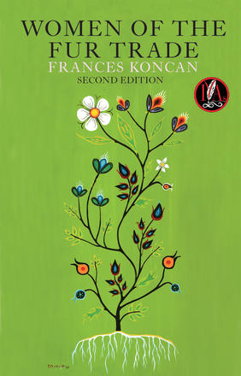  Recommended grades 10+  In eighteen hundred and something something, somewhere upon the banks of a Reddish River in Treaty One Territory, three very different women with a preference for twenty-first century slang sit in a fort sharing their views on life, love, and the hot nerd Louis Riel.  Marie-Angelique, a Metis Taurus, is determined to woo Louis (a Metis Libra)—who will be arriving soon—by sending him boldly flirtatious letters. Eugenia, an Ojibwe Sagittarius, brings news of rebellion back to the fort after trading, but isn’t impressed by Louis’s true mediocre nature. And Cecilia, a pregnant British Virgo, is anxiously waiting on her husband’s return from an expedition, but can’t resist pining over the heartthrob Thomas Scott (Irish Capricorn), who is actually the one secretly responding to Marie-Angelique’s letters. This will all go smoothly, right?  WHY WE LOVE IT: Clever, timely, and funny! This lively, historical satire focuses on the women's stories and power, through the time of the rapidly changing world of the Canadian fur trade. Gen Z will love the language, astrological references, and quick wit of the piece!  LEARN MORE | First Métis Man of Odesa  by  Matthew MacKenzie & Mariya Khomutova  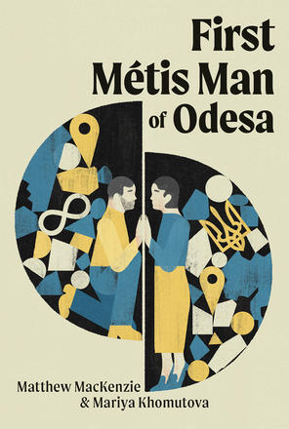  Recommended grades 10+  Matt and Masha hit it off during a theatre research trip in Ukraine. At first they seem like opposites: Masha loves the sea, Matt loves mountains. Masha is Ukrainian, Matt is Métis. But the passionate spark ignited between them cannot be denied. Despite the improbabilities of a cross-continental relationship, a few fairy-tale visits overseas solidifies their bond. But when it seems distance could be the only obstacle in their path, a series of extreme circumstances put their commitment to the ultimate test.  Based on actual events, First Métis Man of Odesa is the extraordinary true story of a whirlwind romance that withstands a global pandemic, a surprise pregnancy, and the Russian invasion of Ukraine. Transcending the usual tropes of documentary theatre, this heartwarming how-we-got-together tale turns art of the here and now into a catalyst for action and a hopeful ode for a better future.  WHY WE LOVE IT: Relevant, sincere, and engaging! This love story is described as a “star-crossed,windswept,war-torn romcom”and will tug at your classroom’s heartstrings.  LEARN MORE
Frozen River (nîkwatin sîpiy)  by  Michaela Washburn, Joelle Peters, and Carrie Costello  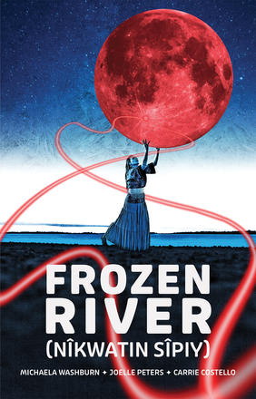  Recommended Grade 2 – Grade 6  Exploring reconciliation and connection through a story that spans seven generations, Frozen River (nîkwatin sîpiy) tells the story of two eleven-year-olds through the eyes of Grandmother Moon. Eilidh and Wâpam are born under the same blood moon, but Eilidh was born in Scotland and Wâpam in Kihci-Manito kâ ayapit, now known as Manitoba. After sailing across the ocean in hopes of a more prosperous life, Eilidh meets Wâpam deep in the forest, and the two become instant friends. Coming from vastly different worlds, Eilidh and Wâpam decide to teach each other about their ways of life. But when a sacred promise between them is broken, the relationship among cultures becomes jeopardized for generations to come.  Frozen River (nîkwatin sîpiy) shows audiences that an openness to learn from those who have protected and honoured the waterways for centuries can lead to healing and reconciliation.  WHY WE LOVE IT: Great connections and easily accessible for youth! A great option for reading buddy programs as it offers discussion on important issues for older grades, while still being digestible for littler friends!  LEARN MORE | Where Have All the Buffalo Gone?  by  Tai Amy Grauman  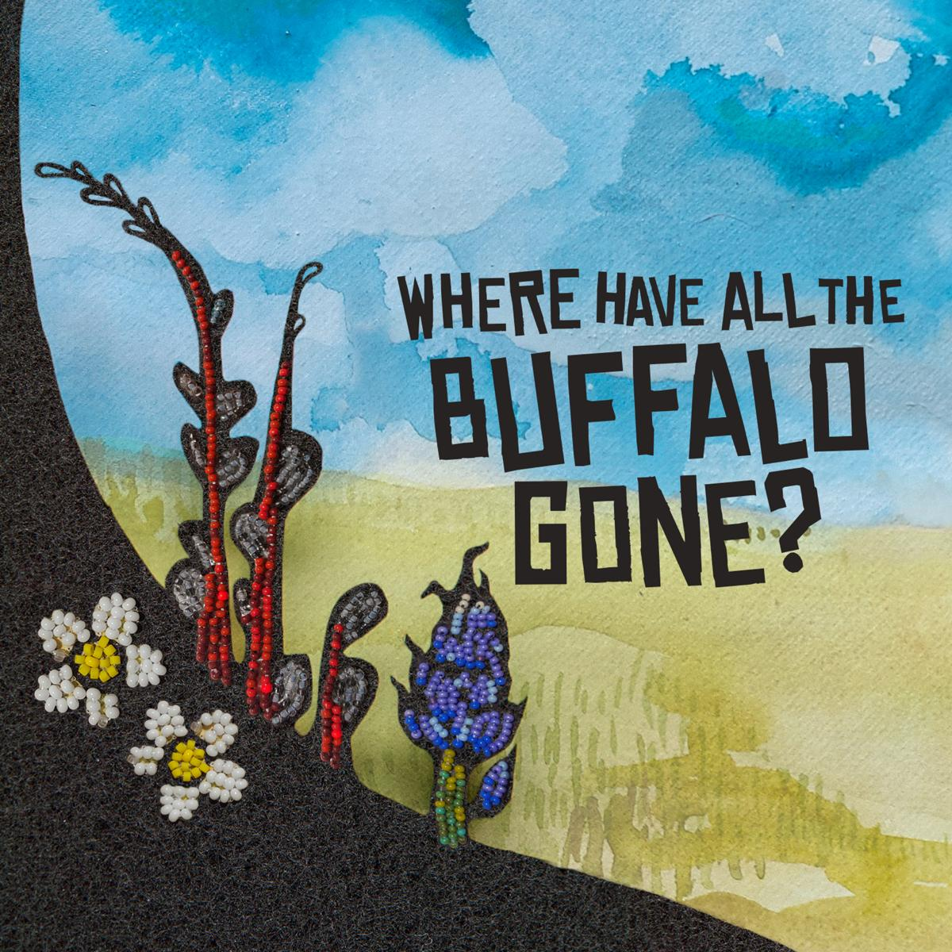  Artwork (above) by Carly Nabess, Beaded Huckleberry and Ion Brand Design  Recommended Grade 4 – Grade 12  A Métis love-story that transcends time to safeguard history.  Where Have All The Buffalo Gone? is a love story through the ages. Two star people and a Buffalo, fall to earth and continue to reconnect throughout history. Our play covers seven different periods of Métis history. We bear witness to the emergence of the Métis nations across the plains, the robust colonization that arises from the fur trade, the disappearance of the buffalo and the political uprising of the Métis Association of Alberta. The story begins during creation amongst the stars and ends in the present day.  Where Have All The Buffalo Gone? specifically shares scenarios from the Callihoo family’s stories, incorporating fiddle music, jigging and a life-like buffalo puppet. Inspired by historical events of the Métis people of Canada, this original play for young audiences explores the loves, the losses and the fight of Treaty 6’s Métis people – and their love and kinship to the buffalo.  WHY WE LOVE IT: Written by the same playwright, Tai Amy Grauman, Where Have All The Buffalo Gone? is a shorter, more accessible Métis love story for our younger friends. With a runtime of 50 mins, this piece is able to explore deeper themes and concepts similar to You Used to Call Me Marie… but more easily digestible for younger audiences!  LEARN MORE

Books

We Sang You Home  by  Richard Van Camp  &  illustrated by  Julie Flett  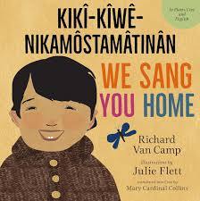  Recommended for pre-school ages  A celebration of the bond between parent and child, this is the perfect song to share with your little ones.  In this sweet and lyrical picture book from the creators of the bestselling Little You, gentle rhythmic text captures the wonder new parents feel as they welcome baby into the world.  THEMES: Family, belonging, babies & newborns  LEARN MORE | Shi-shi-etko  by  Nicola L. Campbell  &  illustrated by  Kim LaFave  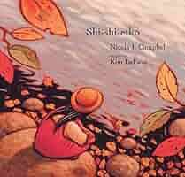  Recommended Grade 1 – Grade 10  In just four days young Shi-shi-etko will have to leave her family and all that she knows to attend residential school.  She spends her last days at home treasuring the beauty of her world – the dancing sunlight, the tall grass, each shiny rock, the tadpoles in the creek, her grandfather’s paddle song. Her mother, father, and grandmother, each in turn, share valuable teachings that they want her to remember. And so Shi-shi-etko carefully gathers her memories for safekeeping.  Richly hued illustrations complement this gently moving and poetic account of a child who finds solace all around her, even though she is on the verge of a great loss.  THEMES: The importance of family, community, and culture. Resilience, memory, and oral tradition.  LEARN MORE | Wôpanâak Seasons: Seeqan, Neepun, Keepun, Pup8n  by  Carrie Anne Vanderhoop  &  illustrated by  Mangeshig Pawis-Steckley  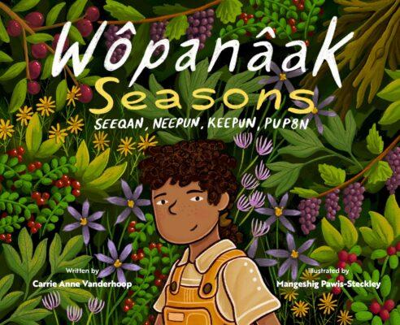  Recommended Grade 1– Grade 6  In Wôpanâak Seasons: Seeqan, Neepun, Keepun, Pup8n, a young Wampanoag child takes readers on a seasonal journey through Aquinnah, on Neope, known as Martha’s Vineyard. Spring brings the return of wildlife; summer brings beach adventures and clambakes; fall is for harvesting and making jams; and winter features cozy gatherings and heartfelt traditions. Each season showcases the rich cultural heritage of the Wampanoag people. With striking illustrations and lyrical prose, this book is about an appreciation of the land and the joy of coming together with family and community all year round.  THEMES: The cyclical nature of seasons, life, and traditions. Cultural heritage. The importance between land and community.  LEARN MORE
The Suntraveller: The Story of the Callihoos in Alberta  by  Elizabeth Macpherson  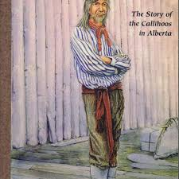  Recommended Grade 8 – Grade 12  The story of the Callihoo family in Alberta from the early 1800s to present day. This book focuses on the humanity behind the historical artifacts found in museums.  THEMES: Family history. Alberta history – from the fur trade to the signing of treaties. Based on historical artifacts.  LEARN MORE | The Marrow Thieves  by  Cherie Dimaline    Recommended Grade 9+  Humanity has nearly destroyed its world through global warming, but now an even greater evil lurks. The Indigenous people of North America are being hunted and harvested for their bone marrow, which carries the key to recovering something the rest of the population has lost: the ability to dream. In this dark world, Frenchie and his companions struggle to survive as they make their way up north to the old lands. For now, survival means staying hidden - but what they don't know is that one of them holds the secret to defeating the marrow thieves.  THEMES: Coming of age, climate change, resilience, identity, resistance, and reclamation.  LEARN MORE | A Really Good Brown Girl  by  Marilyn Dumont  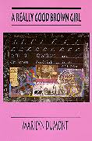  Recommended for Grade 10+  In this collection of poetry, Marilyn Dumont explores what it means to grow up with Métis heritage in the face of institutional and cultural oppression.  Contains mature themes including depictions of racial discrimination, colonization, and sexual violence.  TO ASK STUDENTS:  - Why does it matter who’s voice is telling a story, specifically when these stories involve personal history?  - Why does learning from authentic texts matter?  THEMES: Poetry, memory, identity, the struggle against colonial oppression, expectations, and structures. Intersectional feminism. Connection to land and body.  LEARN MORE

Activity #1: One Location, Multiple Scenes
Suggested for Drama, English Language Arts, and Social Studies classes
Relationality: Relational means indicating relation(s) or relationship; concerning the way in which two or more people or things are connected. It would follow, therefore, that relationality means ‘being related to’; ‘in a relationship’; ‘connectedness. | Goal: Expand students’ understanding of place, community, and consideration of multiple perspectives.

Instructions: You used to call me Marie… follows multiple iterations of Iskwewo and Napew as they move throughout history across the Metis Homelands. The story traverses hundreds of years with ease in a single location; a theatre! In this activity, we invite students in small groups to write (and perform!) their own story through history.

Part 1: Research

- Participants can work in groups of 3-4, depending on your class sizes. Have students pick a simple story that can be condensed to ten lines of text (e.g. the myth of Orpheus & Persephone, Cinderella, etc.)

NOTE: We encourage educators to allow their students to bring in their own cultural myths while respecting that some youth may not want to bring that aspect of themselves into the classroom. We trust that you know your students and their boundaries. We offer that this can be a great time to discuss…
- Why authentic storytelling matters.
- Cultural appropriation versus appreciation.
- Care and community in the classroom!

We also encourage folks (if they want!) to bring in additional languages, just like the characters in the play!

- Once students have chosen a story to adapt, set out the following guidelines…
  - The story must take place in a single location (e.g one country, county, town, or city.)
  - There must be three separate scenes set in three distinct time periods.
  - Each scene needs three lines of dialogue that must be repeated during each scene.
  - Accurate historical information/reasoning for their choices.
  - A single source material (although we encourage creative interpretations!)

EXAMPLE:

SOURCE INSPIRATION: Romeo & Juliet
LOCATION: The West Coast
THEME: Exploring the history of marriage rights in Canada and the United States throughout history using Shakespare’s Romeo & Juliet (with many creative liberties taken!)

SCENE 1: Takes place during the Vancouver race riots of 1907. The setting is in Chinatown with the star-crossed lovers being a interracial couple during this time.

SCENE 2: Takes place in Seattle, Washington in the 1970s. A interracial couple has travelled from California to get married.

Interracial couples from California and other states would often travel to Vancouver, Washington, on the Oregon border, to marry and then return to their states of residence, which were legally required to recognize marriages that took place in other states (Cascade PBS Public Media, In WA’s history of interracial marriage, pride and prejudice, 2021)

SCENE 3: Takes place on June 26, 2015 when gay marriage became legal in the United States. Focuses on a queer couple deciding to get married.

Part 2: Writing and Presenting

- Have groups create a written version of their adaptations. This could be done as …
  - Scenes
  - Scene outlines
  - Storyboard
  - 3 minute pitch

- Have the groups present their new play. This can be done as
  - Movie pitches through a powerpoint presentation. Students are invited to choose their dream actors, location, designers, or create mood boards to let the audience know their creative vision.
  - Performing the scenes.
  - Presenting their storyboard/animation inspiration.
  - Creating a prop, set, or costume piece to be used in their piece (e.g. similar to the puppets through You used to call me Marie…)

Part 3: Reflect

- Have participants reflect on their experiences and their classmates’ creations…
  - What was one new thing they learned?
  - What is one thing they are taking away from the presentations?
  - Was it challenging to have to stick to a primary location? Why or why not?
  - What does a place/location have to offer to a scene?
  - What does relationality mean to you?

Activity #2: Who Tells the Story…
For Social Studies, English First Peoples’ Language Arts, and Visual Arts

“Métis people have always known who they are despite the fact that their history has largely been written by non-Indigenous authors, which has led to the description of Métis as “the forgotten people.¹³¹ The Métis have often been described as “hiding” as a means of survival following the 1870 and 1885 Resistance efforts¹³². The narrative of Métis being “the forgotten people” demonstrates the larger issue of colonial racism and erasure. Métis were intentionally pushed to the margins of society through colonial categorizations of race in law. Their identity appeared to be “hidden” because of prejudice, ignorance, and politics.¹³³Métis were never “forgotten” but, rather, were overlooked by racist and colonial exclusionary policies and movements that overwrite the Métis narrative.”  -Rupertsland Institute, Homeland History: Foundational Knowledge Themes (2021), p. 80 | Goal: Explore the concept of perspective while expanding students research skills. Students will practice analyzing sources while diving into why some sources have received more institutional value than others.  ROSE  Well we know all the Suntraveller’s stories and Michel and Johnny.  JOHN  Ya I know those ones.  ROSE  Okay, so who were their wives?  JOHN  The Maries.  ROSE  Ya, but what do you know about them?  Beat.  ROSE  Those stories don’t just show up, I went looking for them.  -You used to call me Marie…, pg. 73
Instructions: In this activity, students are invited to go looking for the stories that don’t always show up. Throughout this, we invite participants to ask why some stories are told more than others and how things can be lost to history. This activity can also be modified to each class's specific curriculum by specifying time period, historical event, and/or location.
Part 1: Research
- Students are welcome to work individually, in pairs, or in small groups. We recommend adjusting the workload based on how you choose to have students complete this activity.
- Have students choose a historical person to engage with. This person does not necessarily have to be famous but needs to have some sort of paper trail, significant achievement, or documentation that can be researched.
- Have students research the following questions…
  - Who is this person? (e.g. age, gender, time period they lived, where they lived, occupation, etc.)
  - What did they do in their life? Where did they go/travel?
  - Where can you infer they spent most of their time? Can you put together a timeline of the average day of this person?
  - How have people described this person?
    - Are there any sources of how they describe themselves?
  - Why has this person been “forgotten”?
Part 2: Presentation (optional)
- From their research, students are invited to create a piece of artwork that reflects their chosen figure and their life. Students are welcome to get creative about alternative materials, etc. that they feel best represents their research and person as long as there is some form of physical representation created (this could also be a written printout). Some examples are…
  - A poster
  - Album cover
  - Zine
  - Comic book strip
  - Story
  - board
  - Scrapbook
  - Collage
  - Prop/clothing item (e.g. designing a purse the person would have including the historical items inside)
  - Song
  - Poetry/Blackout poetry
  - Crochet/knitting/embroidery
2) Once their pieces have been created, have everyone place them around the classroom like an art gallery. Have students walk around, observe, and look at other people's creations. Feel free to play soft music for ambience if it will offer assistance in creating a reflective space!
Part 3: Reflection
- Have students answer the following questions, first individually. Afterwards we encourage a class discussion, so students can explore what was impactful for others in the room!
  - What pieces of artwork were very effective? Were there any that stuck out to you? Why did they stick out to you?
  - What is one thing you learned about someone and will be taking away from the gallery walk?
  - Was there anything that surprised you during your research and creation? Were there any challenges?
  - Were there any similarities in the historical figures the class chose? Why does it matter to responsibly tell historical stories?
  - What does resilience and resistance mean to you?

Further Learning:
Metis Jigging Dance Class with Rebecca Sadowski
This class is for all ages. Learn the basics of the popular Métis dance, the Red River Jig! Rebecca is an Edmonton-based Métis performer, choreographer, and dance instructor. She recently joined the Good Women Dance Collective as the dance programming curator for the Nextfest Festival and currently teaches dance with Mile Zero Dance Outreach, dancED Movement Projects, and the City of Edmonton.
Youtube link HERE

Métis Gathering Website
A great source to learn about the Métis culture from the Métis Nation-Saskatchewan. This site has more specific info on the Michif language, including a Word of the Day activity!
https://metisgathering.ca/

Rupertsland Institute

An affiliate of the Otipemisiwak Métis Government in Alberta that leads and provides education funding to support the community.
https://www.rupertsland.org/teaching-learning/resources/

Full Circle: First Nations, Métis and Inuit Ways of Knowing
This is a great resource guide for engaging with Indigenous ways of knowing.
https://ied.sd61.bc.ca/wp-content/uploads/sites/112/2019/02/Full_Circle_FN_Metis_Inuit_Ways_of_Knowing.pdf

Additional Resources:
24-Hour Residential School Crisis Line: 1-866-925-4419
First Nations Health Authority Community Supports Guide: ACCESS HERE
VictimLink BC: VictimLink BC provides information and referral services to all victims of crime and immediate crisis support to victims of family and sexual violence, including victims of human trafficking exploited for labour or sexual services.
VictimLinkBC staff can connect you to a network of community, social, health, justice and government resources, including victim services, transition houses and counselling resources. They also provide information on the justice system, relevant federal and provincial legislation and programs, crime prevention, safety planning, protection order registry and other resources as needed.
Call or text: 1-800-563-0808
Email: VictimLinkBC@bc211.ca
Website: https://www2.gov.bc.ca/gov/content/justice/criminal-justice/victims-of-crime/victimlinkbc
BC Association of Pregnancy Outreach Programs: Provides information to support after pregnancy loss. Includes a guide from BC Women’s Hospital + Health Centre.
Website: https://bcapop.ca/page-18599
Works Cited:
B.C. Curriculum Connections

Ministry of Education, British Columbia. 2025.
https://curriculum.gov.bc.ca/
Accessed 03 10 2025
Who are the Métis?
Rupertsland Institute. 2022. Métis Foundational Knowledge Themes. p. 11 https://www.rupertsland.org/teaching-learning/metis-foundational-knowledge-themes/ .
Accessed 16 09 2025

Rupertsland Institute. 2022. Métis Culture and Traditions: Foundational Knowledge Themes. p. 11
https://www.rupertsland.org/wp-content/uploads/2022/03/Metis-Culture-and-Traditions-Foundational-Knowledge-Themes-01.25.22.pdf
Accessed 03 10 2025

Rupertsland Institute. 2022. Métis Culture and Traditions Foundational Knowledge Themes. p. 13
https://www.rupertsland.org/wp-content/uploads/2022/03/Metis-Culture-and-Traditions-Foundational-Knowledge-Themes-01.25.22.pdf
Accessed 03 10 2025

Wood, Ceanna. “Métis.” Rubaboo Teacher Resource Guide, Arts Club Theatre Company. 2022. p. 6. Accessed 16 09 2025.

Wood, Ceanna. “Métis Symbols and Traditions” Rubaboo Teacher Resource Guide. Arts Club Theatre Company. 2022. p. 6. Accessed 16 09 2025.

Grauman, Tai Amy, You used to call me Marie…, 2024, p. 19
Accessed 03 10 2025.

Métis Foundational Values
Rupertsland Institute. 2022. Métis Culture and Traditions Foundational Knowledge Themes. p. 17
https://www.rupertsland.org/wp-content/uploads/2022/03/Metis-Culture-and-Traditions-Foundational-Knowledge-Themes-01.25.22.pdf
Accessed 03 10 2025

Rupertsland Institute. 2022. Métis Culture and Traditions Foundational Knowledge Themes. p. 46
https://www.rupertsland.org/wp-content/uploads/2022/03/Metis-Culture-and-Traditions-Foundational-Knowledge-Themes-01.25.22.pdf
Accessed 03 10 2025

Grauman, Tai Amy, You used to call me Marie…, 2024, p. 16
Accessed 03 10 2025.

Rupertsland Institute. 2022. Métis Foundational Knowledge Themes. p. 35 https://www.rupertsland.org/teaching-learning/metis-foundational-knowledge-themes/ .
Accessed 16 09 2025

Métis Symbols and Traditions
Wood, Ceanna. 2022. “Métis.” Rubaboo Teacher Resource Guide. Arts Club Theatre Company. p. 11. Accessed 16 09 2025.

The Fur Trade and the Métis
Rupertsland Institute. 2022. Homeland History: Foundational Knowledge Themes. p. 40
https://www.rupertsland.org/wp-content/uploads/2022/03/Homeland-History-Foundational-Knowledge-Themes-01.25.22-Rupertsland-Institute.pdf
Accessed 05 10 2025

The Languages of the Métis and You used to call me Marie…

Statistics Canada.
Table 98-10-0216-01 Knowledge of languages by age and gender: Canada, provinces and territories, census divisions and census subdivisions, https://doi.org/10.25318/9810021601-eng . Accessed 12 09 2025.

Rupertsland Institute. 2022. Languages of the Métis: Foundational Knowledge Themes. p. 17
https://www.rupertsland.org/teaching-learning/metis-foundational-knowledge-themes/
Accessed 16 09 2025

Rupertsland Institute. 2022. Languages of the Métis: Foundational Knowledge Themes. p. 19
https://www.rupertsland.org/teaching-learning/metis-foundational-knowledge-themes/
Accessed 16 09 2025

First Peoples’ Cultural Council. 2025. First Nations Languages in British Columbia. p.1
https://fpcc.ca/wp-content/uploads/2024/04/FPCC-LanguageList-2025.pdf
Accessed 16 09 2025

Scott, Peter. 2018. “Cree Code Talkers”. Canadian Encyclopedia.
https://thecanadianencyclopedia.ca/en/article/cree-code-talkers
Accessed 03 10 2025

Rupertsland Institute. 2022. Languages of the Métis: Foundational Knowledge Themes. p. 24
https://www.rupertsland.org/teaching-learning/metis-foundational-knowledge-themes/
Accessed 16 09 2025

Rupertsland Institute. 2022. Languages of the Métis: Foundational Knowledge Themes. p. 22
https://www.rupertsland.org/teaching-learning/metis-foundational-knowledge-themes/
Accessed 16 09 2025

Rupertsland Institute. 2022. Languages of the Métis: Foundational Knowledge Themes. p. 24
https://www.rupertsland.org/teaching-learning/metis-foundational-knowledge-themes/
Accessed 16 09 2025

Papen, Robert. “The Heritage of Métis Language in Western Canada,”
Encyclopedia of French Cultural Heritage in North America, http://www.ameriquefrancaise.org/en/article532/The_Heritage_of_M%C3%A9tis_Language_in_Western_Canada.html. Accessed 12 09 2025.

Grauman, Tai Amy. You used to call me Marie…, 2024, p. 22
Accessed 03 10 2025.
Activities
Allen, Samantha. 2021. WA’s History of Interracial marriage, pride and prejudice, Casade PBS.
https://www.cascadepbs.org/opinion/2021/06/was-history-interracial-marriage-pride-and-prejudice
Glossary
Rupertsland Institute. 2022. Homeland History: Foundational Knowledge Themes. p. 22 https://www.rupertsland.org/wp-content/uploads/2022/03/Homeland-History-Foundational-Knowledge-Themes-01.25.22-Rupertsland-Institute.pdf Accessed 05 10 2025

