TEACHER RESOURCE GUIDE

***The Three Musketeers***

Adapted by Catherine Bush

From the novel by Alexandre Dumas

Image description: “THE THREE MUSKETEERS” is written in bold, black text over a red, blue, and white background. There are illustrations of the Three Musketeers standing atop the text like a staircase.

**2024.25 season**

***Stanley Industrial Alliance Stage***

*January 16–February 16, 2025*

A co-production with the Citadel Theatre

The show is generously sponsored by:

**Table of Contents**

Welcome.................................................................................................... 3

About the Arts Club...................................................................................... 3

c̓əsnaʔəm: The Story of this Land ................................................................. 3

**Pre-Show Resources ........................................................................... 3—18**

Learning Objectives...................................................................................... 4

Connections to the BC Curriculum................................................................ 4

Show Information.......................................................................................... 6

Content Advisory .......................................................................................... 7

About The Playwright..................................................................................... 8

Characters ................................................................................................... 9

Brief Synopsis .............................................................................................. 10

Detailed Synopsis......................................................................................... 10

Setting..........................................................................................................13

The Historical People .................................................................................... 14

Context: Terms at a Glance ........................................................................... 15

Context: The Three Musketeers and What They Represent .............................. 17

Pre-Show Discussion Questions ................................................................... 18

**Post Show Resources ............................................................................ 18—29**

Post Show Discussion Questions .................................................................. 18

Context: Milady and the Role of Women in *The Three Musketeers* ................... 19

Interviews with *The Three Musketeers* Team .................................................. 21

Activity #1: Finger Sword Fighting .................................................................. 23

Activity #2: In Between the Lines ................................................................... 26

Further Reading and Resources .................................................................... 28

Sources........................................................................................................ 28

# **Welcome**

This guide was created for teachers and students. It contains an overview of the play's story as well as informative resources and activities for teachers and students. The guide aims to provide background knowledge and critical perspectives on the play that will yield fruitful discussion and foster an understanding and appreciation of theatre arts.

If you have any questions, comments, or suggestions for the guide, please contact our Education & Community Engagement Coordinator, Mikenzie Page, **mpage@artsclub.com.**

This study guide was written by Stella Jack-Rennie for the Arts Club Theatre Company, Kristi Hansen for The Citadel Theatre, and Desirée Pappel and Ksenia Broda-Milian for Royal Manitoba Theatre Centre.

The content advisory system is designed by Stella Jack-Rennie and the Arts Club Theatre Company’s Teacher Advisory Committee.

# **About The Arts Club Theatre Company**

The Arts Club of Vancouver was founded in 1958 as a private club for artists, musicians, and actors. It became the Arts Club Theatre in 1964 when the company opened its first stage in a converted gospel hall at Seymour and Davie Streets. Now in its 61st season of producing professional live theatre in Vancouver, the Arts Club Theatre Company is a non-profit charitable organization that operates three theatres: the Granville Island Stage, the Stanley Industrial Alliance Stage, and the Newmont Stage at the BMO Theatre Centre. Its popular productions range from musicals and contemporary comedies to new works and classics.

Learn more about the Arts Club Theatre Company at artsclub.com.

**c̓əsnaʔəm: The Story of this Land**

The Stanley Industrial Alliance Theatre stands on the ancestral territory of the xʷməθkʷəy̓əm Nation, and the former city of c̓əsnaʔəm, which was located at the mouth of the Fraser River. The city of c̓əsnaʔəm is an important historical site for Musqueam. It symbolizes the nation's resilience and its connection to the land. We honour the history of this land as a step towards recognition and respect to the Musqueam people. Just as Musqueam was named for the blooming flower məθkʷəy̓, we hope to grow our connection with the land and its people.

The Arts Club Theatre Company would like to acknowledge the traditional, ancestral, and unceded territories of the xʷməθkʷəy̓əm ,Sḵwx̱wú7mesh, and səlilwətaɬ Nations, the original stewards of this land on which we operate. We would like to ask those visiting or living here to share their thanks by supporting local Indigenous artists and communities. Acknowledging is always a start to supporting; as we step forward, we wish to be better partners, healers, and helpers to our Indigenous neighbours.

For further reading, click below to read more about Musqueam’s Story from the Musqueam Indian Band website:

[**Musqueam’s Story**](https://www.musqueam.bc.ca/our-story/)

**https://www.musqueam.bc.ca/our-story/**

# **Learning Objectives**

After viewing *The Three Musketeers* and working through the following activities, students will:

* Engage with classic works while also thinking critically about adaptations of historical figures.
* Develop awareness of various theatre conventions.

Analyze and understand historical, personal, social, and cultural contexts and values when engaging with classic works.

# **Connections to BC Curriculum:**

**Drama 7–12**

*Big Ideas*

* Collaborative drama experiences can build community and nurture relationships with others
* Drama offers dynamic ways to share identity and a sense of belonging
* Individual and collective expression are founded on history, culture, and community
* Drama is a way of sharing and understanding tradition, perspectives, cultures, and worldviews

*Curriculum Competencies*

* Research, describe, interpret and evaluate how artists (dancers, actors, musicians, and visual artists) use processes, materials, movements, technologies, tools, techniques, and environments in the arts (7)
* Describe, interpret and evaluate how performers and playwrights use dramatic structure, elements, and techniques to create and communicate ideas (8,9)
* Reflect on dramatic works and make connections with personal experiences (10,11,12)
* Reflect on dramatic experiences and how they relate to a specific place, time, and context (10, 11, 12)
* Evaluate the social, cultural, historical, environmental, and personal contexts of dramatic works (11,12)

**English Language Arts 7-10 & Literary Studies 11—12**

*Big Ideas*

* The exploration of text and story deepens our understanding of diverse, complex ideas about identity, others, and the world.
* Questioning what we hear, read, and view contributes to our ability to be educated and engaged citizens.
* Texts are socially, culturally, geographically, and historically constructed
* Language and story can be a source of creativity and joy

*Curriculum Competencies*

* Think critically, creatively, and reflectively to explore ideas within, between, and beyond texts (7,8, 9, 10,11,12)
* Recognize and appreciate how different features, forms, and genres of texts reflect different purposes, audiences, and messages (8,9)
* Recognize and understand how different forms, formats, structures, and features of texts enhance and shape meaning and impact (10,11)
* Recognize and understand personal, social, and cultural contexts, values, and perspectives in texts, (7,8,9) including culture, gender, sexual orientation, and socio-economic factors (10,11,12)

**Social Studies 7 & 8**

*Big Ideas*

* Contacts and conflicts between peoples stimulated significant cultural, social, political change.

*Curriculum Competencies*

* Assess the significance of people, places, events, or developments at particular times and places (7,8)
* Identify what the creators of accounts, narratives, maps, or texts have determined is significant (7, 8)
* Characterize different time periods in history, including periods of progress and decline, and identify key turning points that marked periods of change (7, 8)
* Make ethical judgments about past events, decisions, or actions, and assess the limitations of drawing direct lessons from the past (7, 8)

**Show Content:**

**Genre**: Historical Romance (Adaptation)

**Show Dates**: January 16 – February 16, 2025

**Age Range**: Grades 7-12

**Venue**: Stanley Industrial Alliance Stage

**Content Advisory:**

**Age Recommendation**: Grades 7-12This production contains onstage violence, possible flashing lights, and water-based haze and fog. Please contact our box office for more information

**Sexual Content: ●●○○○**

Refer to a lady friend “rendezvous of a delicate nature”, talks of seducing women and having mistresses along with making love

**Alcohol/Drugs:** ●○○○○

One scene takes place in a tavern, where there is a drunk man who starts a fight.

**Strong Language:**

●○○○○

There is no swears used in the show, but the characters use crude language and insult each other in various ways.

**Other:**

**●●○○○**

Verbal descriptions of violence that takes place off stage (e.g. hanging)

**Violence/Injury:** ●●●●●

Most of the show revolves around violence mostly inflicted by people’s swords.

**Death:** ●●●●●

Many characters die in very gruesome ways. Some by sword, poison, and hand to hand combat.

**SPOILER ALERT!**

Anything past this page may contain major plot point spoilers!

Read at your own discretion…

# **About the Playwright:**

# *Assembled by Desirée Pappel for the Royal Manitoba Theatre Centre*

**Catherine Bush -** The Three Musketeers Playwright

Catherine Bush lives in Abingdon, VA where she is Barter Theatre’s resident playwright. While she has written original scripts, she specializes in adaptations for young people. She believes that “an adaptation of a book is not a retelling of the book.” Her prolific body of work includes Dracula, Robin Hood, Anne of Green Gables, The Scarlet Letter, and Great Expectations. Bush’s work comprises dramas, comedies, and musicals. Plays produced at Barter: The Other Side of the Mountain, The Quiltmaker, Comin’ Up A Storm, Wooden Snowflakes, Tradin’ Paint, Where Trouble Sleeps, The Road to Appomattox, Walking Across Egypt, The Controversial Rescue of Fatty the Pig, The Three Musketeers, Winter Wheat (book & lyrics), Ghost, Ghost, Come Out Tonight, Great Expectations, Dracula, Frankenstein, A Christmas Carol, Kentucky Spring (book), and It’s A Wonderful Life. Other produced plays: The Executioner’s Sons, unhINGEd, The Frankenstein Summer, A Jarful of Fireflies, and Just a Kiss, a 2007 Steinberg Award finalist. Catherine has also written twenty-five plays for the Barter Players, whose work serves the younger members of Barter’s audience.

**Alexandre Dumas** (1802-1870) - Source Material Book AuthorAlexandre Dumas was a French writer of great renown who was of Haitian descent. In addition to The Three Musketeers, he is best known for The Count of Monte Cristo. Early in his writing career, he worked for King Louis Philippe during the 1830 revolution. Dumas is known for his romantic writing style, but he wrote in many forms and several genres. His work is often compared to that of his rival’s, Victor Hugo. He married in 1840 and was known to engage in extramarital affairs, fathering a total of four children. Dumas was eventually driven from France to Russia due to his numerous debts, though at the time of his death, he had returned to France. His body rests in the Panthéon in Paris amongst those of other acclaimed French writers. Over time, his writings have been translated into more than 100 languages and made into several movies.

# **Character List:**

**D’Artagnan** - a young man yearning to be a musketeer

**Athos** - one of “The Three Musketeers,” he is cynical

**Porthos** - one of “The Three Musketeers,” he is a vain dandy

**Aramis** - one of “The Three Musketeers,” he is priest-like

**Monsieur de Treville** - Captain of the King’s Musketeers

**Planchet** - Treville’s servant

**Cardinal** **Richelieu** - second most powerful man in France

**Rochefort** - Richelieu’s spy

**Milady (Lady de Winter)** - Richelieu’s spy and Rochefort’s lover

**Kitty** - Milady’s servant and Planchet’s lover

**Jussac** - leader of Richelieu’s guards

**Louis** - King of France

**Anne of Austria** - Louis’ wife, the Queen

**Constance Bonacieux** - the Queen’s maid

**Monsieur** **Bonacieux** - Constance’s father, D’Artagnan’s landlord

**Lord** **Buckingham** - The English Prime Minister, in love with Anne of Austria

**Braddock** - Buckingham’s butler

**Felton** - Buckingham’s assassin

**Ensemble:** Members of the mob, Tavern Patrons, Richelieu’s guards, Patrons of the Golden Lily Inn, Guests at the Palace Ball, Richelieu’s Spies, Richelieu’s Soldiers)

# **Brief Synopsis**

All for one and one for all! In 1625 France, a daring young d’Artagnan wishes to join the famed trio of musketeers­—Athos, Porthos, and Aramis. Harnessing the skills of a swordsman and the heart of a warrior, he sets off with them to thwart a plot of the most dangerous man in France, the evil Cardinal Richelieu. Double-crossings, extravagant sword fights, and sweeping romance remind us of a time when love and honour ruled the world. Packed with wit and action, *The Three Musketeers* will keep you on the edge of your seat!

# **Detailed Synopsis:**

*Assembled by Desirée Pappel for the Royal Manitoba Theatre Centre*

**Act 1**

D'Artagnan has just arrived in Paris and is longing to become a king’s musketeer. Not long after, he encounters Rochefort, who insults him, and the pair duel. During the exchange, it is said that D'Artagnan has a letter from his father recommending him to Treville. The duel stops as Milady enters. D'Artagnan is struck by her beauty, and she takes this opportunity to knock him out. She reveals her ruthless nature, as she wants to kill D'Artagnan, even though he is defenceless, because of his connection to Treville. Instead, Rochefort steals D'Artagnan’s letter to foil his attempt at meeting Treville, and it is revealed that he and Milady are in service to Richelieu.

At the musketeer headquarters, Richelieu has met with Treville. Out of spite for Richelieu, Treville says that any man who steals Richelieu’s ring would be allowed to become a musketeer. D'Artagnan enters and insists on meeting Treville despite having had his letter stolen. The Three Musketeers arrive, and we learn that they were involved in a brawl that included duelling Richelieu’s guards, but Treville forgives them. D'Artagnan finally manages to prove his identity to Treville, who tells him he cannot be given a place in the musketeers; he must earn it. Treville offers him a position with the King’s guards. Treville tells D'Artagnan to see Monsieur Bonacieux to make his living arrangements.

As Athos was wounded by Jussac during the fight, he wishes to find him to exact his revenge. D'Artagnan bumps into Athos on his way out. The two exchange insults and decide to duel. D'Artagnan offers Athos his healing potion, and the two fight. Jussac and three of his men enter. The Three Musketeers and D'Artagnan fight Jussac and his men. Jussac is killed and his men are defeated while the musketeers tell D'Artagnan he is now one of them.

Bonacieux arranges boarding for D'Artagnan, who then meets and instantly falls in love with Bonacieux’s daughter, Constance, a maid to the Queen. Constance has a message from the Queen for her father to deliver to Buckingham, but he says delivering it with Rochefort’s men around is too dangerous. D'Artagnan agrees to deliver the letter. We learn that the Queen Anne and Buckingham are in love and that Richelieu has been spying on them since he saw them together one night. Anne tells Buckingham to leave but sends him off with a diamond set as a gift and the hope that he will escape Richelieu.

When Richelieu learns that Buckingham has returned to England, he is frustrated as he wanted to use him to discredit the Queen. Rochefort informs the Cardinal of the diamond set Anne gifted Buckingham before he left; this was a gift originally given to her by the king. Richelieu tells King Louis that he is concerned about the Queen’s recent melancholy, and although the King reacts coldly, Richelieu convinces him to cheer her up by throwing a ball 7 where she will wear the diamond set. Milady is contacted and it is arranged for her to steal two diamonds from the set and return them to Richelieu. At this point, it is revealed that the Queen previously rejected Richelieu’s advances.

Late one night, D'Artagnan returns home with The Three Musketeers. Constance emerges from the house with another letter from the Queen for Buckingham, asking him to return the diamond set. D'Artagnan and the Three Musketeers agree to deliver the letter. D'Artagnan and Constance kiss before he departs. As the men journey to England, they are intercepted at a bar. A brawl breaks out and the Three Musketeers help D'Artagnan escape with the letter. When D'Artagnan meets with Buckingham to retrieve the diamond set, it is discovered that two of the stones are missing.

It is the night of the King’s ball. Richelieu reveals the missing stones and tells the King that they were found in England. When the King confronts Anne, she shows him that no diamonds are missing from the set. Louis is angry with Richelieu, but he comes up with a lie to explain the diamonds he presented to the King. D'Artagnan tells Constance that Buckingham replaced the missing diamonds before returning the set to Anne. The young couple agree to meet tomorrow night and D'Artagnan gifts her a wallet given to him by his mother. Unknown to them, their exchange is witnessed by Richelieu.

D'Artagnan and The Three Musketeers discuss love. Athos tells of when he was a count and fell in love with a beautiful, smart girl, whom he married. One day, he discovered that she was a criminal who escaped execution for a murder she committed. He says he hanged her for her crime despite his deep love for her. When Constance is supposed to meet D'Artagnan, she is ambushed by Rochefort who takes her to prison for betraying her country. In the struggle, she drops D'Artagnan’s wallet. D'Artagnan arrives and learns that Rochefort has taken Constance to the Bastille. He vows to rescue her.

**Act 2**

D'Artagnan and The Three Musketeers are arguing over rescuing Constance when Treville informs them that his spy, Planchet, who is in a relationship with Milady’s maid, Kitty, has discovered that Constance has been moved to a secret location. Treville tells D'Artagnan and The Three Musketeers to leave in order to protect themselves from Richelieu’s wrath over the failed diamond scheme. D'Artagnan decides to go into Milady’s chambers to find a clue that will lead him to Constance. Kitty agrees to let D'Artagnan into Milady’s chambers while she is away, but Milady returns. She believes that D'Artagnan is Rochefort, reveals her love for him and gifts him a medallion, before discovering that it is D'Artagnan. A struggle ensues and a fleur-de-lys brand is revealed on Milady’s shoulder. They fight, and D'Artagnan narrowly escapes.

Rochefort tells Richelieu that D'Artagnan and The Three Musketeers have fled Paris. Even though Milady wants to go after D'Artagnan, she is charged with finding a way to 8 assassinate Buckingham for Richelieu. He tells her it will be arranged for her to kill D'Artagnan upon her return to France while she stays at a Convent in Bethune. Richelieu then gives Milady a letter stating that her actions are in the interest of France.

The Three Musketeers have been hiding for several weeks. D'Artagnan finally arrives, and after a discussion, Athos realizes that Milady is his wife. Planchet arrives and tells the men that the Queen arranged Constance’s rescue, and she is now at the convent in Bethune. At this moment, a spy for Richelieu enters and a fight occurs.

Milady arrives in Bethune and discovers that Constance is also there. Constance enters and discusses her identity with Milady, who poisons Constance’s wine. Constance then realizes who Milady is, and a struggle ensues, ending with Constance being poisoned by Milady as D'Artagnan arrives. Constance dies in D'Artagnan’s arms. Athos then goes after Milady. He finds her at an inn where he then kills her.

Aramis, Porthos, D'Artagnan, and Treville learn from Planchet that Buckingham has been killed. Athos then arrives and announces Milady’s death and gives D'Artagnan the letter Richelieu wrote for her protection. D'Artagnan goes to Bonacieux to give him the news of his daughter’s death, but Rochefort has already killed him for refusing to give up D'Artagnan’s location. D'Artagnan kills Rochefort in a fight during which Rochefort is seeking to avenge Milady. Richelieu arrives to arrest D'Artagnan, but D'Artagnan gets out of this predicament by using the letter Richelieu wrote for Milady. D'Artagnan also bargains for the Cardinal’s ring. Richelieu then offers D'Artagnan the job as captain of his guards, but he refuses. D'Artagnan gives the ring to Treville, who finally makes him an official musketeer. The Three Musketeers announce their retirement, but they decide to stay when Planchet tells them the Queen has been kidnapped and needs their help again.

# **Setting:**

*Assembled by Desirée Pappel for the Royal Manitoba Theatre Centre*

*Additional context added by Mikenzie Page for the Arts Club Theatre Company*

## **History Behind the Story**

The original book, *The Three Musketeers*, was originally serialized by Alexandra Dumas from March – July 1844, before and during the **July Revolution**. While the novel is a historical adventure, Dumas draws various parallels between the injustices and abuses that occurred and were overturned after the French Revolution. This gives the novel additional political significance at a time when the debate in France between republicans and monarchists were tense.

**The July Revolution** marked the end of Charles X’s reign of France and the beginning of Louis-Philippe’s time on the throne. It lasted three days and was the result of Charles X publishing restrictive commands on his people.

The **fleur-de-lys** is a symbol that is often linked to the French monarchy. In addition to appearing on many important buildings, Louis XIII minted coins with the symbol. If the fleur-de-lys was seen on a person, it indicated they were a criminal. For example, those who committed murder were branded with the fleur-de-lys before their execution. During the French revolution, its representation was the target of vandalism and destruction.

The **Anglo-French** War took place from 1627-1629 and it involved the Siege of La Rochelle and a campaign against the French in North America. In 1625, Richelieu outraged England when he used their ships in a battle. In 1627, the Duke of Buckingham helped the Huguenots fight the French, but eventually lost. Buckingham was again involved in an expedition against France in La Rochelle shortly before his assassination, but the English were once again unsuccessful. In 1629, Richelieu found a means to end the hostilities.

## **The Historical People**

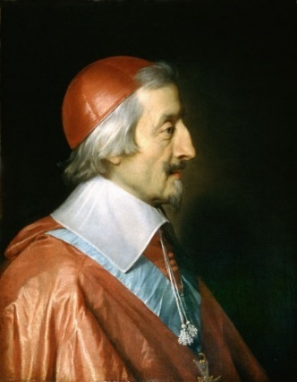

Cardinal de **Richelieu** (1585-1642) was a French minister to King Louis XIII from 1624 to 1642. The prospect of becoming a bishop for his family’s financial security pleased him as he enjoyed learning, debating, and the thought of controlling the lives of others. Even though he was too young to be consecrated, he charmed the pope into giving him papal dispensation. Once working as a bishop, he was known for his obsession with order. Eventually, he became Queen Anne of Austria’s chaplain. Following a revolution in 1617, his office was terminated, but he returned in 1619. In 1624, Richelieu was appointed as first minister and he gained a reputation for being ruthless and was also the topic of various conspiracies. Overall, he was “misunderstood, feared, and detested.” Still, he was intelligent and worked continuously towards his goals. His aim was to render the French King’s power absolute. 1630 was a time of political uncertainty for him as the king’s mother requested Richelieu be dismissed, but the King determined he was reliable and remained loyal to him. Later, Richelieu made it possible for France to begin colonizing Canada. Towards the end of his life, Richelieu found himself pitted against the pope for mostly financial reasons. Before his death in 1642, his secret service exposed the royal Cinq-Mars who was beheaded for creating conspiracies against Richelieu.

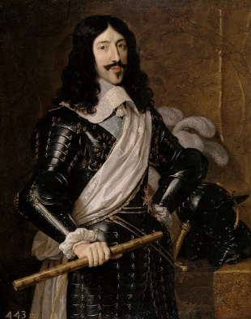**Louis XIII** (1601-1643) was a king of France that was known for mental instability and continuous poor health that made it difficult for him to focus on ruling his country. He was a young king, ascending the throne in 1610 and marrying Anne of Austria when they were 14 years old. Unfortunately, Louis had little interest in his wife, who had several miscarriages, but they eventually had the male heir the king desired in 1638.

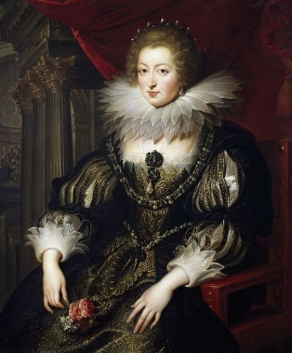

**Queen Anne** of Austria (1601-1666) reigned as Queen of France as Louis XIII’s wife from 1610-1643. In 1625, the Duke of Buckingham confessed he had romantic feelings for the Queen. Cardinal Richelieu encouraged the King to not be influenced by his wife. In fact, when King Louis XIII died, he attempted to remove her sole regency of their son, but Anne managed to have the will annulled.

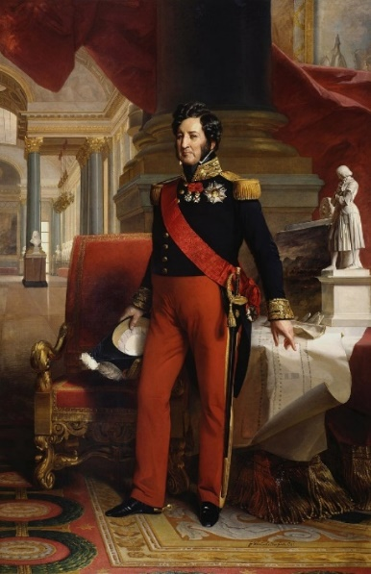**Louis-Philippe** (1773-1850) was the king of France when Dumas penned *The Three Musketeers.* From 1789, he played and important role in the French Revolution, which caused him to be exiled from the country and the arrest and execution of family members. He was able to return to France at the First Restoration. He ascended to the throne following The July Revolution of 1830 and he became known as the “Citizen King.” The King’s daughter married Queen Victoria’s uncle in 1832, which created a great relationship between France and England. Though it had obstacles, there were royal visits between both countries in 1843, 1844, and 1845. The King abdicated his throne in 1848 as a result of the Revolution of 1848.

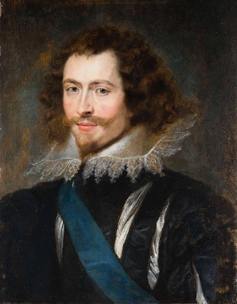The **Duke of Buckingham** (1592-1628) was an unpopular English statesman. In 1627, he commanded men in a war against France. In August of 1628, he was killed by John Felton in Portsmouth.

**Context: Terms at a Glance***Assembled by Desirée Pappel for the Royal Manitoba Theatre Centre*

**This section defines and offers context for some of the vocabulary used throughout the script.**

**Assassinate**: to murder (a usually prominent person) by sudden or secret attack often for political reasons

**Base**: lacking higher qualities

**Bludgeon**: to hit with heavy impact

**Boor**: a rude person

**Dandy**: a man who gives exaggerated attention to personal appearance

**Demise**: death

**Disconsolate**: cheerless

**Discretion**: cautious reserve in speech

**Dispose**: to get rid of

**Duplicity**: contradictory doubleness of thought, speech, or action; especially giving a false impression of one’s true intentions by deceptive words or action

**Eminence**: a person of high rank

**Endeavour**: attempt

**Endure**: continue

**Fearsome**: causing fear

**Fiend**: a person of great wickedness

**Fraught** with peril: a situation that involves great danger and risk

**Heed**: pay attention

**Imprudent**: lacking good judgment

**Incessantly**: continually; without stopping

**Knave**: a tricky deceitful person

**Lackey**: someone who does menial tasks or runs errands for another

**Pawn**: one that can be used to further the purposes of another

**Petty**: having little or no importance

**Prowess**: extraordinary ability

**Rascal**: mischievous person

**Regale**: to entertain

**Resurrect**: to raise from the dead

**Ruse**: a crafty deception

**Sanction**: give approval to

**Sanctity**: the state of being holy or sacred

**Sacrilege**: a violation of what is sacred

**Slumming**: to be in the company of those on a lower social scale than oneself

**Sou**: a coin

**Spurned:** to show unwillingness to accept

**Supersede**: to take the place of

**Unscathed**: not injured

**Venomous**: poisonous; in this case, having or showing evil

**Was in his cups**: intoxicated

**Wretch**: miserable person

# **Context: The Musketeers and What They Represent**

*Assembled by Kristi Hansen for The Citadel Theatre*

*“We serve our King and country. We answer to the call. All for one! And one for all!”*

–The Three Musketeers, *The Three Musketeers*

There were three main Musketeers in the classic novel *"The Three Musketeers"* by Alexandre Dumas. Their names were Athos, Porthos, and Aramis. Later they were joined by D'Artagnan. Thus, making up the four Musketeers. In a world fraught with danger and intrigue, four courageous souls emerged from the shadows, bound together by loyalty, honour, and an unbreakable bond. Athos, Porthos, Aramis, and D'Artagnan—the legendary Four Musketeers—embarked on a thrilling journey. Their unique talents and unwavering camaraderie forge a formidable force against adversity. Amidst the chaos of their time, they became the embodiment of valour. Their names are symbols of hope, resilience, and an enduring spirit that transcends the test of time. Each of the four Musketeers had distinct characteristics that made them unique and memorable:

1. **Athos:** Athos is the most mature and noble of the group. He is a natural leader and acts as a father figure to the other Musketeers. He is brave, intelligent, and reserved, often keeping his personal life and past a secret.

2. **Porthos:** Porthos is the strongest and most boastful of the Musketeers. He is a lover of fine clothes and good food and enjoys the luxuries of life. Despite his vanity, he is loyal to his friends and a formidable fighter.

3. **Aramis:** Aramis is the most intellectual and spiritual of the group. He is well educated, often quoting poetry and scripture. He aspires to leave the Musketeers and join the priesthood, but his loyalty to his friends and sense of duty keeps him from doing so.

4. **D'Artagnan:** D'Artagnan is a young, ambitious man from Gascony who dreams of becoming a Musketeer. He is brave, hot-headed, and sometimes impulsive, but his loyalty and friendship with the other Musketeers become his defining traits. He matures and develops into a skilled and honourable swordsman.

Together, these four characters embody the famous motto, "All for one, and one for all," signifying their unwavering loyalty and unity in the face of adversity. While the Musketeers themselves are fictional characters and not directly related to personality assessments, their distinctive characteristics can be seen as representative of different personality stereotypes.

# **Pre-show Discussion Questions**

1. What do you already know about the story of *The Three Musketeers*?
2. What media (TV, film, theatre) do you typically see fight scenes in? Can you name some examples?
3. Can you think of other famous adaptations in pop culture?
4. What do you know about world history in 1625? What do you know about the societal expectations of people living during this time period?

# **Post-show Discussion Questions**

1. Who were the Musketeers in real life and why were they formed?
2. How does the historical context of the time change your opinions on the characters and their actions? Does it?
3. How often do you see villainous women in media? Where do you see women who are allowed to be mean or hurtful as well as powerful and strong?
4. How do the men in this show talk about love and women? Is this authentic to masculinity today or how has the representation of masculinity in media changed?
5. What do you think the message of the show is? What is your takeaway?
6. Is there anything you didn’t understand about the show?

# **Context: Milady and the Role of Woman in the *The Three Musketeers*** *Assembled by Kristi Hansen for The Citadel Theatre*

*“Surely you wouldn’t kill an unarmed man in the presence of a lady.”* –Rochefort, *The Three Musketeers*

In Alexandre Dumas’ original text, the concept of masculinity is greatly emphasized given that the majority of the characters are male and they portray meaningful roles, such as the musketeers. However, with a female character like Milady, the reader is opened to the concept of femininity showing the strength and length women, such as Milady, had and will go through to get what they want despite what the society at that time thought was appropriate behavior for women.

During this time period of the seventeenth century, “the first wave of femininity” has come to the public. Many people believed that women were to be “maternal and domestic,” but Dumas created the character of Milady, who was the complete opposite of what a woman was expected to be at the time, which was a stay-at-home mother whose duty was to have children, raise them and maintain the house. There have been many instances in which Milady had to use vulgar and dangerous manipulations and actions in situations where it might have been for her own survival or because it was part of her job.

Milady is a character that reflects feminism in the sense that women can be intelligent, self-efficient, and strong. It is through the traits and actions of Milady that Dumas also shows how Milady is not a representation of women of the society in that century, but of what women could be. Dumas also emphasizes that there are issues with this rising concept of feminism given that the society at that time believed that women were to be inferior to men and the contradicting views on actions taken upon men and women that is still seen today, such as, men and women doing the same thing, but women being viewed negatively for it.

The adaptation of *The Three Musketeers* playing at the Citadel Theatre was created by American playwright, Catherine Bush. Catherine Bush lives in Abingdon, Virginia where she works as Barter Theatre’s playwright-in residence. In 2014, Barter Theatre’s former Producing Artistic Director Rick Rose was considering *The Three Musketeers* for his 2015 season, but he couldn’t find an adaptation that he liked, so he approached Catherine about writing one. When asked about her biggest challenge in adapting Alexandre Dumont’s story this is what she had to say:

*I hated the characters as written in the book. I’m referring to the Three Musketeers and D’Artagnan. Dumas did not write them for the women of the #MeToo generation. They treated women horribly; used them when convenient then threw them away like trash. My partner had to listen to a lot of “oh my God, I HATE these guys!” exclamations while I was reading the book. I’m a romantic who loves a noble hero – when D’Artagnan tells Constance he loves her, I wanted him to mean it and stay true to her. I wanted the Three Musketeers to be the kind of men I wouldn’t mind hanging out with – flawed, but with a sense of honor, a working knowledge of right and wrong. I wanted romance and adventure, heroes and villains – and all that informed the writing.*

# **Interviews with *The Three Musketeers* Team** *Assembled by Kristi Hansen for The Citadel Theatre*

**INTERVIEW WITH *THE THREE MUSKETEERS*’ FIGHT DIRECTOR, JONATHAN HAWLEY PURVIS**

**As a Fight Director, what is your process for creating fight choreography?**

For me, it all begins with the story. I ask myself: what purpose does the fight have to forward the story? Why is it important that these characters fight instead of talk? What kind of story do I want to tell within the fight? With these questions in my mind I start to get an idea how I want the fight to go. I also have to consider the tone or the style of the piece. Violence/Fighting can invoke a lot of different emotions; thrilling, scary, intense, silly, etc. My job as a Fight Director is to design the fights to fit the narrative energy of the story. When it finally comes down to the individual moves, I save that for the rehearsal hall. I like to choreograph directly with the performers, playing to each person's strengths and instincts, using their ideas and inspiration to add to the fight. If I've done my job well, the actors feel awesome and the fights tell a great story!

**JONATHAN HAWLEY PURVIS** *FIGHT DIRECTOR*

*Photo credit: Ryan Parker Photography*

**What is your advice for folks on where to start if they are interested in training as Actor Combatants and Fight Directors?**

Most post-secondary theatre programs offer some sort of Stage Combat portion of their programming. This is a great way to "get your feet wet". To pursue further training, take a look at Fight Directors Canada or American Society of Fight Directors if you want to travel south to our neighbours. Both associations offer lots of training opportunities in the form of workshops and training camps. Sometimes local theatres will offer occasional workshops suited to what the community is asking for, I have run fight workshops to this purpose in the past. These are good places to start.

**INTERVIEW WITH *THE THREE MUSKETEERS*’ PERFORMER, MORGAN YAMADA**

**As an Understudy you will be learning not only various lines for each role, but fight choreography, as well. What is your process for learning all your tracks and each bit of choreography?**

Learning multiple roles and fight choreography as an understudy is a new experience for me, and I am still figuring it all out. But I've found helpful little tricks to make it a bit easier. I utilize apps like *Stage Write* to organize notes, choreography, and scene blocking for each character, to document all the different character tracks and notes. Additionally, *Script Rehearser* helps me run lines while voicing other characters' lines, helping my memorization. I usually learn by doing, so using these tools has been really helpful for me. Moreover, the support from the whole *Musketeers*’ team has been amazing, just like they say in play, "all for one, and one for all", we are all working together to put on the show, so we are running lines, choreography and helping each other out whenever we can, and I am so thankful for that!

**MORGAN YAMADA**

*PERFORMER*

*Photo credit:* Kaylin Schenk Photography

**As someone who also creates fight choreography themselves, do you find it easier or harder to learn another fight director’s choreography?**

As someone who creates fight choreography, learning another fight director's work is a delightful experience and so fun. As a Fight Director, we get to dream up the fights but don't usually get to perform them on stage every night, so it is such a treat! It also lets me add new approaches to stage combat, and different ways of teaching and building choreography to my creative toolbox, making the process not only fun but is making me a better Fight Director. Just like anything in theatre, I think collaboration makes us better and getting to learn from an amazing fight choreographer like Jonathan is awesome!

**Activity #1: Finger Sword Fighting**

*Assembled by Stella Jack-Rennie for the Arts Club Theatre Company*

**Fencing Terms***Assembled by Desirée Pappel for the Royal Manitoba Theatre Centre*

**Advance*:** Basic forward movement from En Garde position   
**Draw:** to pull a weapon out of the place where it is carried  
Duel: a combat between two persons   
**En Garde*:** Ready position for fencing.   
**Lunge:** A basic attacking move in fencing   
**Parry*:** Defensive Action that stops an offensive action, such as blocking an attacking blade with your own   
**Surrender:** to give up completely   
**Thrust:** An attack made by moving the sword parallel to its length and landing with the point

*\*from “Better Fencer” website by Jason Rogers*

*Suggested for Drama classes*

***Goal****: To improve students’ spatial awareness of themselves, the room, and each other along with their quick-thinking and multitasking skills.* *This activity can be done in groups or as a class.*

In *The Three Musketeers*, there are numerous fight sequences where the Musketeers are outnumbered and facing certain death, they need to use their wit as well as their strengths to defend themselves and overcome their foes. This exercise puts students in the swords masters’ shoes as they practice their listening and awareness as they follow a script and ward off assailants as a warmup to learning real stage combat.

**Part 1: Basic One on One Duel**

1. Break up the class into groups of 2 and spread them throughout the room!
2. Rules of the game:
   1. Both players extend one hand in front of your body with just your pointer finger sticking out. This will be your “sword”. Put your other arm behind you with the back of your hand stuck flat behind the middle of your back.
   2. The goal of the game is to touch the centre of your partners palm with your finger, without getting your palm touched by the other player
   3. Do not purposefully poke the other player, and respect any boundaries they put in place before playing the game
3. To start the game the teacher says “3,2, 1...” and then the class all shouts “En guard!”
4. When someone get tapped out, that person must die loudly dramatically in the way of their choosing.

**Part 2: Classroom Fight**

1. Have the entire class fight each other! The students will have to expand their awareness even more to be conscious of everyone in the class.
   1. Two people could team up on one, but it could leave them more vulnerable to attack!
2. The same rules apply!
3. To add an extra challenge, in this fight students must hop on one foot at all times!

**Part 3: Group Three Musketeer Duel**

1. Before doing part 3, print out handouts of the Three Musketeer scripts below
2. Break up the class into groups that correspond to the scenes below and give them copies of the script and let them decide characters and give them time (10-15 mins) to rehearse the scene before the “fight”. Memorization is optional.
   1. Actors can “choreograph” the fight to decide the victor or to play the game live to see who wins!
3. Separate the groups into actors and audience and have each team present their scene and duels!

**Part 4: Reflection**

1. What did you learn about stage combat that you didn’t know before?
2. What version of the game did you find it easier to play?
   1. Did you develop a strategy to win? If so, what was it and how did it make it easier?
3. What version of the game did you like playing the most?
4. Did you find it harder or easier with a script?

**Scene #1:** 2 Characters - D’Artagnan & Rochefort

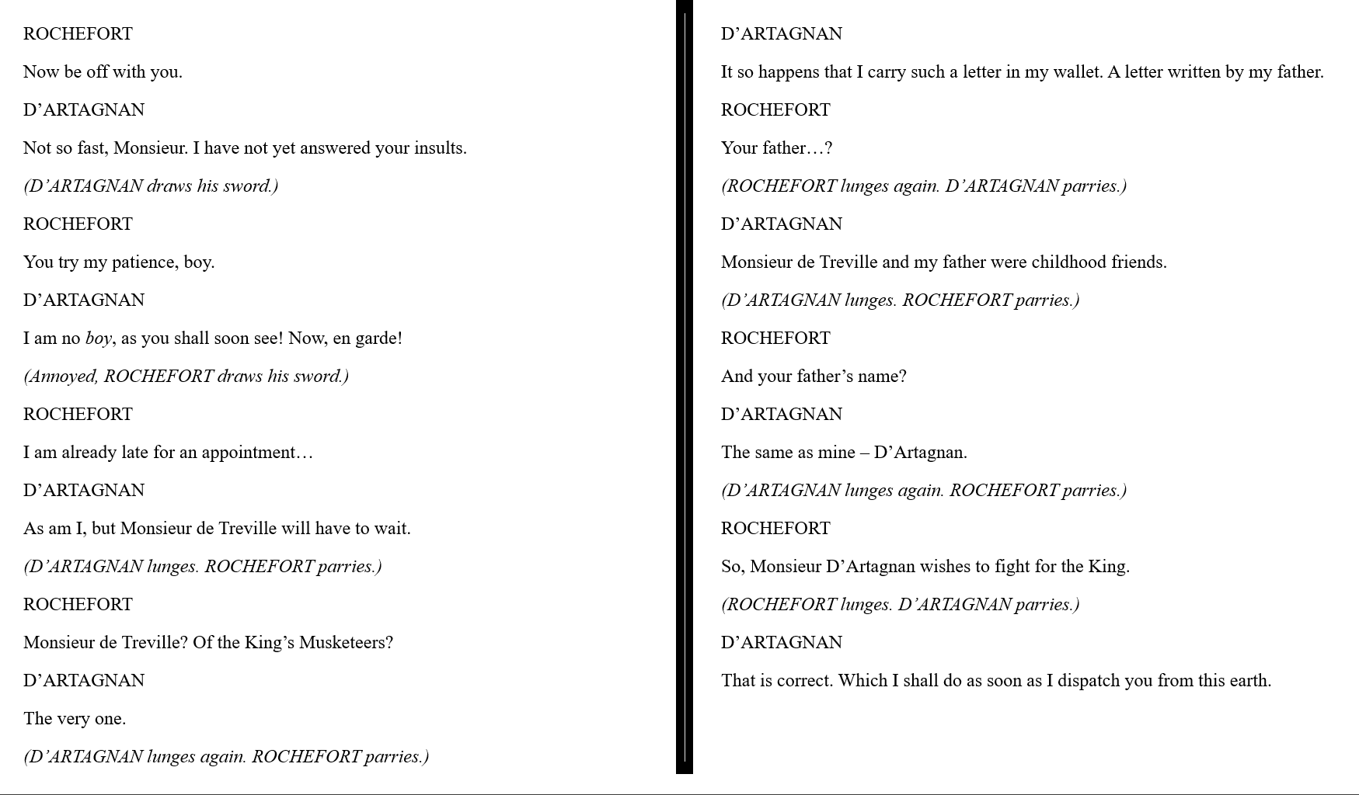

**Scene #2:** 8 Characters – Jussac, Cahusac, Bicarat, Lemieux, Porthos, Athos, Jussac, D’Artagnan

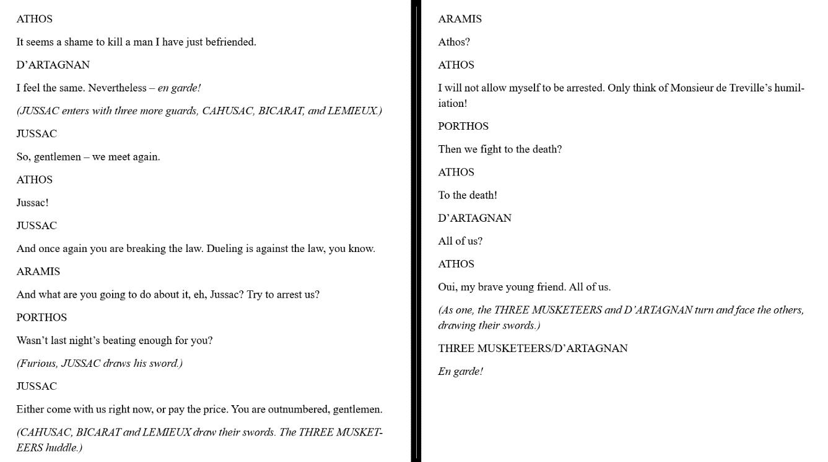

**Scene #3:** 8 Characters – Jussac, Guard 1, 2, 3, Porthos, Athos, Jussac, D’Artagnan

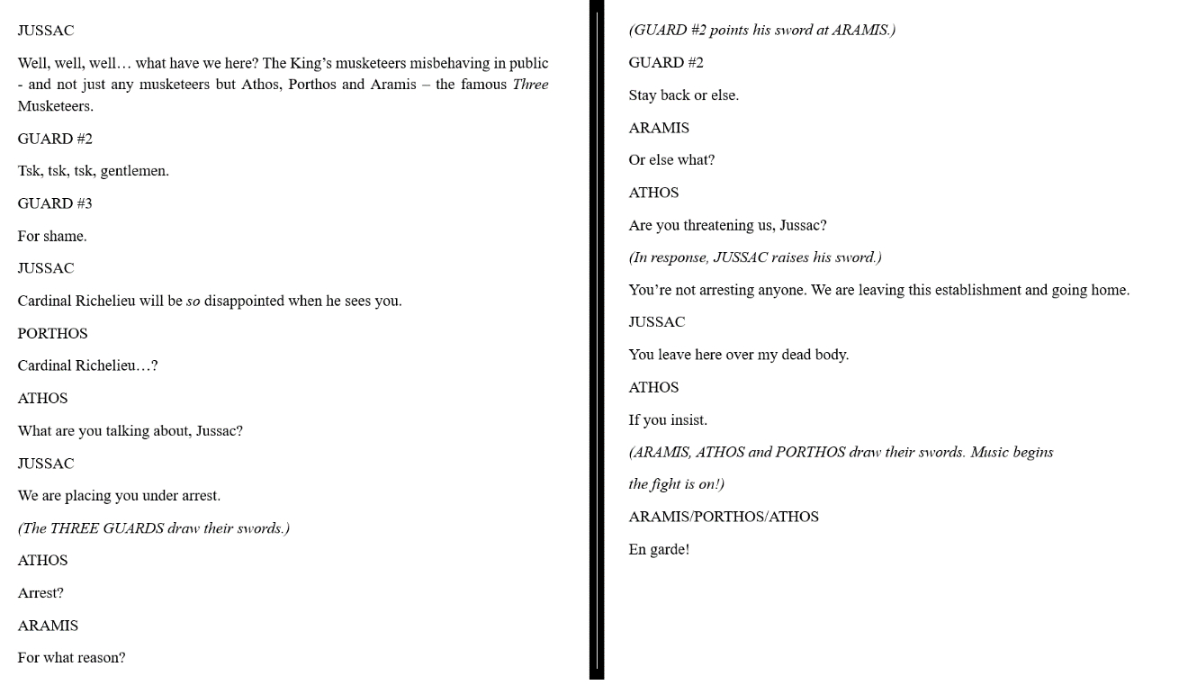

**Activity #2: In Between the Lines***Assembled by Stella Jack-Rennie for the Arts Club Theatre Company*

*Suggested for English, Social Studies, and Drama classes*

***Goal****: To work on students writing and perception of the characters in the play existing as real people who have lives outside the story (though fictionalized) and being able to use both literary works and historical information to create fictional works. This activity can be done alone or in a group.*

The Oxford Reference defines adaptation as “The process of making a work of art upon the basis of elements provided by an earlier work in a different medium”, in other words: taking a story and creating or retelling a new piece of art in a different way in a different art form. This production of *The Three Musketeers* is an adaptation of the book by Alexandre Dumas, and Dumas took inspiration from the real people and nobility of the time with D'Artagnan, Porthos, Aramis and Athos being the nicknames for four real Musketeers at the time. In this activity, students will learn how to write their own adaptation with a Three Musketeers twist!

**Instructions:**

**Part 1: Activity**

1. Brainstorm
   1. Have each team come up with what characters and what setting they want to write about.
      1. Who was your favourite character in *The Three Musketeers*? Who was your least favourite character? Who was the character you related the most to? Who are characters you can imagine would be in that world of the play but aren’t?
      2. Where was your favourite scene in the play located? Where was your least favourite scene in the play located? What was a location you think they didn’t use enough, or at all?
   2. What are your favourite adaptations of a text? What did you like or dislike that you want to include in your script? (ex. Clueless, Mean Girls, Bridget Jones Diary, The Last Of Us)
      1. What style or genre do you want the scene to be written? Do you want it to be funny, dramatic, romantic, sad, etc.
2. Research! Have the class research the time period.
   1. What were the 1600’s like?? What were the customs at the time? How are the beliefs of that time different than beliefs today?
   2. Who were the musketeers in real life and why were they formed? If the musketeers were created because of colonization, do you still admire what they did?
3. Have the students write a 1–2-page scene (depending on grade) based on *The Three Musketeers*.
   1. It must include:
      1. A clear **SETTING** (Where are we?)
      2. At least 2 **CHARACTERS** (Who is in the scene?)
         1. What are the characters ***GOALS***? What do they want from each other?
      3. A **CONFLICT** (What is getting in the way of the characters interacting?)
      4. A **BEGINNING**, **MIDDLE**, and **END**
   2. Are you having trouble writing your script? Here are some writing tips:
      1. Make your writing relatable! Your best writing will always be writing from your own experience. How can you relate to the characters and their circumstances? Or how do you not relate?
      2. Write what YOU find funny, don’t write a “joke”
      3. Get it on your feet! Get a partner and improvise together, and write down your favourite lines
4. Get your friends to read your scripts out loud!
   1. How does it sound to you out loud? Are there things you want to change?
   2. Ask your friends if they have any notes or questions about your script.

**Part 2: Reflection**

1. Did you enjoy writing a script? How do you find it different from writing prose or poetry?
2. Were you missing any of the story elements at the beginning? How did adding them in effect your script?
3. Were the notes given to you by your peers helpful? How did applying them in your script help your piece overall?

**FURTHER READING & RESOURCES**

For the Good of the Realm A feminist *The Three Musketeers* by Nancy Jane Moore

Catherine Bush’s website

*The Three Musketeers* Study Guide from LitCharts

*The Three Musketeers* Story: Story for Teenagers From English Fairy Tales | YouTube

Video: *The Three Musketeers* by Alexandre Dumas | Characters & Author From Study.com

# **Sources**

Royalmtc.ca, accessed on March 21, 2024. Created by Desirée Pappel. Edited by Ksenia Broda-Milian for Royal MTC.

<*The Three Musketeers* Enrichment Guide>

Orlandoshakes.org, accessed on March 21, 2024

<Playwright Spotlight: *The Three Musketeers*>

Grace, Leslie. “Catherine Bush Has the Best Job” *Alliance Mountain Empire*, accessed on March 21, 2024

<Catherine Bush Has the Best Job>

Bassi, Rhohit. “Which Musketeer are You?” *Linkedin.com*, accessed on March 21, 2024.

<Which Musketeer are You?>

Rampton, Martha. "Four Waves of Feminism." *Pacific University*, accessed on March 21, 2024.

Faden, Alison. “A Feministic idea in *The Three Musketeers* by Alexandre Dumas”. *HCC Learning Web*, accessed on March 21, 2024.

Novels for Students. . Encyclopedia.Com. 29 Jul. 2024 .” *Encyclopedia.Com*, Encyclopedia.com, 8 Aug. 2024, www.encyclopedia.com/arts/educational-magazines/three-musketeers.

“Adaptation.” *Oxford Reference*, oxfordreference.com/display/10.1093/oi/authority.20110901084355758. Accessed 31 July 2024.

*Alexandre Dumas - Books, Ethnicity & Quotes - Biography*, www.biography.com/writer/alexandre-dumas. Accessed 8 Aug. 2024.

*Amazon.Com: French Musketeer 1622–1775 (Warrior, 168): 9781780968612: Chartrand, René, Turner, Graham: Books*, www.amazon.com/French-Musketeer-1622-1775-Warrior-Chartrand/dp/1780968612. Accessed 8 Aug. 2024.

“America’s Most Trusted Dictionary.” *Merriam-Webster*, Merriam-Webster, www.merriam-webster.com/. Accessed 8 Aug. 2024.

“Anglo-French War (1627–1629).” *Wikipedia*, Wikimedia Foundation, 17 Mar. 2024, en.wikipedia.org/wiki/Anglo-French_War_%281627%E2%80%931629%29.

“Anne of Austria.” *Encyclopædia Britannica*, Encyclopædia Britannica, inc., www.britannica.com/biography/Anne-of-Austria. Accessed 8 Aug. 2024.

“Bastille Day.” *Encyclopædia Britannica*, Encyclopædia Britannica, inc., 14 July 2024, www.britannica.com/topic/Bastille-Day.

“Bastille.” *Encyclopædia Britannica*, Encyclopædia Britannica, inc., 18 July 2024, www.britannica.com/topic/Bastille.

“Cardinal Richelieu.” *Encyclopædia Britannica*, Encyclopædia Britannica, inc., 26 July 2024, www.britannica.com/biography/Armand-Jean-du-Plessis-cardinal-et-duc-de-Richelieu.

*Catherine Bush’s Work Comes Home; Writing Keeps Her in Virginia | Lexington Herald Leader*, www.kentucky.com/entertainment/performing-arts/article44499552.html. Accessed 8 Aug. 2024.

“Fleur-de-Lis.” *Encyclopædia Britannica*, Encyclopædia Britannica, inc., www.britannica.com/topic/fleur-de-lis. Accessed 8 Aug. 2024.

“Fleur-de-Lys.” *The Canadian Encyclopedia*, 11 May 2016, www.thecanadianencyclopedia.ca/en/article/fleur-de-lys.

“George Villiers, 1st Duke of Buckingham.” *Encyclopædia Britannica*, Encyclopædia Britannica, inc., www.britannica.com/biography/George-Villiers-1st-duke-of-Buckingham. Accessed 8 Aug. 2024.

“Glossary of Fencing.” *Wikipedia*, Wikimedia Foundation, 4 May 2024, en.wikipedia.org/wiki/Glossary_of_fencing.

“July Revolution.” *Encyclopædia Britannica*, Encyclopædia Britannica, inc., 20 July 2024, www.britannica.com/event/July-Revolution.

“The July Revolution.” *Encyclopædia Britannica*, Encyclopædia Britannica, inc., 27 June 2024, www.britannica.com/biography/Louis-Philippe/The-July-Revolution.

*Louis XIII: Biography, King of France, French Royalty*, www.biography.com/royalty/louis-xiii. Accessed 8 Aug. 2024.

“Newgate Prison.” *Encyclopædia Britannica*, Encyclopædia Britannica, inc., www.britannica.com/place/Newgate-Prison-historical-prison-London. Accessed 8 Aug. 2024.

“Newgate Prison.” *Wikipedia*, Wikimedia Foundation, 10 May 2024, en.wikipedia.org/wiki/Newgate_Prison.

“News.” *Catherine Bush Playwright*, catherinebushplays.com/. Accessed 8 Aug. 2024.

Rogers, Jason. “Better Fencer.” *Substack*, betterfencer.com/fencing-terms-glossary. Accessed 8 Aug. 2024.

“Romance.” *Encyclopædia Britannica*, Encyclopædia Britannica, inc., www.britannica.com/art/romance-literature-and-performance. Accessed 8 Aug. 2024.

“The Three Musketeers.” *Encyclopædia Britannica*, Encyclopædia Britannica, inc., www.britannica.com/topic/The-Three-Musketeers. Accessed 8 Aug. 2024.

“Urban Dictionary, August 8: Plumb.” *Urban Dictionary*, www.urbandictionary.com/. Accessed 8 Aug. 2024.