

TEACHER RESOURCE GUIDE
Elf: The Musical
Book by Thomas Meehan and Bob Martin
Music by Mathew Sklar
Lyrics by Chad Beguelin

Based on the film by David Berenbaum

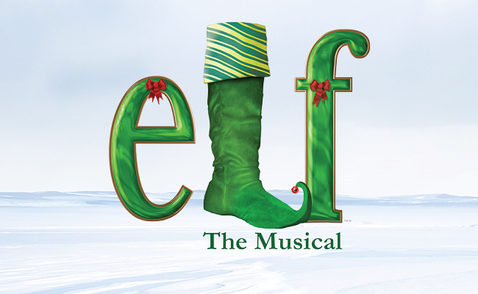
Image description: ‘Elf the Musical’ written in green lettering against a snowy background. The ‘L’ is in the shape of a stocking.
2026.27 season
Stanley BFL Canada Stage
November 12–December 27, 2026
This show is generously sponsored by:




Table of Contents
Pre-Show Resources 2–11
Welcome 2
About the Arts Club Theatre Company …………………………………………………………………………….3
c̓əsnaʔəm: The Story of this Land ……………………………………………………………………………………3
Attending the Show …………………………………………………………………………………………………… 4
Learning Objectives…………………………………………………………….………………………………………. 5
Connections to BC Curriculum 5
Show Information …………………………………………..……………………………………………………………7
Brief Synopsis: Elf 7
Long Synopsis: Elf…………………………………………………………………………………..……………………. 8
About the Creative Team 10
Characters 10
Pre-Show Discussion Questions………………………………………………………………………………..11

Post-Show Resources 12–21
Post-Show Discussion Questions 12
Activity 1: Fish out of Water (Grade 5–7) 13
Activity 2: A Trip Down Memory Lane (Grade 5–7) 14
Activity 3: One-Word Story (Grade 8–12) 16
Activity 4: Character Analysis and Creation (Grade 8–12) 16
Resources 20
Sources 20

Welcome
This guide was created for teachers and students. It contains an overview of the musical’s story as well as informative resources and activities for teachers and students. The guide aims to provide background knowledge and critical perspectives on the musical that will yield fruitful discussion and foster an understanding and appreciation of theatre arts.
If you have any questions, comments, or suggestions for the guide, please contact our Education & Community Engagement Manager, Mikenzie Page, mpage@artsclub.com, or our School Program Liaison, Delaney Lathigee, dlathigee@artsclub.com.
This study guide was created by Avrel Festinger and Mikenzie Page.

About the Arts Club
The Arts Club of Vancouver was founded in 1958 as a private club for artists, musicians, and actors. It became the Arts Club Theatre in 1964 when the company opened its first stage in a converted gospel hall at Seymour and Davie Streets. Now in its 63rd season of producing professional live theatre in Vancouver, the Arts Club Theatre Company is a non-profit charitable organization that operates three theatres: the Lindsay Family Stage at Granville Island, the Stanley BFL Canada Stage, and the Olympic Village Stage at the BMO Theatre Centre. Its popular productions range from musicals and contemporary comedies to new works and classics.
Learn more about the Arts Club Theatre Company at artsclub.com

c̓əsnaʔəm: The Story of this Land
The Stanley BFL CANADA Stage stands on the ancestral territory of the xʷməθkʷəy̓əm Nation, and the former city of c̓əsnaʔəm, which was located at the mouth of the Fraser River. The city of c̓əsnaʔəm is an important historical site for xʷməθkʷəy̓əm (Musqueam). It symbolizes the nation's resilience and its connection to the land. We honour the history of this land as a step towards recognition and respect to the Musqueam people. Just as Musqueam was named for the blooming flower məθkʷəy̓, we hope to grow our connection with the land and its people.
The Arts Club Theatre Company would like to acknowledge the traditional, ancestral, and unceded territories of the xʷməθkʷəy̓əm ,Sḵwx̱wú7mesh, and səlilwətaɬ Nations, the original stewards of this land on which we operate. We would like to ask those visiting or living here to share their thanks by supporting local Indigenous artists and communities. Acknowledging is always a start to supporting; as we step forward, we wish to be better partners, healers, and helpers to our Indigenous neighbours.
For further reading, click below to read more about xʷməθkʷəy̓əm
(Musqueam’s ) Story from the Musqueam Indian Band website:
Musqueam’s Story
https://www.musqueam.bc.ca/our-story/our-territory/place-names-map/

Attending the Show

Arriving at the Theatre
Please arrive at the theatre with 30 minutes before the show to pick up and distribute tickets. Buses may unload passengers in the loading zone in front of the theatre, but engines must be turned off while doing so. They will have to find alternate parking for the duration of the show. More parking information can be found at our website HERE.
Theatre Etiquette
In order to ensure an enjoyable show for all audience members, please share these general theatre etiquette guidelines with students and participants.
- Please turn off mobile phones and other electronic devices for the duration of the show. If you are concerned about missing an emergency call, please leave your name or device and seat location with a front of house attendant and they will alert you.
- No outside food or drink is allowed in the theatre (sealed water bottles are fine!).
- Please be modest with your use of fragrances so that audience members with allergies can also enjoy the performance.
- If you must leave the theatre during the performance, you will be seated again at the intermission or another appropriate interval.
- Reactions are welcome and the best part of live theatre! We do ask that you please respect your fellow audience members and the performers by refraining from talking during the performance.
- If you have a complaint about another guest, please tell a front of house attendant or the Front of House Manager rather than approaching the person yourself. They will be happy to address your concerns.
- The Arts Club seeks to create an environment with reduced barriers for all. We want to provide a place where all people feel welcome and can maintain their independence and their dignity. Learn about our Accessible Performances here.
- Our Accessibility Coordinator, Amy Amantea, will be happy to have a conversation with you about you or your students’ access needs, and how they may be addressed during your time with us at your performance, workshop, and/or backstage tour. Reach out at aamantea@artsclub.com.

Learning Objectives
After viewing Elf: The Musical and working through the following activities, students will:
- Explore themes of belonging and identity through forming personal connections to the show.
- Engage with close reading and building off a dramatic text in order to ultimately create original work inspired by it.
- Reflect on what it means to be authentic to one’s self, in spite of interpersonal challenges and obstacles.

Connections to BC Curriculum
Arts Education 5–8
Big Ideas
- Dance, drama, music and visual arts are each unique languages for creating and communicating.
Curricular Competencies
• Observe, listen, describe, inquire, and predict how artists (dancers, actors, musicians, and visual artists) use processes, materials, movements, technologies, tools, techniques, and environments to create and communicate.
• Describe, interpret, and respond to works of art and explore artists’ intent.
• Respond to works of art using one’s knowledge of the world.
English Language Arts 5–8
Big Ideas
- Language and text can be a source of creativity and joy.
- Exploring stories and other texts helps us understand ourselves and make connections to others and to the world.
Curricular Competencies
• Use a variety of comprehension strategies before, during, and after reading, listening, or viewing to guide inquiry and deepen understanding of text.
• Communicate in writing using paragraphs and applying conventions of Canadian spelling, grammar, and punctuation.
• Respond to text in personal and creative ways, and critical ways.
Drama 9
Big Ideas
- Identity is explored, expressed, and impacted through dramatic experiences.
Curricular Competencies
- Explore relationships between identity, place, culture, society, and belonging through dramatic experiences.
- Describe, interpret, and evaluate how performers and playwrights use dramatic structures, elements, and techniques to create and communicate ideas.
Drama 10
Big Ideas
- Drama offers dynamic ways of exploring our identity and sense of belonging.
Curricular Competencies
- Reflect on dramatic works and make connections with personal experiences.
- Make connections with family and community through drama and theatre.
Drama 11
Big Ideas
- Drama offers dynamic ways to explore and share identity and a sense of belonging.
Curricular Competencies
- Reflect on dramatic works and make connections with personal experiences.
- Document and respond to dramatic works and experiences in a variety of contexts.
Drama 12
Big Ideas
- Drama offers dynamic ways to express our identity and sense of belonging.
Curricular Competencies
- Reflect on dramatic works and make connections with personal experiences.
- Describe, analyze, and evaluate ways in which props, technologies, and environments are used in drama, using discipline-specific language.
Literary Studies 9
Big Ideas
- Exploring stories and other texts helps us understand ourselves and make connections to others and to the world.
Curricular Competencies
- Apply appropriate strategies to comprehend written, oral, and visual texts, guide inquiry, and extend thinking.
Literary Studies 10–12
Big Ideas
- The exploration of text and story deepens our understanding of diverse, complex ideas about identity, others, and the world.
Curricular Competencies
- Apply appropriate strategies in a variety of contexts to comprehend written, oral, visual, and multimodal texts, to guide inquiry, and to extend thinking *note that strategies include asking questions and identifying themes.

Show Information
Genre: Musical
Show dates: November 12–December 27, 2026
Age range: Recommended for grade 5–12
Venue: Stanley BFL Canada Stage

Brief Synopsis
Elf: The Musical follows Buddy, who lives in the North Pole and works in Santa’s workshop. Although the life of toy-making is wonderful, Buddy doesn’t quite fit in with the other elves. He is slow at making toys and much taller than his coworkers. It ultimately turns out that everyone’s favorite elf isn’t an elf at all, but rather a human! With permission from Santa, Buddy embarks on a journey to the faraway land of New York City to find his father. However, once he arrives, Buddy discovers that his father is on the naughty list and his brother does not believe in Santa! Now, Buddy must re-teach his family as well as the city of New York, the true meaning of Christmas. Based on the 2003 movie, the hilarious, and fun-filled, Elf: The Musical reminds us of what is truly important in life: family (and of course, presents).

Long Synopsis
The show opens with Santa Claus watching TV on Christmas Day. He talks to the audience and begins to read a Christmas story about Buddy the Elf. We now turn our focus to Buddy and the other elves working in Santa’s workshop, two weeks before Christmas. Charlie wanders over to Buddy’s workstation and Buddy sheepishly explains that he has not reached today’s toy-making quota. Shawanda and Charlie talk about Buddy, and Shawanda lets slip that Buddy is not really an elf, but rather human. Buddy overhears this and runs to Santa for answers. Santa explains that Buddy’s mother, Susan Wells, passed away when he was a baby and Buddy was consequently placed in an orphanage. Then, one Christmas Eve, a baby Buddy crawled into Santa’s toy sack. So, Santa brought him back to the North Pole and raised him as an elf. Santa explains that Buddy’s father, Walter, does not know he exists. He shares that Walter lives in New York City and works for a publishing company located in the Empire State Building. Buddy decides to go to New York to find his father.
Walter is having a hard time at work. The last Christmas children’s book his company published was unsuccessful. Walter’s son, Michael, and wife, Emily show up to his office, expecting to go Christmas shopping. Walter insists that he is too busy with work to go.
Buddy arrives at Walter’s office. Walter’s secretary, Deb thinks that someone sent Buddy as a singing holiday telegram. Buddy tells Walter that he is his son and Walter kicks Buddy out of the building. The security guards ask Buddy where he is from and his answers - the North Pole - prompts security to drop him off at Macy’s. As Buddy wanders into the store, a Macy’s manager mistakes him as an employee in the toy department. The manager makes an announcement that tomorrow Santa is coming to Macy’s which excites Buddy.
While working at Macy’s, Buddy meets Jovie, who also works in the toy department. He asks Jovie on a date. The next morning, Buddy loses his cool when ‘Santa’ comes into the store, and it turns out not to be the real Santa, but rather someone dressed as Santa. The police escort Buddy out of Macy’s and take him to Emily and Walter’s house. Buddy says he will help Michael build a model turbine wind machine if Michael writes a letter to Santa. Walter comes home, and Emily tells him that Buddy is going to stay with them. The next morning, Emily shares that she did some investigating and has confirmed that Buddy is in fact Walter’s son. Buddy goes into work with Walter. Mr. Greenway tells Walter that he is out of a job unless he comes up with a new Christmas book by December 24.
Jovie and Buddy go on a date. Buddy encourages Jovie to think back on her childhood Christmas memories. Jovie confesses that she has always wanted to have Christmas Eve dinner at the Tavern. Buddy promises that he will make Jovie’s dream come true.
Back at the office, Walter and his associates are brainstorming Christmas stories. Mathews shares that he has access to an unpublished Christopher Smith book that they can use. While no-one is watching, Buddy shreds the manuscript, to make snow. In a rage, Walter tells Buddy to go home, get his stuff, and leave for good.
Act Two
After his fight with his dad, Buddy leaves a note for Walter, Michael, and Emily. He apologizes and insists that they will never see him again. Buddy walks around the city and ultimately enters a Chinese restaurant. He is surrounded by fake Santas, who lament that nobody respects Santa Claus anymore. Suddenly, Buddy remembers that he had made plans with Jovie for Christmas Eve. He rushes to the Tavern, to find a disappointed Jovie. Buddy gives Jovie her Christmas present, a snow globe. While Jovie accepts the gift, she is still upset with Buddy and walks away.
Emily and Michael read Buddy’s note. As Michael stares out the window, he notices Santa Claus flying through the sky. Emily sees this too, and the two realize that Buddy was right: Santa is real! Emily and Michael rush to Walter’s office, but Walter doesn’t have time to speak with them. They try to explain that Buddy has gone missing, but Walter is too focused on his deadline. Mr. Greenway shows up to the office awaiting Walter’s pitch. Soon, Buddy arrives. As Walter falters and fumbles in front of Mr. Greenway, Buddy announces that he has a Christmas story to pitch and proceeds to tell the tale of Buddy the Elf. Mr. Greenway likes the story but suggests that they change the character of Buddy into a horse. He also tells Walter that they will both have to work all night and tomorrow on Christmas Day. Walter quits.
Buddy and co. leave the office and run into Santa, who explains that his sleigh won’t fly, because not enough people believe in him anymore. Buddy takes matters into his own hands and convinces New York City to believe in Santa. He selects random people and uses Santa’s iPad, to tell them what Santa got them for Christmas when they were children. Jovie enters the crowd and joins Buddy in singing a Christmas song. The crowd’s newfound Christmas spirit fuels Santa’s sleigh.
In the epilogue, Santa welcomes Michael, Walter, Emily, Buddy, his now wife Jovie, and their baby, into his home for Christmas dinner.

About the Creative Team:
Mathew Sklar (Composer)
Mathew Sklar (b. 1973) is a Tony and Emmy award-winning composer from New Jersey. Known for the Broadway musical The Prom as well as The Wedding Singer and Elf: The Musical, Sklar continues to compose critically acclaimed work.
Bob Martin (Book)
Bob Martin (b. 1962) is a tony-award winning actor, writer, and director from Toronto, Ontario. Past projects include co-writing musicals such as The Drowsy Chaperone, The Prom and Elf: The Musical. Martin also co-created the award-winning series “Slings & Arrows”.
Thomas Meehan (Book)
Thomas Meehan (1929-2017) was a tony award-winning writer, best known for the musical Annie and the stage adaptation of Hairspray.
Chad Beguelin (Lyrics)
Chad Beguelin (b. 1969) is a tony nominated playwright and lyricist. He worked on the stage adaptation of Disney’s Aladdin as well as the musicals, The Prom, The Wedding Singer, and Elf: The Musical.

Character List:
Buddy: Optimistic and energetic, Buddy lives in the North Pole and works in Santa’s Workshop. He craves a sense of belonging and wants desperately to connect with his family, but his earnestness and positivity can create a disconnect between himself and jaded New Yorkers.
Jovie: Cynical but ultimately good-hearted, Jovie works as a store elf at Macy’s. She has a hard exterior, but as both the audience and Buddy get to know her, we realize she still has some Christmas spirit within her.
Walter Hobbs: A workaholic who largely ignores his wife and son, Walter works at Greenway Press, a Children’s book publisher. He is devoid of Christmas spirit, optimism, and light-heartedness.
Emily Hobbs: Mother of Michael and wife to Walter, Emily is empathetic and practical. She wants her husband to start spending more time with his family.
Michael Hobbs: Michael is Walter and Emily’s son and Buddy’s half-brother. Mature, with wit beyond his years, 12-year-old Michael has temporarily lost touch with childish whimsy.
Deb: Walter’s assistant. Deb brings much-needed joy to the office.
Santa Claus: Worn out by his job and worried about the world’s lack of Christmas spirit, Santa is a little cranky but ultimately still kind.
Shawanda: A thoughtful elf that works alongside Buddy in Santa’s workshop.
Charlie: An elf that oversees all the other elves.
Mr. Greenway: Walter’s boss. The embodiment of a workaholic.

Discussion Questions Pre-Show (Recommended for Grades 5–7)
- What is your favourite part of the holidays?
- Describe your perfect holiday (for example, a perfect Christmas or Thanksgiving). What do you picture? Who is with you? What are you doing? Why is this your perfect holiday?
- Do you think the holidays can be both a happy and difficult time for people? Why or why not?
- Have you ever felt like you did not belong somewhere? If you’re comfortable, share an example. How did it feel?
- What does it mean to be a "fish out of water"?

Discussion Questions Pre-Show (Recommended for Grades 8–12)
Holiday Cheer
- What is your favourite part of the holidays?
- Do you agree that holidays can be both a joyful and difficult time for people? Why or why not?
- In your opinion, what makes the perfect holiday (for example Christmas or Thanksgiving). Why?
Identity and Belonging
- What makes up identity? In other words, what makes us who we are?
- What does belonging mean to you? In your opinion, what does it mean to belong somewhere?
- What does it mean to be a “fish out of water”?
- If you’re comfortable, share an example of a time you struggled with your identity or sense of belonging. How did it feel?

Discussion Questions Post-Show (Recommended for Grades 5–7)
The Stage Performance
- Have you seen the movie version of Elf before? If yes, how does it compare to the musical version?
- How did the show use theatrical elements such as lighting, set, costumes, and props to create a holiday atmosphere? What was your favourite costume/set piece/prop and why?
Storytelling
- Storytelling is a popular theme in Elf: The Musical. What are the different ways storytelling or stories are featured in the musical?
- Why do you think storytelling is such a prominent part of the show?
- If you could sum up Elf: The Musical in one word, what would it be? Why?
- What do you think the moral of Elf is? What did the musical teach you? Use your answer to question four to help guide you.
Endings
- In the beginning of the Musical, Buddy is searching for a place to belong. Do you think he finds belonging by the end of the Musical? Explain your answer.

Discussion Questions Post-Show (Recommended for Grades 8–12)
Storytelling
- Storytelling is a popular theme in Elf: The Musical. What are the different ways storytelling or stories are featured in the musical?
- Why do you think storytelling is such a prominent part of the show?
- What is the effect of Santa narrating the show? Do you think there would be a significant difference if someone else narrated Elf? Why do you think the writers chose Santa to narrate?
- What do you think the moral of Elf is? Do you agree with this moral?
Belief
- What does belief mean to you? (To answer this question, you are encouraged to consider what you believe in).
- How has your sense of belief changed as you have grown up? Think of Santa, the Tooth Fairy etc.

Activity 1: Fish out of Water (Recommended for Drama 5–7)
In Elf, Buddy travels from the North Pole to a completely new environment, New York City. Elf is thus a fish out of water story – a tale of someone who initially does not quite belong in their new environment. In this activity, students will reflect on and act out other fish out of water stories.
Instructions
Divide the class into groups of four to improvise the following scenarios.
1) A tiger in a coffee shop.
2) An office worker working as a farmer.
3) A grade (5/6/7) student suddenly in a grade 12 class.
4) A dancer working as a dentist.
5) A pop star performs in an opera.
Three students will act as the “regular” people and the fourth student will act as the fish out of water. For example, in scenario one, one student will act as the tiger while the others act as the coffee shop workers. Groups should rotate scenarios, spending 2-3 minutes on each scene.

Activity 2: A Trip Down Memory Lane
Recommended for Drama 5–7, English Language Arts 5–7
In Elf, Buddy tries to reignite the Christmas Spirit within Jovie. He does this by singing about childhood, exclaiming “Remember who you were back then? Let those moments live again”. In this activity, students will write their own lyrics to Buddy’s song. They can either write about their own childhood memories or make some up. These can be memories about Christmas, other holidays, or childhood generally. Students should pay attention to the song’s rhyme pattern and try their best to copy it.
*Modification for Drama classes: After writing one set of lyrics, place students in small groups to write their second set of lyrics collaboratively. Instead of a reflection, in their groups, students can then create a tableau based on their lyrics.
Part 1: Brainstorm
Brainstorm a list of cheerful memories. These don’t have to be holiday related, but they can be. Once you have come up with one-two examples each, you can move onto part two.
Prompts to help with brainstorm:
1) What is a memory that always cheers you up?
2) Think about your favourite Christmas/holiday. Who was there? What did it look like?
Part 2: Lyric Writing
Use the worksheet on the following page to write your own lyrics. Write two sets of lyrics.
Original lyrics:
And if you’re short on cheer (A)
Think about that year (A)
You woke up to find a brand new snow had fallen (B)
The ornaments you made (C)
Way back in second grade (C)

Your lyrics!
Memory 1:
And if you’re short on cheer (A)
Think about that year (A)
You (B)
(C)
(C)

Memory 2:
And if you’re short on cheer (A)
Think about that year (A)
You (B)
(C)
(C)

Part 3: Reflection
In a paragraph response, or as a class, answer the following questions.
- Why do you think Buddy wanted Jovie to think about her childhood memories?
- Do you think there is something special about memories? Why?
- How did you feel when you thought back to some of your memories?
- Do you know what nostalgia is? How does nostalgia connect to memory.

Activity 3: One-Word Story
Recommended for Drama 8–12
In Elf, Buddy travels from the North Pole to a completely new environment, New York City. Elf is thus a fish out of water story – a tale of someone who initially does not quite belong in their new environment. In this warmup, students will create their own fish out of water story – one word at a time.
Instructions:
Sit in a circle. As a group, create a fish out of water story. Each person in the circle will add one word to the story at a time. For example, person 1: once, person 2: upon, person 3: a, person 4: time etc….
Build the story as you go!

Activity 4: Character Analysis and Creation
Recommended for Drama 8–12, English Language Arts 8, Literary Studies 9–12
Part 1: Analyze
Read the selected scenes from Elf: The Musical. Pay special attention to Buddy, and his distinctive voice, actions, and point of view. How does he respond to situations? What are some traits that would describe him. What sets him apart from others in these scenes? After reading these scenes, write some notes about Buddy’s character traits.

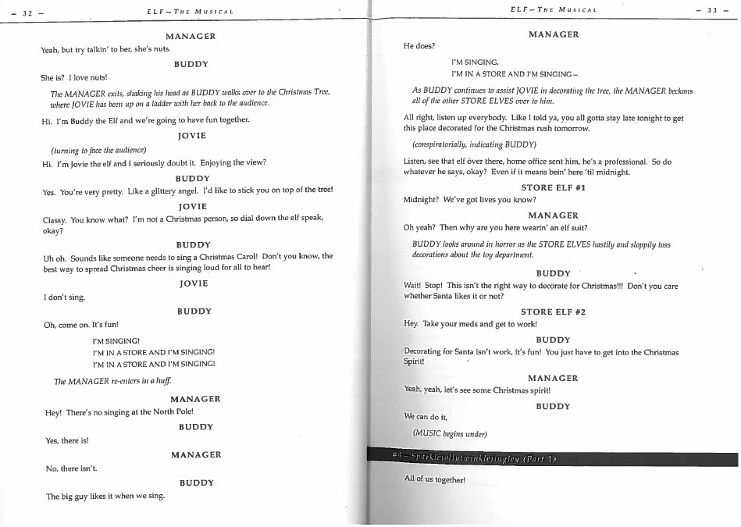

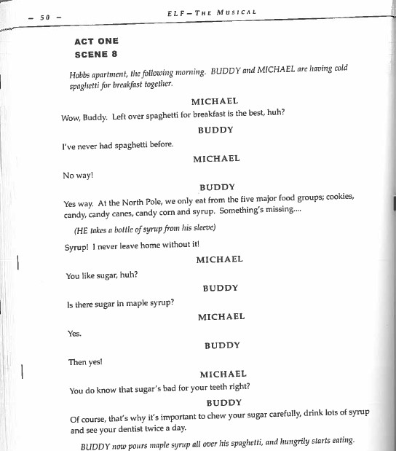

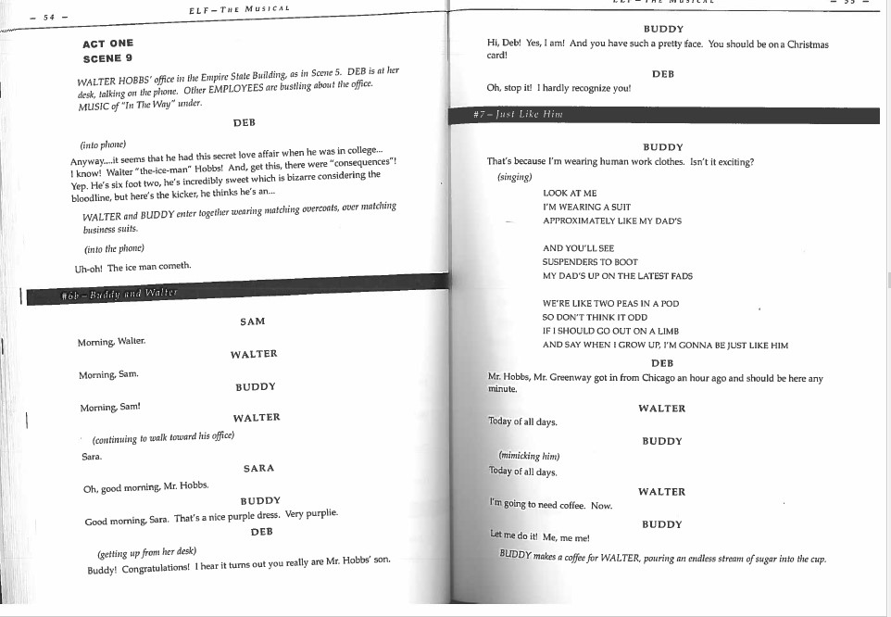

Part 2: Write your own scene.
Now that you have some notes on Buddy’s characteristics, write a one-two page scene between Buddy and a character of your choosing. When writing Buddy’s dialogue, focus on recreating Buddy’s voice and distinctive traits.
Possible scenarios to explore in your scene (you can also create your own).
- Buddy and Michael go driving.
- Buddy and his dad go to the ice cream store.
- Buddy and Jovie go to the movies.
Part 3: Reflect.
In a paragraph response, explain which character traits of Buddy’s you found in the text and which traits you included in your dialogue.
Be sure to:
- Create a list of Buddy’s traits you located in the text after reading the previous scenes.
- Ground these claims in textual evidence. For example, if you say that Buddy is earnest and literal, you must cite dialogue to back this claim up (for example, when the manager calls Jovie nuts, and Buddy responds, I love nuts”).
- Explain where in your dialogue you recreated these traits.

Resources
For further information on the creative team behind Elf
Mathew Sklar:
https://www.matthewsklar.com/
Bob Martin:
https://www.bobmartincreative.com/about-1
Thomas Meehan:
https://playbill.com/article/thomas-meehan-tony-winning-writer-of-annie-dies-at-88
Chad Beguelin:
https://www.chadbeguelin.com/
For further information on the Broadway opening
https://playbill.com/article/elf-the-musical-about-a-misfit-toymaker-opens-on-broadway-com-173564
For further information on close reading
https://writingcenter.fas.harvard.edu/pages/how-do-close-reading
List of Character Traits
https://ideonomy.mit.edu/essays/traits.html
Sources
Curriculum Information
https://curriculum.gov.bc.ca/
Creative Team Biographical Information
https://www.matthewsklar.com/
https://www.bobmartincreative.com/about-1
https://playbill.com/article/thomas-meehan-tony-winning-writer-of-annie-dies-at-88
https://www.chadbeguelin.com/
Photos
https://en.wikipedia.org/wiki/Matthew_Sklar
https://www.imdb.com/name/nm0551991/
https://www.hollywoodreporter.com/news/general-news/thomas-meehan-dead-tony-winning-writer-annie-was-88-1031813/
https://www.chadbeguelin.com/

